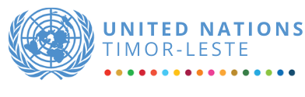

FINAL REPORT
UNSDCF 2021 – 2025 Final Evaluation
Timor-Leste

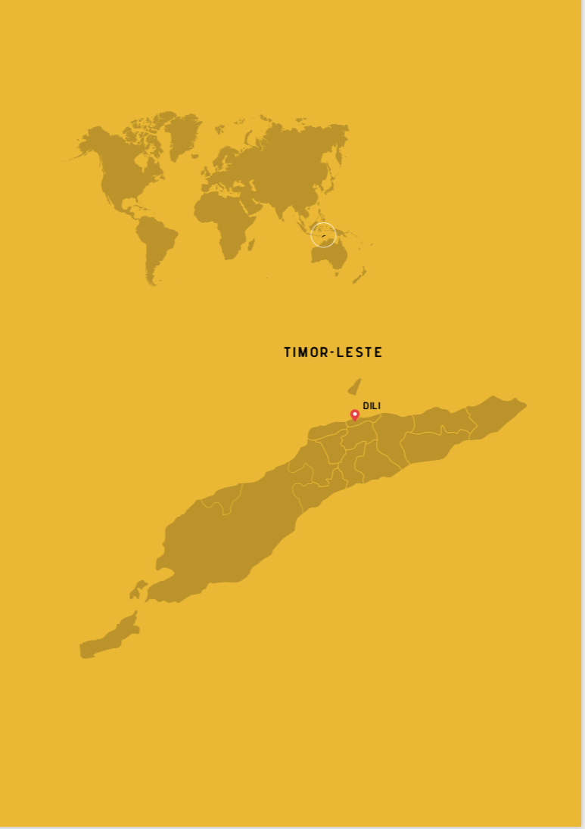

November 2024

The evaluation report is authored by the team of external consultants:
Ms. Magda Stepanyan, evaluation Team Leader, international expert
Ms. Brigida Soares evaluation team member, national expert
Mr. Almanzo Salsinha, evaluation team member, national expert

Evaluation Management team includes:
Ms. Ainhoa Jaureguibeitia, UNICEF Deputy Representative to Timor-Leste
Mr. Lino TasikPina, Data Management and Results Monitoring, UN RCO, Timor-Leste

Acknowledgment:
This evaluation was conducted by an independent team of evaluation experts. While this report is the product of many contributions, any errors or omissions are solely the responsibility of the evaluation team. The analysis, recommendations, and views expressed in this report are those of the evaluators and do not represent those of UN Country Team in Timor-Leste or any of the individuals and organizations referred to in the report.

Table of contents:
EXECUTIVE SUMMARY 7
Introduction 12
Country context 2
Methodology 13
Findings 16
RELEVANCE AND ADAPTABILITY 16
COHERENCE 21
EFFECTIVENESS 24
EFFICIENCY 38
COORDINATION AND GOVERNANCE 43
SUSTAINABILITY 47
ORIENTATION TOWARDS IMPACT 48
Conclusions 49
Recommendations 50
Limitations and lessons learned 53
Summary of performance rating 54
Annexes 56
Annex 1: TOR 56
Annex 2: Revised evaluation questions 75
Annex 3: List of project sites visited 77
Annex 4: Analysis from CSO survey 84
Annex 5: Overview of funding per agency per year per RG 90
Annex 6: State budget expenditures 2021-2025 94
Annex 7: Budget delivery rate per Agency, per year, per results group 96
Annex 8: Budget delivery rate per outcome and sub-outcome area, per year 101
Annex 9: List of stakeholders interviewed 103
Annex 10: Inception report 108
Annex 11: UNEG ethical code of conduct 109
Annex 12: Structure of the case studies 110
Annex 13: Analysis of staffing across UNCT 112

List of Acronyms

Acronym | Full Term
ADB | Asian Development Bank
ACCESS | Accelerating Clean Energy Access to Reduce Inequality
ACAPS | Assessment Capacities Project
ASEAN | Association of Southeast Asian Nations
ATP | Aid Transparency Portal
BCTL | Banco Central do Timor-Leste (Central Bank of Timor-Leste)
CCA | Common Country Analysis
CAS | Complex adaptive systems
CEDAW | Convention on the Elimination of All Forms of Discrimination Against Women
CERF | Central Emergency Response Fund
CF | Country Framework
CPDs | Country Programme Documents
CPE | Country Program Evaluation
CSOs | Civil Society Organizations
COVID-19 | Coronavirus Disease 2019
CV | Curriculum Vitae
DCO HQ | Development Coordination Office Headquarters
DFAT | Department of Foreign Affairs and Trade (Australia)
DPCU | Development Partners Coordination Unit
DPM | Development Partners Meeting
ESCAP | United Nations Economic and Social Commission for Asia and the Pacific
EU | European Union
ECE | Early Childhood Education
EM | Evaluation Methodology
FAO | Food and Agriculture Organization
FMIS | Financial Management Information System
GBV | Gender-Based Violence
GoTL | Government of Timor-Leste
GTG | Gender Theme Group
HDI | Human Development Index
HCT | Humanitarian Country Team
IASC | Inter-Agency Standing Committee
IC | international consultant
ICU | Intensive Care Unit
ICT | Information and Communication Technologies
ILO | International Labour Organization
IMF | International Monetary Fund
INETL | National Institute for Statistics, Timor-Leste
INFF | Integrated National Financing Framework
IOM | International Organization for Migration
JP | Joint Programming
JWPs | Joint Work Plans
KOIKA | Korea International Cooperation Agency
KORK | Kmanek Oan Rai Klaran
LDCs | Least Developed Countries
LNOB | Leaving No One Behind
LFPR | Labor force participation rate
MAF | Management and Accountability Framework
M&E | Monitoring and Evaluation
MSSI | Ministry of Social Solidarity and Inclusion
NCs | National Consultants
NCPA | National Civil Protection Authority
NDCs | Nationally Determined Contributions
OECD DAC | Organisation for Economic Co-operation and Development Assistance Committee
OHCHR | Office of the United Nations High Commissioner for Human Rights
PAA | Annual Action Plans
PF | Petroleum Fund
PMT | Programme Management Team
PSHT | Persaudaraan Setia Hati Terate
RG | Result Group
RCO | Resident Coordination Office
SEA-PLM | Southeast Asia Primary Learning Metrics
SEAMEO | the Southeast Asian Ministers of Education Organization
SDC | Swiss Agency for Development and Cooperation
SDG | Sustainable Development Goals
SDP | Strategic Development Plan
SWGs | Sector Working Groups
ToC | Theory of Change
TVET | Technical and Vocational Education and Training
UNCDF | United Nations Capital Development Fund
UNCT | United Nations Country Team
UNCTAD | United Nations Conference on Trade and Development
UNCT-SWAP | UN Country Team System-Wide Action Plan
UNDIS | UN Disability Inclusion Strategy
UNDP | United Nations Development Programme
UNDRR | United Nations Office for Disaster Risk Reduction
UNESCO | United Nations Educational, Scientific and Cultural Organization
UNEP | United Nations Environment Programme
UNEG | United Nation Evaluation Group
UNFPA | United Nations Population Fund
UNICEF | United Nations Children's Fund
UNIDO | United Nations Industrial Development Organization
UNEG | United Nations Evaluation Group
UN OCHA | United Nations Office for the Coordination of Humanitarian Affairs
UNSDCF | United Nations Sustainable Development Cooperation Framework
UNTFHS | United Nations Trust Fund for Human Security
UNV | United Nations Volunteers
UN Women | United Nations Entity for Gender Equality and the Empowerment of Women
USAID | United States Agency for International Development
VfM | Value for Money
VNR | Voluntary national reviews
VPU | Vulnerable Persons Unit
WASH | Water, Sanitation and Hygiene
WB | World Bank
WFP | World Food Programme
WHO | World Health Organization
WTO | World Trade Organization

EXECUTIVE SUMMARY

INTRODUCTION
This document presents the Report for the Final Evaluation of the United Nations Sustainable Development Cooperation Framework (UNSDCF) Timor-Leste 2021-2025, carried out during June – October 2024 by independent evaluators. The purpose of evaluation is to ensure accountability, learning and improvement of the operational environment, and provide recommendations for the next planning cycle of the UNSDCF or CF. The evaluation was focused on the whole scope of collective efforts of the UN Agencies in Timor-Leste geared towards realization of six strategic priorities of the CF: (i) Nutrition, food security and sustainable agriculture; (ii) Sustainable economic opportunities and decent work for all; (iii) Access to quality education and life-long learning outcomes and skills; (iv) Quality health care and well-being; (v) Accountable, inclusive and participatory governance and quality public services; (vi) Sustainable management of natural resources and resilience to climate change.

The evaluation methodology used mixed method approach to utilize both qualitative and quantitative data and used desk review; 75 semi-structured individual interviews, eight group interviews, three stakeholder workshops (with each stakeholder groups: the representatives of national authorities, UN Agencies, and CSOs), eight project site visits, survey among CSOs, and three case studies on UN coordination, policy-influencing work, and crisis response and recovery efforts. The Inception report is provided in Annex 10.

The evaluation team have the final judgement on the findings, conclusions and recommendations of the evaluation report.

FINDINGS

Relevance and adaptability

Finding #1: The UNSDCF TL 2021-2025 is largely aligned with the national needs and high-level priorities of Timor-Leste but it misses nexus narrative to provide issue-based, stakeholder-specific and area-based roadmap for the collective and bilateral efforts of the UN Agencies. While there were no revisions of the CF, UN Agencies remained highly responsive to often ad-hoc and unsystematic requests from the Government of Timor-Leste. High responsiveness, in often cases, resulted in inconsistent programming, outcomes of which are either not integrated into existing national systems or there is no system to integrate those results into.

Finding #2: UN has demonstrated high level of responsiveness to country’s needs in emergency context related to COVID-19, flood (2021) and drought (2023-2024), which was largely appreciated by the Government of Timor-Leste. As a trusted partner, UNCT allowed for raising international appeals and mobilizing international humanitarian support to those most in need. Some delays in humanitarian assistance were also noticed due to procurement restrictions in UN system but also because of choices made by the Government opting for different pathways for provision of humanitarian assistance. Addressing existing and emerging emergency needs in a more sustainable way, require long-term institutional development with the focus on Civil Protection Authorities primarily but also those who have shared mandates for crisis management and civil protection.

Coherence

Finding #3: CF serves as a general reference document rather than a solid foundation to guide UN Agencies to harmonize and consolidate their programming in spirit of One UN or to engage in transformative partnerships with other development stakeholders in Timor-Leste. Unhealthy competition for limited resources among UN Agencies, limited resources and authority of RCO, as well as their primary accountability to their corporate priorities rather than towards the CF, leaves little space for meaningful collective actions as modus operandi.

Finding 4: Developed back in 2019, the CCA was reviewed on annual basis but with limited consultations with Agencies. CCA was considered informative for general understanding of the context and specifically, changes in priorities of the Government and legal updates. Due to lack of reliable data, including M&E data, the CCA provided limited ground for the UN Agencies’ programming on understanding the remaining gap to address its dvelopment priorities.

Effectiveness

Findings #5: UN Agencies have demonstrated a large volume of collective efforts towards supporting realization of six strategic development priorities in Timor-Leste. While there is still a tendency of immediately shaping a large project missing the state of piloting and prototyping, many examples indicate highly successful efforts of UN Agencies in prototyping and integrating new practices in national systems as well as effective scale up. Much of capacity development efforts, while relevant, require more renewed format to allow for more tailored learning depending on the available capacities and on the complexity of the learning subject. Highly successful efforts were invested in shaping institutions and the regulatory environment in Timor-Leste, while their implementation remains another challenge. While much of data was produced with support of UN Agencies, it is not systematized to be translated into knowledge and inform development decisions adequately.

Finding #6: The UN system follow LNOB principle with different degree of attention and efforts towards its various elements. Gender mainstreaming is high in the agenda of UNCT and it was tabled as a strategic discussion point with the Government of Timor-Leste not least due to processes initiated under the Spotlight Imitative. Significant efforts were invested to promote disability inclusion and human rights.

Efficiency

Finding #7: At individual level, almost none of UN Agencies in Timor-Leste was constrained by lack of funding. On the contrary, the funding is at the level expected but the delivery rate across UN Agencies indicates some inefficiency of operations steadily improved towards 2023. There is high degree of inefficiency in the UNCT Timor-Leste which was largely caused by sub-optimal performance of the DCO HR function and the recruitment process of the UN Agencies, high transaction costs, lack of functioning M&E and knowledge management system. A high level of inefficiency in the process of strategic decision-making within UNCT is also caused through diffused roles and responsibilities between senior and junior staff members. The UNCT communication towards external audience is strategically failing by not responding to the narrative that causes reputational impact on UNCT in Timor-Leste. UN continues to offer unique value-for-money to the Government of Timor-Leste through providing legitimate representation and inclusion of the country in various regional and global dialogues.

Coordination and governance

Finding #8: The role of RC, while supported with mandate, has little if any practical lever to foster collective action if there is no good will from the Agencies. The governance mechanism around CF is largely dysfunctional and the burden of coordination lies predominantly on RC with limited authority and resources. The RGs are largely dysfunctional though efforts are made to improve the situation. The UN Communications Group (UNCG) and the Gender Thematic Group (GTG) and the Youth Results Group are meeting regularly to streamline the UN’s efforts in these thematic areas. The M&E team has nominal functionality. Importantly, there are largely same people involved in these groups, the division of roles and responsibilities is blurred and causes much of confusion. Programme Management Team (PMT) was recently created and could start playing active role in shaping functional distributive governance and improved coordination within the UNCT. Without functional Head of RCO the work of UNCT was largely constrained. Strong role of the RC to coordinate UN Agencies is welcome by the Government and the donors. There are attempts to shape joint programming but the strong sense of shared intent is missing and programming remains largely fragmented.

Sustainability

Finding #9: Much has been done by UN Agencies to establish preconditions for sustainability, yet it remains largely uncertain and fragile due to the country’s dependency on limited oil and gas revenues.

Impact

Finding #10: Through its programming UN Agencies contributed towards strengthening socio-economic resilience in Timor-Leste through inter alia directly addressing causes of vulnerabilities, building coping capacities and contributing to response and recovery capabilities across individual and institutional stakeholders. The development dynamic as well as the volume and typology of efforts invested by UN in Timor-Leste provides promising signals of approaching acceleration on the development curve though with mid-term horizon.

CONCLUSION

UN is a long-standing trusted partner of the Government of Timor-Leste. Over years and during the period marked by ‘triple shocks’ for the country (referring to political impasse, pandemic effects, and natural disasters). UN Agencies have demonstrated that they remain reliable and strong partner of the Government of Timor-Leste and this partnership needs to receive a fresh format and content with the new IX Constitutional Government in office.

UN Agencies demonstrated large scale of strong efforts towards achieving development results through shaping normative context, building capacities of the national and local partners, prototyping, and scaling up. However, there are serious gaps and quality concerns that require immediate attention. The current CF serves of its maximum capacity as a reference document indicating strategic priorities, with very weak results framework. The governance structure around the CF is largely dysfunctional. There is high inefficiency across UNCT that too requires immediate attention. The UN Agencies are expected to overcome their institutional contradictions at the operational level and consolidate around the RC to allow UN to speak one voice and perform above all expectations.

Despite the challenges, the UN Agencies in Timor-Leste demonstrated remarkable efforts and progress towards multiple development needs along six strategic priorities of CF. The ‘quiet’ work of UN requires the attention it deserves to be fully and adequately visible on the development landscape of various actors in Timor-Leste.

RCO and the role of RC remains critical and instrumental in creating conducive environment within UNCT to foster collaboration and cooperation among UN Agencies and engagement in transformative partnerships with external stakeholders.
IMPORTANT NOTE: The evaluation team have the final judgement on the findings, conclusions and recommendations of the evaluation report. The evaluation report will be followed by a mandatory management response and action plan drafted by the evaluation steering committee.

Introduction
This document presents the Report for the Final Evaluation of the United Nations Sustainable Development Cooperation Framework (UNSDCF) Timor-Leste 2021-2025. The evaluation is commissioned by the UN Resident Coordination Office (RCO) as an independent evaluation to be conducted by one international and two national experts during the period of June – October 2024. The TOR is provided in Annex 1. The UN Agencies that have signed the Cooperation Framework (CF) include the following: ESCAP, FAO, ILO, IOM, OHCHR, UNCDF, UNCTAD, UNDP, UNDRR, UN OCHA, WHO, WFP, UN Women, UNV, UNIDO, UNICEF, UNFPA, UNESCO, UNEP.

The purpose of this evaluation is threefold: (i) accountability, i.e. to provide a systematic and evidence-based review of the overall progress made towards the intended outcomes; (ii) learning and operational improvement, i.e. to provide lessons learned to all engaged partners to further enhance their performance, and (iii) inform the development of the next round of the cooperation framework through a set of strategic recommendations based on credible and reliable evidence.

Designed in line with the national strategic priority areas (SRA) of the Government of Timor-Leste, the Cooperation Framework (CF) has six outcomes as presented in the Exhibit 1 below.

The scope of the evaluation is defined by the following:
- Time period: the evaluation captures the whole period of the implementation of the UNSDCF Timor-Leste 2021-2025 since its inception. While the focus on 2021-2023 embraces summative lenses, the focus on 2024 and onward maintains formative lenses providing inter alia recommendations for the enhanced performance within the remaining period of the CF.
- Geography: the evaluation captures the whole geographic scope of the projects, programmes and joint programmes implemented under the current CF.
- Programmatic focus: the evaluation captures the whole programmatic scope of the CF across its six outcomes with due attention to the six core programming principles, e.g., accountability, Leave no one behind (LNOB), Human Rights-based approach, gender equality, resilience and sustainability.

The primary intended users of this evaluation include the following: UNCT, national counterparts, including national and local authorities, civil society organizations, academia and private sector as well as bi-lateral and multi-lateral donors, regional development partners, and the broader development partners.

The report is structured in seven sections and annexes. The current section introduces the evaluation purpose, scope, intended users and the evaluation questions. The second section provides country context. Section three explains evaluation methodology. Section four details the findings per evaluation criteria. Sections six provides overall conclusions and recommendations. Section seven provides lessons learned and discussed limitations. Section eight offers summary performance rating. The document is complemented by a list of annexes to provide additional details for readers.

Exhibit 1: ToC per outcome areas in the cooperation framework
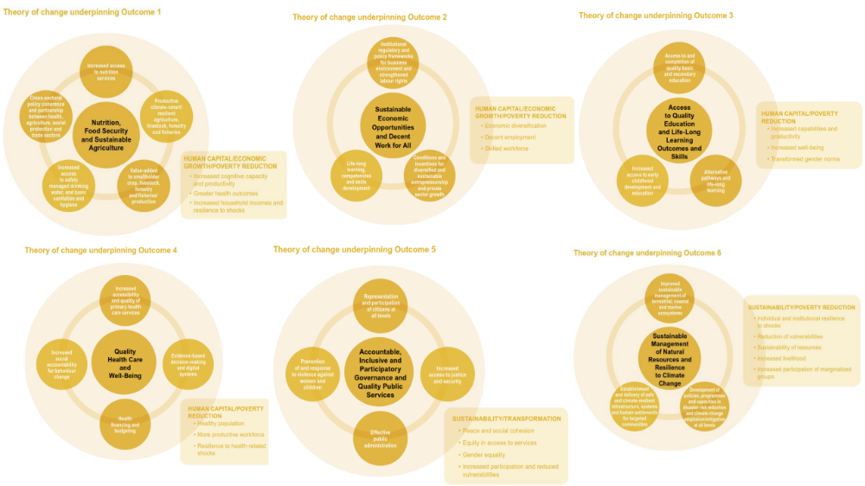

Country context
Timor-Leste is a very small country with extremely complex context. Timor-Leste has an area of 15,000sq/km and is located in the South-East Asia, at the eastern end of the Indonesian archipelago. The total population includes 1,340,434 people (678,087 males and 662,347 female). The GoTL has prioritized the achievement of SDGs already back in 2015 in the Resolution No.34 and placed it at the core of its strategic development goals. The human development index (HDI) in Timor-Leste put the country in the Medium human development category, 155 out of 193 as of 2024. Between 2000 and 2022, Timor-Leste’s HDI value decreased on 14.3%. There is no information available on the SDG Ranking of Timor-Leste.

Table 1 provides some basic statistic to indicate the development context and the status of national progress towards sustainable development goals (SDGs) in Timor-Leste.

Table 1: Development indicators in Timor-Leste

(2022) GDP per capita, current US$ | 1284.3
(2022) International poverty rate ($2.15) | 24.4
(2022) Gini index | 28.7
Acute level of food insecurity | 27%
(2020) Stunting, children under 5 years old | 48%
Malnutrition, children | 9%
(2023) Pre-school education | 27%

Political and cultural context: Timor-Leste’s rich history goes back to ancient times, however, the contemporary political context in Timor-Leste could be better understood by the following critical historical memories: its independence from 450 years of Portuguese colonization in November 1975, after nice days of which it was invaded by its neighboring Indonesia, and its independence from Indonesia after fierce resistance movement for 24 years and regained independence in 2002. This was preceded by the UN administered Referendum in 1999 on independence from Indonesia where Timorese overwhelmingly voted for independence, followed by subsequent violence from militia anti-independence groups and the establishment of UN Transitional Authority (UNAMET) from 1999 to 2002.

Timor-Leste experienced a prolonged period of political stability, while political parties were generally free to operate. Timor-Leste is ranked as 72 from 100 in the world in the Global Freedom status. Since its independence, Timor-Leste held competitive elections and is currently ruled by the IX Constitutional Government in office since 2023. The IX Constitutional Government is placing much focus on country-owned and country-driven aid. One of the defining features of the public administration system in Timor-Leste is easy access to all levels of the system and flat work hierarchy culture. Timor-Leste has been a beacon of democracy, human rights and media freedoms in the region, but it has not been without its share of political instability - political crisis/violence of 2006 linked to security issues, political instability of coalition government and breakdown of ruling coalition government in 2021.

Timorese have strong family ties and sense of belonging to community and to Roman Catholic Church. Catholicism is practiced by around 99,6% of the population. Catholic church is a very strong and influential institution in the country. The long-standing and heroic fight of Timorese has resulted in a ‘survival’ culture, and a sense of faire distribution of resources within the society, very strong national pride and reluctancy of being dependent on international aid.

Although 40% of the seats in the National Parliament are held by women, women are still underrepresented in leadership and decision-making roles nationwide. Only 1 out of 13 Presidents of the local authorities in 13 municipalities and special administrative region, is a woman. While there is representation of women in the highest body, it has not trickled down to local bodies. Women’s representation in non-political institutions also remains very low.

Timor-Leste has achieved SDG indicator 5.5.1 on women’s representation in Parliament and is on track to achieve indicator 5.c.1 on tracking budgets for gender equality.

Governance and public administration system: Timor-Leste have established a democratic governance framework with a semi-presidential system, featuring executive, legislative, and judicial branches. The centralized public administration system manages most functions from the capital, Dili, with efforts to decentralize through municipalities still in the early stages. Despite some progress, Timor-Leste’s public administration remains in a developmental phase, with ongoing efforts to modernize institutions and improve service delivery. Reforms, such as the Public Administration Reform Program and decentralization initiatives, aim to enhance local governance and efficiency. While anti-corruption measures and e-government efforts are being introduced, the system continues to struggle with limited capacity, institutional weaknesses, and unequal service delivery, especially in rural areas. International support and civil society engagement remain critical in advancing governance reforms and addressing these challenges. Timor-Leste receives direct budget support, which is linked with the performance towards a set of key performance indicators (KPIs). However, due to insufficient progress towards KPIs, in 2023, the EU suspended its funding of $55 million initially planned for 2021-2024. The IX Constitutional Government has placed on hold previously agreed loans with World Bank and ADB.

Language: Tetum and Portuguese languages have been given official status, while Bahasa Indonesia and English considered working languages with another 15 or more spoken indigenous languages. Language in TL is an issue of very critical and sensitive nature that explains its ‘belonging’ and its national identity. While the formal documents in Timor-Leste are in Portuguese, this language has limited utility beyond formal circles in the Government. Instead, Tetum has broader use among population but has linguistic limitations to express complex concepts and therefore, limited utility for the formal communication (e.g. in law making, strategic planning and reporting). Besides, to fulfill the criteria of accession to ASEAN, Timor-Leste must improve proficiency in English as a working language across the whole society to allow engagement with government, business, and people within the region.

Demographic context: With the highest annual population growth in Southeast Asia at the birth rate of 1,8 percent annually between 2015-2022, Timor-Leste is a very youthful country with 65% of its population aged below 30 years. About 50% of the population of the country is female. Timor-Leste has the fastest declining fertility rate in world ( -4,6%) which provides a potential to kick-start Timorese economy, known as a ‘demographic dividend’. There is though significant risk of missing this demographic dividend because children are not receiving the necessary investment in health and education to compose a strong workforce for the national economy.

Development context: After its independence, Timor-Leste was faced with state building challenge of paramount significance through (re)building all systems, ranging from public infrastructure to institutional and legal frameworks to provision of critical public services and boosting economy, science, innovation and creativity.

The Government of Timor-Leste produced two Voluntary national reviews (VNRs) to take stock of the progress made towards the realization of SDGs. Hence, the first VNR 2019, highlighted the achievements of the Phase I and defined the next five key steps to accelerate SDG implementation for the Phase II:
- Increasing public understanding and encouraging active participation of citizens in implementing the SDGs
- Integrating SDGs into government budgeting, policies and programmes of line ministries to inform medium-term planning and expenditure frameworks
- Enhancing government capacity for data collection, analysis and monitoring
- Piloting an integrated mechanism for national reporting to the various UN bodies
- Strengthening existing and new partnerships and advocating for financing for sustainable development as part of the exit strategy for Timor-Leste’s least developed country graduation.

While the first VNR focused on SDG 16, the second VNR 2023 was focused on the well-being of the people, mainly covering SDGs 1-5, 8, 16, and 17. It covered the period of ‘triple shocks’ for the country referring to political impasse, pandemic effects, and natural disasters the cumulative socio-economic impact of which have been detrimental to the country’s development gains. It revealed a crucial trade-off for the country between achieving fiscal consolidation and maintaining robust social protection, particularly during times of multiple shocks. To harness ‘demographic dividend’ UN Agencies in Timor-Leste focused on the following six strategic priority areas (SPA):
- SPA1: Nutrition, food security and sustainable agriculture
- SPA2: Sustainable economic opportunities and decent work for all
- SPA3: Early childhood development and life-long learning outcomes and skills
- SPA4: Quality health care and well-being
- SPA5: Accountable, inclusive and participatory governance and quality public services
- SPA6: Sustainable management of natural resources and resilience to climate change.

Several considerations to be factored in understanding the extreme complexity of development context in Timor-Leste.

(1) Economic profile: Timor-Leste is one of the eight Least Developed Countries (LDCs) in Asia and one in 45 LDCs in the world. The share of the population to earn less than USD 2.15 per day is forecasted to 20.7% in 2024. Timor-Leste is very much dependent on oil and gas revenues that is operated through the Petroleum Fund, an account of the Ministry of Finance held in Timor-Leste’s Central Bank (BCTL - Banco Central de Timor-Leste). All of country’s petroleum revenue flows into the Fund, while outflows from the Fund are used to purchase international securities and to source the State Budget. As of 2024, 80% of the state expenditure come from the Petroleum Fun (PF), being spent on salaries and subsidies. Government is the largest employer in Timor-Leste. The Subsidy for Support of Elders and Invalids was created by the IV Constitutional Government back in 2008, initially started with USD 20 annually reaching to USD 80 for 70-79 years old people and USD 100 for 80+ years old in 2024. In 2022 a USD 1 billion Veterans Fund was created in recognition and valorization of the national liberalization struggle. As of 2024, 33,000 people receive subsidy from the Government of Timor-Leste with the total amount of USD 88,816,253.00.

Remittances is the second largest source of revenue. Remittances inflow in Timor-Leste doubled during 2015-2021 and continue to increase with main countries of labour destination being South Korea and Australia. In 2019, 62,9% of Timorese population was of a working age.A large majority (80%) of active population are engaged in agricultural activities with the main agricultural products including corn, grain, potato, etc, cash crops include coffee, rubber, coconut, etc. Agriculture is the largest non-Government economic sector in the Timor-Leste non-Oil economy. Timor-Leste imports and thereby largely dependent on the price fluctuation of a large number and variety of goods and food items offered at the international market, e.g. rice, meat, mineral water, motor cards, cement, etc. For instance, increase in rice price at the global market have had a direct impact on the food security in Timor-Leste since January 2022.

(2) Multidimensional fragility through the prism of some data: As of 2024, the country faces multidimensional fragility due to complex factors and their interplay. Particularly, Timor-Leste remains at high risk of food insecurity, having highest rate of child malnutrition and stunting in Asia. There is no data on the percentage of deliveries attended by health personnel beyond 2016 data indicating the 57%. While 72,4% of the population can read and write, the access to education, quality of early childhood education (ECE), pre-primary education remains of significant challenge. Timor-Leste is predominantly agrarian country with 63,2% of population living in rural areas. The predominantly rain-fed agriculture in Timor-Leste is exposed to climate change and specifically, El Niño impact, heightening already high risk of food insecurity.
Timor-Leste is a patriarchal society, where most of the women are economically dependent on husbands. The employment rate is forecasted to 30.8% in 2024. The labor force participation rate (LFPR) is at 35.9, whereby 41.9 (male) and 29.8 (female). The women’s role in professional employment is the issue of economic empowerment. 80% of women are not paid for their work (compared with 33% of men) and only 27% of women participate in the labour force, compared to 56% of men.
The census conducted in 2022 indicates that 64,6% of the population is under the age of 30, of which the majority (34,8%) are children under the age of 14. The 30.5% of young people of the age group 15-24 years is not in education, employment or training (NEET). The child-related SDG progress was mapped by UNICEF in 2021 indicating inter alia the proportion of children living below the national poverty line as 43 as of 2020. Youth (15-24 years old population), while remaining a critical driver of economic prosperity, constitute 29,8% of the total population in Timor-Leste. Child labour is a significant issue in Timor-Leste though the available data are derived from the 2016 National Child Labour Survey, indicating 67,688 children of age group 5-17 years or 16% being engaged in some form of economic activity. As indicated by UN-Women, only 27.9% of indicators needed to monitor the SDG’s from a gender perspective were available in 2020. Timor-Leste has maternal mortality rate of 142 per 100,000. Gender-based violence (GBV) is of high importance in Timor-Leste and a Vulnerable Persons Unit (VPU) of the police exists in each of the 13 districts and tasked with dealing with vulnerable persons such as women or children who have experienced abuse or violence.

Violence Against Women and Girls (VAWG) remains one of the most widespread human rights abuses in Timor-Leste: 59% of Timorese women (15–49 years) report having experienced physical and/or sexual violence by an intimate partner in their lifetime and 47% in the previous 12 months. However, only 20% of women who have experienced physical or sexual violence have sought help. The demand-side barriers often relate to lack of access to information and assets and social beliefs. Therefore, there is a need for stronger delivery of essential services and also to create awareness and demand for it. Data on time use for women in Timor-Leste is unavailable; this represents a significant data gap (SDG target 5.4).

(3) Donor landscape and coordination mechanisms: While Timor-Leste is not a usual donor darling country and does not got a high presence of donors and bilateral partners, the development landscape of country is quite vibrant ranging from UN Agencies to multilateral donors (e.g., WB, ADB) and bilateral donors operating either through their national aid agencies (e.g., JICA, KOIKA, USAID) or through the delegations and embassies in Timor-Leste (e.g., EU delegation, Australian embassy, New Zealand embassy, embassy of China, etc.) and increasingly, bilateral technical support being provided by ASEAN countries (Brunei Darussalam, Indonesia, Malaysia, Philippines, Singapore, Vietnam and Thailand) to prepare the country for ASEAN accession. Aid space is rather fragmented, often driven by divergent vision on what to prioritize for the country’s speedy development (e.g., infrastructure, economy, private sector, etc.). For the donor partner countries, the priority setting is often driven by the roadmaps of development cooperation being an extension of the foreign policies of those countries. Strong visibility and branding on the side of donors is a critical driver of funding modalities and requirements, in often cases imposing limiting constrains for the implementing partner.

While differences in approach and perspective could be translated into more harmonized and complementary efforts, this does not seem to be the case in Timor-Leste. Though, there are few coordination mechanisms between the Government of Timor-Leste (GoTL) and the development partners:
- Development Partners Meeting (DPM), a high-level forum where the GoTL and its development partners come together to discuss development priorities, strategies and coordination. This is very formal meeting predominantly focused on informing who does what rather than providing avenue for strategic discussions. It is held annually and chaired by the Prime Minister or a senior government official.
- Sector Working Groups (SWGs), thematic working groups with focus on specific sectors such as (1) general coordination; (2) cross cutting issues; (3) economy, trade, diversification, rural; (4) infrastructure; (5) human development / services; (6) state and institutional reform. These groups include representatives from relevant government ministries, development partners, and sometimes civil society organizations. SWGs provide a platform for more operational discussions on sectoral issues, planning and coordination activities. While more at the technical level, these WGs too are often platforms for information sharing and less on shaping shared planning.
- Development Partners Coordination Unit (DPCU), situated within the Ministry of Finance acts as a central coordinating body that facilitates communication between the government and development partners, ensuring that aid activities are aligned with the national development plan. The Ministry of Foreign Affairs (MNEC) is responsible for the inter alia coordination of the policy in the field of development cooperation and is to work closely with the Ministry of Finance, mandated by the aid coordination function.
- Aid Transparency Portal (ATP) provides information on aid flows, projects, and results. This portal enhances transparency and accountability, allowing both the government and development partners to track progress and outcomes. However, the quality and frequency of the information submitted by the development partners varies.
- Regular Bilateral and Multilateral Consultations. In addition to the formal structures, regular bilateral and multilateral consultations between the government and development partners ensure continuous dialogue and collaboration. These meetings help address emerging issues and maintain a strong partnership.

(4) Coordination between the GoTL and UN: The coordination between the GoTL and UN Agencies is also meant to be organized through bilateral meetings of UN Agencies with representatives of the national authorities and through Joint Steering Committee, which is largely dysfunctional with only one meeting taken place in 2023 and none since then. Since the IX Constitutional Government entered in office in 2023, there is a visible shift in attitude towards UN in Timor-Leste. This is a worrying signal resulting in significant slowdown of UN-GoTL strategic relationships and as an impact, on missed opportunities to mobilize vast expertise and resources of UN system from around the globe. It also gives the signal of the role the new Government of Timor-Leste intends to place in global and regional multilateral system.

It is also important to note the distinct layer of complexity of regional agencies especially ESCAP who do not have presence in the country and coordinate from Bangkok, Korea, Fiji etc. Regional agencies directly negotiate programs with government without strategic way of engagement with other UN agencies/RC beyond consultations - usually one meeting to inform when the programme has been negotiated and signed. While some are highly specialized and contribute to the development objectives of CF, they are often outside the purview of the CF.

(5) Civil society space: Very thin space for civil society organizations in the country but CSOs are getting considerable prominence from the side of international development partners. UN Agencies collaborate with CSOs within the scope of their projects and across a range of priority sectors: disability, health and education; advocacy; youth; conflict prevention and peace building; women empowerment; and human rights. Constraints on capacities of the CSO’s and social partners (Employers’ and Workers’ organizations) is a significant obstacle for their more prominent role. However, as it is evidenced from the CSO survey carried out within this evaluation, the CSOs have rather different perception of their capacities. All respondents unanimously agred (100%) that there is a strong and active civil society in Timor-Leste.

(6) Clandestine networks: There are five martial and ritual arts groups, clandestine networks, supported and consulted from abroad and linked to youth violence in Timor-Leste: PSHT, Kera Sakti (ISD), Arte Rituais 77, Kolimau, and KORK. This phenomenon, while little known, is widely prevailed in the society with a broad membership and tight connections with the whole fabric of the society. The groups were registered and just got banned temporarily by government. There is a commission responsible for regulating them under the office of the Vice Prime Minister for Social Affairs. The RCO and the World Bank are currently supporting a national NGO, Belun, to conduct a survey of the MAGs as part of plans to jointly establish a ‘Social Risk Register’ in Timor-Leste.

(7) National Development Strategy: The main national strategic document was and remain the Strategic Development Plan 2011-2030 that guides state-development towards graduation from least developed country (LDC) to upper-middle income country by 2030. The SDP defined the pathway of achievements in four sectors – (i) social capital, (ii) economy, (iii) infrastructure, and (iv) institutions - in three phases reflecting prioritization of efforts through Phase 1 (2011-2019), Phase 2 (2019-2025), and Phase 3 (2026-2030). The SDP has total of 149 sub-goals and is aligned with SDGs and their indicators. Table 2 below provides full overview of the strategic priorities under SDP 2011-2030 and its updated version.

Since 2023, the IX Constitutional Government is elected and have proposed a new national Programme to shorten the path outlined in SDP, remaining largely within those four priority sectors with some more details attached to each of them. The Programme proposes the following six main areas of intervention: (i) rule of law, (ii) development of social capital, (iii) development of infrastructure, (iv) development of the economy, (v) the government consolidation and good governance, and (vi) fight against corruption. Table 2 provides an overview of the development priorities proposed respectively by the VIII and IX Constitutional Governments. Even through there are few areas that have received more prominent attention in this Programme, it predominantly reflects the priorities of the previous one. The strategic aspiration to join ASEAN and WTO brings some deadlines in the medium-term time horizon.

(8) Accession to ASEAN and WTO: The GoTL is in the process of integration into ASEAN. After 11 years, Timor-Leste was granted an official status of observer in ASEAN in 2022. Since 2023, ASEAN’s member states adopted the Roadmap for Timor-Leste’s full membership. The accession comes with the requirements to fulfill certain criteria necessary for the ASEAN membership. Some of the requirements are relatively straightforward, while others require extensive preparation and time to achieve (e.g., ensure required physical infrastructure and logistic readiness to host ASEAN meetings). There are concerns about country’s preparedness related to the degree of economic diversification, level of unemployment and poverty, education attainment, and such.

(9) Disaster context: COVID-19, flood and drought. During the course of the implementation of the CF, Timor-Leste encountered three major disruptive events that significantly impacted the development gains already achieved and the pace to progress towards strategic development priorities, i.e. (i) COVID-19 (January 2020 – May 2023), (ii) flood caused by Cyclone Seroja that affected 10 out of 13 municipalities in Timor-Leste in 2021, and (iii) El Niño-induced drought (2023-2024) that affected 900,000 people (70% of the population of Timor-Leste), whose primary income source is agriculture. The pandemic restrictions resulted in slowing down and delaying many of the programmatic activities across all UN Agencies.

Table 2: Overview of the strategic priorities under SDP 2011-2030 and its update from 2023

Development priorities under SDP 2011-2030 | Revised development priorities, 2023
Economy  - Rural development  - Agriculture  - Petroleum  - Tourism  Private sector investment | Economy  - Blue economy  - Agriculture, livestock, fisheries and forestry  - Petroleum and mineral resources  - Tourism  - Trade  - Industry  - Private sector  - Employment  - Cooperatives  - Environment
Social capital  - Education and training  - Health  - Social inclusion  - Environment  Culture and heritage | Social capital  - Education and Training  - Health  - Social Inclusion, Social Protection and Social Solidarity  - National Liberation Fighters  - Culture and heritage  - Youth  - Sports  - Information and Communication Technologies (ICT)  - Media  - Civil Society (and Religion)
Infrastructure  - Roads and bridges  - Water and sanitation  - Electricity  - Sea and airports  Telecommunications | Infrastructure  - Governance of infrastructure sector  - Road Network  - Water and Sanitation  - Energy  - Transport  - Meteorology and geophysics  - Telecommunication  Postal Services
Institutions
- Security
- Defense
- Justice
- Public sector and good governance
- National development agency, economic policy and investment agency
Consolidation of Government
- Macroeconomic Policy
- Financial Sector
- Public Finance

 | Democratic Rule of Law
Good governance and fighting corruption
- Public Administration
- Decentralization
- Electoral Administration
- Spatial planning
- Rural development
- Special administrative region of Oe-Cusse Ambeno and Special Social Market Economy Zone
- eGovernment
- Justice
- Defense and Security
- International Relations and Foreign Policy
- Delimitation of land and maritime borders
- Institutional Development of Foreign Policy
- Timorese communities Abroad

Methodology
The evaluation methodology used mixed method approach to utilize both qualitative and quantitative data. The evaluation approach was based on three considerations: (i) the Theory of Change (ToC) approach to consider the results chain of the CF and to explore progress made towards each outcome; (ii) system based approach to account for the complexity of the context around the CF and make conclusions on the evaluation questions with due considerations of the interplay of various contextual factors; and (iii) participatory approach to ensure that all stakeholders had faire opportunity to participate in the CF’s evaluation and provide recommendations for the most optimal way forward.

The data collection instruments included the following:
- desk review of multiple documents;
- 74 semi-structured individual interviews and eight group interviews (with M&E and Gender and Youth thematic teams as well as with six Results Group (RG) under UNCT);
- stakeholder workshops – one workshop with the representatives of the national authorities, one workshop with the representatives of all six UN results groups, and one workshop with the representatives from civil society organizations;
- survey among CSOs;
- project site visits (the evaluation team visited eight project sites in Manatuto and Baucau municipalities); and
- two case studies. The selection of case studies was done jointly with the UN resident coordinator’s office (RCO) and the evaluation management team (EMT). It was agreed to explore not a project or programme but to look into three priority themes, namely, (i) coordination of UNCT internally and with the external partners; (ii) collective efforts of UN Agencies in disaster response and recovery during COVID-19, flood in 2021, and drought in 2023-2024; and (iii) collective efforts of UN Agencies in policy influencing and supporting national legal and regulatory framework in Timor-Leste. Taking into consideration that ‘coordination’ is within the focus of evaluation and covered by evaluation questions as well as the extreme time limitation for this evaluation, there is no separate case study on ‘coordination’. Instead, all the findings are reflected through the coordination-related questions in the evaluation findings. The structure for case studies on UN crisis response and UN efforts to support regulatory environment in Timor-Leste is proposed in Annex 12.

The sampling strategy was based on the stakeholder mapping caring out during the inception phase. The evaluation team created a long list of 170 stakeholders, categorized as (i) representatives from the UN Agencies; (ii) national and local authorities; (iii) CSOs, media; (iv) businesses; (v) academia, and (vi) donors. The stakeholders were mapped accroding to their engagement in implementation of each outcomes. The sampling strategy employed availability sampling and ensured stakeholder respresetnativeness across different category of stakeholders. However, to ensure some degree of geographic and programmatic representativness in the sampling the evaluation team (i) visited projects sites and engaged with the local level project beneficiaries (hence, the sampling included not only national level but also local level key informants); (ii) interviewed a wide range of stakeholders engaged in different programmatic activities (hence, the sampling included key informants engaged in a range of programmatic activities with the UN Agencies). The rule of good maximum sample size usually does not exceed 10%. However, acknowledging significant gap in data in this case, the evaluation team applied purposive sampling to shortlist 30% of the key stakeholders from the initial long-list of 170 stakeholders and went extra mile to interview 75 people instead of 51 (as the sampling with 30% shortlist would suggest).

The data collection and analysis were guided by the evaluation matrix designed at the inception phase to capture the points of interests and concerns and to organize findings accordingly. For data analysis two distinct path were chosen: (i) change analysis to assess the progress towards the CF’s outcomes by comparing the results indicators at the output, sub-outcome and outcome levels against the targets as defined in the CF’s results framework; and (ii) context-sensitive contribution analysis to explore cause-effect’ patterns and conclude about the contribution made or not to both intended and unintended outcomes of the CF. The focus of the contribution analysis was not to quantify the degree to which the outcomes achieved but to provide evidence to support reasonable conclusions about the contribution made to the desired outcomes of the CF. Systems lenses were applied for this analytical approach.

The evaluation team was vigilant to gender and human rights issues across the evaluation process. For this purpose, the evaluation team employed several strategies:
- a workshop was organized with the CSO representatives to discuss LNOB principle in the work of UN and the Government
- survey was administered among CSO organizations in Timor-Leste to collect their insights
- the evaluation coordinated with the on-going LNOB study in UN Timor-Leste and benefited from the findings of the study. Towards that end, (i) the CSO workshop was conducted together with the Development Coordination Officer for LNOB from UN RCO Indonesia who was conducting the LNOB study for the RCO Timor-Leste); (ii) the joint workshop with the representatives of all UN Results groups was also organized in partnership with the Development Coordination Officer for LNOB from UN RCO Indonesia to ensure that cross-cutting issues are dully attended during the discussion; (iii) the survey instrument was jointly shaped by the evaluation team and the LNOB Officer; and (iv) the evaluation team put efforts to ensure gender representativeness among key informants.

The evaluation was guided by the OECD DAC evaluation criteria and includes the following: relevance and adaptability, coherence, effectiveness, efficiency, impact orientation and sustainability. Additional critical criteria was on coordination of the UNCT internally and with the external partners toward the realization of the CF. Annex 2 provides revised Evaluation questions. Table 3 below provides an overview of the stakeholder interviewed across key categories of stakeholders. The list of stakeholders interviewed is provided in Annex 9.

Table 3: List of stakeholders interviewed individually
Total number / short-listed number | UN partners | Government implementing partners | CSOs, media | Private sector | Academia | Donors | Total
Total # | 22 | 75 | 54 | 6 | 5 | 22 | 184
Short-listed # | 7 | 23 | 16 | 2 | 2 | 7 | 57
Interviewed (Female/Male) | 12 F / 15 M | 7 F / 22 M | 5 F / 3 M | 0 F / 2 M | 1 F | 3 F / 5 M | 28 F / 46 M
Difference | + 20 | + 6 | - 8 | 2 | - 1 | + 1 | + 17

For the quality assurance throughout the evaluation process, the evolution team adhered to the UNEG evaluation norms and standards as well as to UNEG ethical code of conduct. The quality assurance of the evaluation deliverables is carried out by the Evaluation Reference Group (ERG). The evaluation was carried out with full adherence to the UNEG Ethical Code of Conduct and UNEG Norms and Standards for Evaluation. Special focus on human rights, gender equality, youth and disability inclusion was maintained throughout the whole evaluation through: (i) how the results were analyzed, e.g. if the interventions addressed these cross-cutting issues and advanced the rights of the target groups. The findings for this evaluation were informed by the Leave No One Behind (LNOB) study carried out in parallel to this evolution by Arben Sejdaj, Development Coordination Officer for LNOB, RCO Indonesia. (ii) how the evaluation process was approached, i.e. to ensure adequate representation of men and women in all stages of the evaluation.

Findings
This section is composed of the evaluation findings organized per evaluation criteria and per evaluation question.
Intensive data triangulation was applied across multiple sources for data, sources and methods to validate evaluation findings. Annex 3 provides the list of project sites visited. Annex 4 provides the analysis from the CSO survey.

General remarks on the findings from the TOC analysis: The evaluation team organized individual meetings with all six results groups as well as a joint workshop with the representatives of all Results Groups to discuss the relevance of TOC and possibly to reconstruct it as well as to define the progress made, gaps and opportunities to be considered for the way forward. The findings of the workshops suggest that the current TOC is still relevant as it is fully in line with the national priorities; it is very broad and can include any emerging priorities. The conclusion was that there is no need to reconstruct the TOC at this point but there is a need to sharpen the focus of UN’s efforts in the country for the next strategic planning cycle. The development of the new TOC should be based not only on the needs on the ground but also on the capability analysis of the UNCT as well as strong narrative defined by UNCT to indicate which nexus areas are of priority to address for the next five years.

RELEVANCE AND ADAPTABILITY

Question 1: To what extent are the CF objectives aligned and consistent with the needs, priorities, and policies of the government (including alignment to national development goals and targets, national plans, strategies and frameworks).

Finding #1: The UNSDCF TL 2021-2025 is largely aligned with the national needs and high-level priorities of Timor-Leste but it misses nexus narrative to provide issue-based, stakeholder-specific and area-based roadmap for the collective and bilateral efforts of the UN Agencies. While there were no revisions of the CF, UN Agencies remained highly responsive to often ad-hoc and unsystematic requests from the Government of Timor-Leste. High responsiveness, in often cases, resulted in inconsistent programming, outcomes of which are either not integrated into existing national systems or there is no system to integrate those results into.

In the context of high prevalence of complex development challenges, however, the question is not ‘which challenges to address’ but ‘which challenges to address first’ to ensure system-level impact and spillover effect across the whole society. This requires complexity-based solutions, leveraging on possible cross-sector interfaces and building synergetic impact across various systems. The main strategic document to guide development aid in the country was and remains the Strategic Development Plan (SPD) 2021-2030 and its updated version introduced by the IX Constitutional Government in 2023.

Aligning with the SDP 2011-2030 and building on UN Agencies comparative advantages, CF was designed to address mostly the priorities under Phase 1 (outcomes 1, 3, 4, 5), but also under Phase 2 (outcome 2) and Phase 3 (outcome 6). The SDC was highly ambitious, similarly was CF by targeting a highly ambitious set of outcomes that require much longer-term efforts that can possibly be covered by the 5-year cycle of the CF. Besides, it does not provide a roadmap leaving UN Agencies with sense of direction only.

There were no adjustments or revisions of the CF introduced over the course of its implementation or after the new Programme was introduced by the IX Constitutional Government. The CF was mostly a refence document and there was no shared need to revise the document that was serving such a narrow purpose. Besides, there was no strong narrative emerging from any UN Agency that would not be possible to encapsulate into the existing scope of the CF’s outcomes and sub-outcomes.

At the level of each UN Agency, there was a complex dynamic on how each Agency would respond to country development needs. This happened mostly at the bilateral level in the context when the operational priorities from the national authorities were rather unsystematic and regularly changing. In the absence of strong nexus narrative, i.e. an issue-based, stakeholder-specific and area-based roadmap on how UN Agencies collectively intend to realize the outcomes of the CF, these ‘responsiveness’ caused inconsistency in efforts and questioned the sustainability of results.

Nexus narrative explained: issue-based, stakeholder-specific, and area-based

Complex challenges required complex solutions which are always at the intersect of various systems or domains, i.e. nexus solutions. Defining nexus narrative would explain the roadmap to nexus solutions. Complex solutions could be conceptualized and implemented through a distributed network of UN Agencies and its partners in Timor-Leste. However, there is a need for a consolidated intend and guidance to allow for that distributive governance. The CF provides an indication of nexus challenges but should also explain the nexus narrative, e.g., the logic of programming that is hinged on
- which actors to work with or for?
- which geographic area?
- what question or what agency?
Addressing these three A’s from system perspective would entail shaping such programming that would allow removing contextual constrains or enhancing points of traction to allow enabling constrains for the system to produce desired outcomes. For instance, a joint programme where the same group of beneficiaries with a range of demands and needs and located in the same area is targeted by different UN Agencies to address a range of issues, whereby each UN Agency takes the responsibility for a specific issue or issues. In this case, the approach is area-specific, it is also stakeholder-specific, and it is also issue-based. Through bringing the three A’s together, it’s possible to combine area-based approach with portfolio-approach and ensure highest effectiveness of each intervention. Nexus narrative will also open opportunities how to engage various UN Agencies in a meaningful joint programming in the spirit of UN reforms.
In the context of multiple, dire and immediate challenges, the responsiveness at the operational level often did not result in integration of the outcomes into the existing national system to create ripple effects. Several evaluations carried out by the UN Agencies indicate the fragmented and inconsistent objective-setting from the national authorities, e.g. Cluster evaluation on Roads for development (ILO, 2023), or Country-led evaluation of Preschool Education in Timor Leste (UNICEF, 2022), or Enhancing rural access agro-forestry improving access to agro-forestry area (ILO, 2023), Country-led Formative Evaluation of Early Childhood Education in Timor Leste (UNICEF, 2022).
Another example concerns the discontinuation of Bolsa da Mãe, a major social protection programme, announced by the Government of Timor-Leste in November 2023. The programme provided the pregnancy and children's subsidies, called “Bolsa da Mãe Jerasaun Foun” subsidies of USD8-USD10 to those in need. The creation of the subsidy was adopted by the Council of Ministers on December 2021 and fully funded by Australia with the budget of 16Million Australian Dollar, which is USD 17 million. UN engagement in such initiative was supported by the global data on the benefits of cash transfer over more traditional food distribution in case of food emergency confirmed also through the Joint Donor Statement on Humanitarian Cash Transfers. However, the initiative was suspended and USD 7 million of donor funds remained unspent.
Despite the main pattern of ‘disarrayed’ requests from the national authorities, there are also multiple examples with successful responsiveness that were highly justified and led to tangible results (e.g. investment in decentralization efforts of UNDP which was not initially envisaged in the CF).

Important to note that disarray is also caused to a large extend by the priority-setting of the donor agencies in Timor-Leste providing earmarked funding in line with the commitments of their national authorities to the state of Timor-Leste. Depending on the donor funds, UN Agencies would comply with the donor requirements. This creates an extremely complex dynamic further fueling competition among UN Agencies. For instance, while gender equality is the key element of the Multi-Annual Indicative Programme (MAIP) for 2021-2027 of EU, it does not prioritize addressing gender-based violence, yet it remains a critical and continuous point of attention and programming for UN Women and a priority under the CF.

Question 2: How dynamic and responsive has the CF been to emerging and unforeseen needs, especially those of the most vulnerable, disadvantaged, and marginalized groups?

Finding #2: UN has demonstrated high level of responsiveness to country’s needs in emergency context related to COVID-19, flood (2021) and drought (2023-2024), which was largely appreciated by the Government of Timor-Leste. As a trusted partner, UNCT allowed for raising international appeals and mobilizing international humanitarian support to those most in need. Some delays in humanitarian assistance were also noticed due to procurement restrictions in UN system but also because of choices made by the Government opting for different pathways for provision of humanitarian assistance. Addressing existing and emerging emergency needs in a more sustainable way, require long-term institutional development with the focus on Civil Protection Authorities primarily but also those who have shared mandates for crisis management and civil protection.

Substantial response and recovery efforts were mobilized by UN Agencies to address three major disasters that took place during the CF’s implementation period and have significantly impacted the development context in Timor-Leste, i.e. (i) COVID-19 (January 2020 – May 2023), (ii) flood caused by Cyclone Seroja that affected 10 municipalities out of 13 in Timor-Leste in 2021, and (iii) El Niño-induced drought (2023-2024) that affected 900,000 people (70% of the population of Timor-Leste), whose primary income source is agriculture.

UN Agencies managed to quickly repurpose their funding and mobilize emergency support to address critical needs related both to response and recovery. For instance, to respond to drought, UN mobilized emergency grant funding of USD 2million from the UN Central Emergency Response Fund (CERF) for the provision of emergency food, water, nutrition and agricultural assistance to the affected population in six municipalities. At the operational level, the process was challenged by the bureaucracy of UN (e.g. delays in procurement, or delays in distribution) but also by the choices made by the national authorities regarding procurement. ‘Too late, too less, too expensive’ as it was mentioned by one of the respondents. For the response to COVID-19, UN has conducted socio-economic impact assessment in 2021 to inform pandemic response and recovery plans of various stakeholders.

Besides, efforts were invested in supporting regular service provision in the country, for instance, in organizing elections during pandemic. In 2020, amidst COVID-19, a series of elections at the national and municipal levels have been planned in Timor-Leste. UN (specifically, UNDP, UN Women, IOM, OHCHR) helped in organizing all elections with full respect to mandatory COVID-19 restrictions to ensure the continuation of practice of democratic election in Timor-Leste.

While the pandemic was largely a ‘black swan’ event, floods and droughts in Timor-Leste has recurrent nature and require anticipatory action for preparedness. During the drought crisis, FAO has demonstrated strong anticipatory action through providing an assessment of drought conditions at the provincial level with special focus on potential impact on agricultural. As a result, FAO issued drought alerts covering the entire country in October 2022 and internal funds from its anticipatory action window to start putting this process into action.

The criticality of resilience building requires due attention to prevention and preparedness activities with whole-of-society focus and with multi-hazard perspective. With weak institutions, the needs for capacity development for the National Civil Protection Authority (CPA) and those institutions that have shared mandates for crisis management and civil protection is very high in Timor-Leste.

UN coordinates emergency preparedness and humanitarian response efforts through the Humanitarian Coordination Team (HCT). The UNRC, CPA President, and INGO representative (CARE International) co-chaire the HCT, with mandated UN agencies leading the clusters as per Inter-Agency Standing Committee (IASC). Contingency Plans are updated on a yearly basis. The Terms of reference was updated last March 2024 to reflect the UNRC as the chair and membership from UN agencies, INGOs, NGO, and Embassies.

COHERENCE

Question 3: To what extent has the CF promoted complementarity, harmonization and co-ordination within the UN and other key development partners to maximize the achievement of results?

Finding #3: CF serves as a general reference document rather than a solid foundation to guide UN Agencies to harmonize and consolidate their programming in spirit of One UN or to engage in transformative partnerships with other development stakeholders in Timor-Leste. Unhealthy competition for limited resources among UN Agencies, limited resources and authority of RCO, as well as their primary accountability to their corporate priorities rather than towards the CF, leaves little space for meaningful collective actions as modus operandi.

The UNSDCF Timor-Leste 2021-2025 is one of the first-generation CFs developed after the initiation of UN reforms back in 2017. For the first time this document attempted to introduce a unified vision of UN Agencies in Timor-Leste with a theory of change (ToC) for each outcome and with the role of each Agency expected to achieve those outcomes. The CF has become a document that each UN Agency could refer to when exploring programmatic opportunities in Timor-Leste. It does not, however, provide the critical guidance for UN Agencies to shape their programmatic portfolio in a complimentary, harmonized, and coordinated way. Neither is it the foundation to guide engagement of UN Agencies in strategic and transformational partnerships with other key development actors in the country. There are several major factors contributing to this situation:

(1) The quality of the CF and its results framework: The CF has achieved its greatest value when was presented to the external stakeholders as the first strategy representing collective aspiration of UN Agencies in Timor-Leste in the spirit of the UN reform and in line with the national strategic priorities. However, the results framework shaped around the CF is not conducive, guiding, or even informative.
- Outcomes: The CF’s outcomes are of impact level. Timor-Leste had a comparative advantage of having a state M&E system linked to SDG indicators and budget planning and realization. That system is no longer in place to track the progress of the outcomes’ indicators directly through the national M&E system. The viable alternative to explore joint efforts to track progress towards high-level SDG indicators is the National Institute of Statistics of Timor-Leste (INETL), co-founded by UNDP back in 2000 and receiving continuous support from UN Agencies.
- Sub-outcomes: Instead, the sub-outcomes are the results where the UN Agencies could demonstrate and claim their progress with higher degree of confidence. The challenge at this level, though, is that indicators are not fully adequate while baselines and targets are absent or unwarranted. In this situation, UN Agencies cannot have evidenced story of progress made towards the sub-outcomes, which is explained by the lack of shared course of action, joint programming, and strong nexus narrative for maximizing the achievement of results. Moreover, there is no sound monitoring and evaluation (M&E) system in place around the CF to continuously track the progress towards its outcomes and inform decision-making across all UN Agencies accordingly.
- Outputs: As the initial version of the CF was lacking output indicators, in 2023 some output indicators were chosen by the Agencies from a list of globally available outputs indicators created by the DCO HQ. The selected few outputs are largely insufficient or adequate to provide fair indication or capture the wide range of efforts each UN Agency invested in Timor-Leste.

On additional note, the classification used in the CF along ‘outcomes/sub-outcomes/outputs’ does not correspond to the UN INFO guidance of how to measure the progress. The latter requires ‘outcomes/outputs/sub-outputs’, whereby outputs are above activity level results. The CF reporting of outputs indicates largely activity level results, which provide systemic constrain that does not allow to capture the complexity of the evolving development context in Timor-Leste and subsequently, the results produced by the UN. The activity level outputs should remain highly agile driven by emerging evidence to support on how to progress towards sub-outcomes and should be captured only retrospectively by the M&E function.

(2) The institutional set up of UN Agencies is such that each Agency is faced with two authorizing environments. First, it has its own corporate strategic priorities that must be fully reflected in each country office strategy and portfolio of operations. Hence, there is a corporate strategy document, which is translated into regional strategy or action plan and expected to be adequately translated into national Country Programme Documents (CPDs). The M&E and reporting system of each Agency at country level is also linked with that of the corporate one. Second, the CF comes as a parallel line of results, indicators and reporting, which is hardly feasible to operationalize i.e. harmonize with results, indicators and reporting lines in the country portfolio of each Agency. As of Management and Accountability Framework (MAF), UNCT members have two accountability lines – towards their respective entities and towards the RC for their contribution to agreed results as defined in the CF. However, the second line of accountability is very weak and depends largely on good will of the UNCT member.

(3) The realization of the CF requires careful match of strategic priorities with the capabilities available in the composition of the UNCT. Complex problems require complex solutions and mobilization of comparative advantages of various UN Agencies. While the CF does indicate the nexus to drive sustainable development and generate synergetic impact across multiple systems, it does not define the nexus narrative (e.g. an issue-based, stakeholder-specific and area-based roadmap to create decentralized but aligned collective actions among UN Agencies), meaning, the roadmap on how UN intends to address the nexus problems and generate the nexus impact collectively. As a result, this makes it challenging to fully leverage the comparative advantages of each UN Agency to the degree expected. The latter became somewhat possible on an ad-hoc basis when attempting to shape a joint project and to respond to specific requirements attached to each call for proposal.

(4) There is often unhealthy competition among UN Agencies to mobilize resources and ensure footprint in certain thematic or geographic area driven inter alia by the corporate expectations at regional or HQ levels as well as fragmented requests from the development community and the government. This is a distractive factor that impacts the dynamic among UNCT in Timor-Leste. This also impedes UNCT to benefit from its comparative and competitive advantages vis-à-vis other development partners. In Timor-Leste, there is no history and culture to mobilize the benefits of country-level pooled fund (development) as inter-agency fund consolidated under Resident Coordinator (RC) leadership to leverage collective UN power while addressing country priority SDGs as defined in CF.

(5) RCO inadequate resources (human & financial) and authority to coordinate/ensure coherence of programmes (including joint programmes) in often cases leaves RC with limited instruments to influence the quality of coordination among UN Agencies. An example, the IX constitutional government in December 2023 abolished the Bolsa da Mae Jerusaun Foun which was as a result of joint advocacy by UN and development partners to provide cash to pregnant women, children under 5 and children with disabilities. Instead, government changed its agreed course of action to food distribution scheme and requested support from the WFP. In this situation, UN Agencies individually remained responsive but collectively missed One UN principle. It is expected by all external stakeholders that UN would position its voice more strongly in Timor-Leste and that the UN RC will have stronger role to lead collective efforts of UN Agencies in the country.

Question 4: Post UN reform, to what extent have UN agency programmes and work plans been effectively and meaningfully derived from Common Country Analysis (CCA) both in design and implementation?

Finding 4: Developed back in 2019, the CCA was reviewed on annual basis but with limited consultations with Agencies. CCA was considered informative for general understanding of the context and specifically, changes in priorities of the Government and legal updates. Due to lack of reliable data, including M&E data, the CCA provided limited ground for the UN Agencies’ programming on understanding the remaining gap to address its dvelopment priorities.

CCA was developed back in 2019 and revised annually with limited consultations with UN Agencies. The revised CCAs provided an overview of the challenges in development context in Timor-Leste, especially, regarding any shift in national priorities. For instance, the CCA 2023 indicated the shift of national priorities towards pre-school learning declared by the President with a 230% budget increase in 2023 or the launch of Youth Action Plan in 2023 with allocation of USD 58 million or 2.7% of the national budget.

The revised CCAs were also useful as they compile and referenced several relevant data sources and studies carried out by UN Agencies or other development partners over the course of the previous years and remained relevant for the year of the CCA. For instance, CCA 2023 refers to Timor-Leste Social Protection Review (2020) carried out by the World Bank, or the child-related SDG progress portal of UNICEF, etc.

There are various studies carried out by each UN Agency in the country, there is also accumulation of expertise among UN staff to observe emerging development patterns and to respond effectively. However, there is no adequate M&E and tightly linked knowledge management within the UNCT to allow such critical reflections in the updated CCAs to indicate remaining gap vis-à-vis the CF’s outcome. The UN Agencies shape their annual programming based on various factors in response to the emerging needs and based on their internal evidence and analytics.

EFFECTIVENESS

Question 5: How effective has the CF been in achieving the results outlined in the results framework? What have been indications of the benefits for the people and institutions targeted by the interventions, including the most vulnerable, disadvantaged, and marginalized population?

Findings #5: UN Agencies have demonstrated a large volume of collective efforts towards supporting realization of six strategic development priorities in Timor-Leste. While there is still a tendency of immediately shaping a large project missing the state of piloting and prototyping, many examples indicate highly successful efforts of UN Agencies in prototyping and integrating new practices in national systems as well as effective scale up. Much of capacity development efforts, while relevant, require more renewed format to allow for more tailored learning depending on the available capacities and on the complexity of the learning subject. Highly successful efforts were invested in shaping institutions and the regulatory environment in Timor-Leste, while their implementation remains another challenge. While much of data was produced with support of UN Agencies, it is not systematized to be translated into knowledge and inform development decisions adequately.

During the evaluation, the team was increasingly puzzled with the question ‘what to evaluate?’. Evaluation of the progress towards CF’s outcomes based on the results framework is unfair to the huge volume of very diverse and dedicated efforts from all UN Agencies in Timor-Leste. Stronger guidance and quality oversight from the DCO was expected to support UNCT in Timor-Leste to maximize the value of such strategic planning document as the CF. The results framework does not capture that diverse and rich efforts. Neither did the CF’s M&E system, hardly in place and functional, allow capturing the scale and the depth of the efforts. Therefore, the decision was made to explore the programmatic performance of UN Agencies in Timor-Leste irrespective of their formal linkages to the CF’s results framework, meaning, the linkages with the indicators of outcomes, sub-outcomes and outputs. This stance is also supported by the argument raised earlier that there was no strong narrative on behalf of any UN Agency that could not be absorbed by the current CF. Hence, the shift from outcomes to strategic priorities and therefore, the rephrased question is: how effective were UN Agencies in progressing towards the strategic priorities outlined in CF?

Table 4 below provides an overview of the progress to indicate the current status of the key progress indicators mentioned in the CF. Progress along these indicators cannot be achieved by UNCT only and are result of collective efforts of all development actors in Timor-Leste. It indicates very slow but progress across the largest number of progress indicators; there are also few indicators where no information of the progress was available in Timor-Leste.

While lack of progress to SDGs is universal, the pace of progress in Timor-Leste questions the ambition of graduation from LCD status to the status of middle-income country. On this backdrop, there are strong evidence to suggest that UN Agencies predominantly individually than collectively have invested significant efforts to address development challenges in the country.

The effectiveness analysis was focused on the progress made under each outcome area through the following modalities: (i) prototyping and integrating into existing systems, (ii) capacity development and awareness raising, (iii) normative work and institutional development, and (iv) generating data and sharing knowledge. Therefore, slight modification to the evaluation questions introduced for the Effectiveness section. Another important caveat was to look at the effectiveness of UN operations in Timor-Leste through the prism of the financial weight of their programmatic portfolio of UN operations vis-à-vis either government budget or the development spendings of the large donors in the country. In this comparison, UN has very modest share with only around $40-50 million annual spending, however, the criticality of its investments remains very high.

Question 5a: How effective were UN Agencies in prototyping, demonstrating ‘proof of concept’ and integrating into existing systems?

There is still a tendency of immediately shaping a large project missing the state of piloting and prototyping to stress-test what works and what does not and sharpen the proposed model. However, UN Agencies have demonstrated a great number of highly successful prototyping and in often cases, integration of the prototypes in the national systems to allow meaningful scale up and replication.

An example is the work done through UNDP Timor-Leste Accelerator Lab that allowed for tailored solutions to address complex challenges with practical solutions. Another example is demonstrated by UNICEF through its WASH innovation project (2019), focused on supporting basic WASH services in communities as well as in schools and health centers. Or the work of UNICEF on Primero in 2024. Primero is a case management web application established in the Ministry of Social Solidarity and Inclusion (MSSI) to help social service providers coordinate critical support for vulnerable children. Another example is the resilient housing prototypes created by UN-Habitat, a non-resident UN Agency in Timor-Leste, which through its intervention contributes to the achievement of the development priorities of the country in 2024.

One of the great examples of prototyping and then integrating into national system is the work carried out by WFP since 2019 on school feeding model, which has been integrated into national education system through the School Meals Coalition Declaration: Nutrition, Health, and Education for all children, a commitment to continue the expansion of the national school feeding programme since 2021. As of 2024, around 100,000 children benefit from the programme. Currently, WFP is supporting the Government of Timor-Leste with prototyping school kitchen and installing them in 11 locations (Dili, Baucau, Ermera, Aileu, Manatuto, Liquiça, Viqueque, Oecusse, Bobonaro, Ainaro, Covalima) with intention to allow integration of such kitchen model into the national programme.

The whole scope of such initiatives, as well as their critical value for the progress of Timor-Leste is not easily visible or regularly messaged to the government, to the donors, even to the sister UN Agencies or general public. There is no consolidated communication strategy towards high-level progress made by the UN in Timor-Leste to make the work carried out by various UN Agencies in the country, adequately visible and appreciated as it deserved to be. This causes a confused understanding among stakeholders, particularly external ones, about the value delivered by UN Agencies in Timor-Leste and their invaluable contribution to the slow but progress the country is making towards its development goals.
Table 4: Key progress indicators as of UNSDCF 2021-2025

Indicator | Baseline | SDG Indicator | Data Source | Change from the Baseline | Reference | Difference in Progress (i) in Numbers | Colour Code | Indicates
Prevalence of stunting (height for age <-2 SD) among children under 5 years | 50% | 2.2.1 | Timor-Leste Food and Nutrition Survey 2013 | 46.70% | DHS 2020 Link | 3.30% | Green | This reduction indicates progress in addressing stunting among children under 5 in Timor-Leste, suggesting improvements in nutrition and health interventions. Although a 3.3% reduction is positive, stunting rates are still high, and continued efforts are needed to further reduce the prevalence and achieve SDG 2.2.1.
Prevalence of food insecurity in the population | 36% | 2.1.2 | Ministry of Agriculture and Fisheries IPC 2018 | 22% | Census 2022 Link | 14% | Green | This significant reduction reflects notable progress in reducing food insecurity within the population. The improvement suggests effective efforts in agriculture, food distribution, and social support systems. At 22%, food insecurity remains a concern, requiring continued initiatives to further reduce it in line with SDG 2.1.2.
Annual growth rate of real non-oil GDP | 4.80% | 8.2.1 | International Monetary Fund Country Report No. 19/124 | 2.5% | IMF Report & ADB Report | 2.30% | Red | This reduction indicates a slowdown in economic growth in Timor-Leste due to global economic challenges, inflation, and reduced public spending. Continued efforts towards economic diversification and infrastructure investment are needed to improve future growth prospects. This aligns with SDG 8.2.1.
Unemployment rate | 10.40% | 8.5.2 | Mini Labour Force Survey 2016 | 2.30% | VNR Report 2023 | 8.10% | Green | This significant decrease in the unemployment rate indicates substantial progress in job creation and labor market improvements. It reflects a positive trend towards achieving SDG 8.5.2. However, it's important to assess whether this drop is due to genuine economic growth or other factors.
Percentage of children aged 36–47 months who are developmentally on track on the Early Child Development Index score | 43.90% | 4.2.1 proxy | Early Childhood Development module in Demographic and Health Survey 2016 | 20% | UN Report | 23.90% | Red | This significant decline indicates a worrying trend in early childhood development in Timor-Leste, suggesting fewer children are meeting developmental milestones. Immediate intervention is needed to address this trend, aligning with SDG 4.2.1.
Adult and youth literacy rates | 64.4% to 84.4% | 4.6.1 proxy | Population and Housing Census 2015 | 86% to 87% in 2023 | UNFPA Report & World Bank Report & UNFPA Report | 22.10% | Green | This substantial improvement reflects significant progress in educational access and literacy programs in Timor-Leste. It aligns with SDG 4.6.1, which targets achieving literacy and numeracy for all youth and a substantial proportion of adults by 2030. Continued efforts are necessary to achieve universal literacy.
Under-5 mortality rate (deaths per 1,000 live births) | 41 | 3.2.1 | Demographic and Health Survey 2016 | 35 to 37 deaths per 1,000 live births | WHO Report | 5 deaths per 1,000 live births | Green | This decrease reflects progress in reducing child mortality, indicating improvements in healthcare and nutrition. However, continued efforts are needed to reach the SDG 3.2.1 target of reducing the under-5 mortality rate to at least 25 per 1,000 live births by 2030.
Maternal mortality ratio (deaths per 100,000 live births) | 195 | 3.1.1 | Demographic and Health Survey 2016 | 187 | UNICEF Report | 8 maternal deaths per 100,000 live births | Green | This slight decrease indicates modest progress in improving maternal health in Timor-Leste. While the reduction is positive, the maternal mortality ratio remains high. Continued investment in healthcare infrastructure and maternal health services is essential to achieve the SDG 3.1.1 target.
Birth and death registration system put in place and being used for planning purposes | No | 17.19.2b | Ministry of State Administration Civil Registration and Vital Services | No data available | No data available | - | - | No data is available, so progress cannot be assessed.
Number of victims of human trafficking per year | 508 | 16.2.2 | International Organization for Migration; United States Department of State 2019 Trafficking in Persons Report | No data available | No data available | - | - | No data is available, so progress cannot be assessed.
Percentage of ever-partnered women and girls aged 15 and older subjected to physical and/or sexual violence by a current or former intimate partner, in the previous 12 months | 34.60% | 5.2.1 | Demographic and Health Survey 2016 | No data available | No data available | - | - | No data is available, so progress cannot be assessed.
Direct economic loss, damage to critical infrastructure and number of disruptions to basic services, attributed to disasters | 11.5% of GDP | 1.5.2 | United Nations Development Programme Green Climate Fund project 2020–2026 | No data available | No data available | - | - | No data is available, so progress cannot be assessed.
Percentage of households utilizing drinking water from an improved source within a round trip collection time of not more than 30 minutes (basic service level) | 78% | 6.1.1 | Joint Monitoring Plan for Water Supply and Sanitation 2019 | 80.60% | VNR Report | 2.60% | Green | This slight improvement suggests progress in expanding access to clean drinking water. While the change is positive, further efforts are needed to ensure universal access, aligning with SDG 6.1.1. More investments in water infrastructure are necessary.

Question 5b: How effective were UN Agencies in capacity development and awareness raising?

‘There is a lot of T-shirts!’ This is the reflection of one of the respondents but also the notion that resonates with many responders. While the awareness raising have significant value on popularizing ideas, in the small country of Timor-Leste where every project feels proud to organize a mass event and have the highest possible representation from the Government of Timor-Leste, this creates a sense of fatigue.

Individual and institutional capacities in Timor-Leste remained a huge impediment to the country’s progress and received continuous attention from the UN Agencies over the years including the period that covers the implementation of the current CF. In all projects there are individual capacity development elements, if not explicitly mentioned and budgeted, then at least, materialized through the process of collaboration with the national and municipal authorities. Analysis of some capacity development efforts revealed the pattern when such efforts are usually formatted in a knowledge transfer event that takes from few hours to few days. Besides, participation in the capacity development events, especially those that take place outside Timor-Leste, are perceived as bonus for the senior executive team members of the national authorities, creating a pattern when similar people routinely participate in different events irrespective of their thematic expertise and current mandate.

The reflections from the respondents suggest that this approach is not sufficient to internalize knowledge irrespective of its complexity but of course, the more complex it is, the more time and learning efforts are required. This is particularly valid point when attempting to strengthen capacities at the municipal level and/or across knowledge areas where no prior background could be expected, e.g. multi-hazard risk assessment at the local level or construction and maintenance of critical infrastructures.

Question 5c: How effective were UN Agencies in normative work and institutional development?

The Government of Timor-Leste holds the central role in shaping regulatory priorities, primarily through the Council of Ministers, national sectoral plans, and the annual budgetary process. While the UN provides significant support, the government leads the decision-making process, identifying regulatory priorities based on data, development plans, and consultations with various stakeholders. UN Agencies in Timor-Leste was actively engaged in shaping normative landscape and strengthening institutions across various sectors and including ministries, agencies, CSOs, etc. Since 2021, UN has played a crucial role in supporting Timor-Leste’s policy development and regulatory framework across multiple sectors, reflecting its commitment to advancing sustainable development, gender equality, education, healthcare, and decent work. Herewith, a selection of key normative work that UN Agencies supported to develop and adopt: National Fisheries Policy (2023), Digital Economy Strategy (2023), Law on the right of Person with disabilities (2024), Law for the Protection of Children and Young People in Danger (2024), Draft National Disaster Risk Management Strategy, Draft Climate Change Law (2024), Public Health Emergency Law (2023), Renewable energy regulation (2024), National Action Plan on Gender Equality (2024-2028), Child Protection Law in 2023. Since 2019 UN Women is supporting on the implementation of the Convention on the Eliminations of All Form of Discrimination Against women (CEDAW) helping Timor-Leste’s align its national laws and policies with international gender equality standard. Under this umbrella of work the 2nd Generation of National Action Plan 1325 on Women, Peace and Security (NAP 1325)(2024) was developed.

Individual UN agencies lead specific initiatives based on their specialized mandates. However, coordination across different agencies can sometimes be challenging, particularly when their mandates or priorities diverge. Overcoming these challenges requires robust coordination both within the UN system and with the Timor-Leste government to align objectives and maximize the impact of regulatory reforms. Important to note that policy influencing in Timor-Leste depends on many factors including the political will of the Government, political dynamics within the Parliament that can delay adoption of the legislative documents, capacities of UN to speak one voice, and the cultural specifics and their understanding and factoring in the normative documents.
The capacity development efforts are very diverse. Table 5 below provides some examples of the capacity development efforts carried out by UN Agencies.

The Gender Marker has three categories:
- Principal (P): This indicates that the main result of the activity is to reduce inequalities and promote social inclusion.
- Significant (S): This indicates that the activity is designed following a gender analysis to have a positive impact, contributing to gender equality and/or empowering women and girls, as well as marginalized groups (through gender mainstreaming or an integrated gender approach).
- Not Targeted (NT): This indicates that the activity is designed within a program or sub-program without including a gender analysis or addressing the concerns and needs of women, men, vulnerable, and marginalized groups.
UN Women supported national authorities to introduce Gender Marker, a mandatory for all public administrative sectors to identify the proportion of the budget allocated and spent on the promotion of gender equality, the empowerment of women and girls, persons with disabilities, and marginalized groups, both directly and indirectly. In the 2025 Budget Circular (page 17 of 47), sectors must classify their Annual Action Plans (PAA) after conducting a gender analysis, as an integral part of gender-sensitive budgeting. For the 2025 fiscal year, the Gender Marker is applied at the activity level.
The child marker has three categories, which are as follows:
- Specific (S): The "Specific" category applies to activities that are specifically aimed at addressing the rights of children related to survival, development, protection, and participation.
- Expanded (E): The "Expanded" category applies to activities that provide goods and services that directly benefit everyone, including children. In simple terms, the beneficiaries of these activities are both adults and children.
- Indirect (I): This category refers to activities that have an indirect contribution to the development and well-being of children.
UNICEF supported national authorities to Child Marker, a self-assessment tool that facilitates the government in effectively identifying (tagging) and monitoring (tracking) programs and activities of public administrative entities with budget allocations that support commitments to the rights of children aged 0-18 to improve transparency and accountability.

Table 5: Examples of Capacity Development supported by UN Agencies in Timor-Leste, 2021 - 2023

Year | Capacity Building Support | UN Agency | Government Counterpart | Status of Support | References
2021 | Training on sustainable farming techniques; support for National Action Plan for Nutrition and Food Security | FAO | Ministry of Agriculture and Fisheries (MAF) | Completed | FAO Report 2021
2021 | Nutrition-sensitive agriculture workshop; aligned with National Food and Nutrition Security Policy | WFP | Ministry of Health (MoH), MAF | Completed | WFP Annual Report 2021  https://www.wfp.org/publications/annual-country-reports-timor-leste
2022 | Capacity building on integrated food security systems; support for Agriculture and Food Systems Transformation Strategy | FAO | MAF, Secretary of State for Food Security | Ongoing | FAO Progress Report 2022
2022 | Technical assistance for nutrition programming; integration into National Health Sector Strategic Plan 2020-2030 | UNICEF | MoH | Completed | UNICEF Health Report 2022  https://www.unicef.org/media/136806/file/Timor-Leste-2022-COAR.pdf%20Technical%20assistance%20for%20nutrition%20programming;%20integration%20into%20National%20Health%20Sector%20Strategic%20Plan%202020-2030
2023 | Training for agricultural extension services; support for Rural Development Program | FAO, UNDP | MAF | Ongoing | FAO Country Report 2023
2023 | Capacity building for nutrition data management as part of the National Nutrition Strategy | WHO | MoH | Completed | WHO Report 2023
2024 | Workshop on sustainable food systems; aligned with National Adaptation Plan for Climate Change | FAO, UN Women | MAF, Secretary of State for Food Security | Planned | FAO, UN Women Initiative Plan 2024
2024 | Climate-resilient agriculture practices training; support for National Climate Change Policy | UNDP | MAF | Planned | UNDP Climate Report 2024  https://climatepromise.undp.org/what-we-do/where-we-work/timor-leste
2024 | Community-based nutrition training as part of the Community-Based Nutrition Program | UNICEF | MoH, community health workers | Ongoing | UNICEF Progress Report 2024  https://www.unicef.org/timorleste/reports/timor-leste-glance
2021 | Training on entrepreneurship skills for youth and women; support for National Employment Strategy 2017-2030 | ILO | SEFOPE | Completed | ILO Report 2021 https://www.ilo.org/sites/default/files/wcmsp5/groups/public/@dgreports/@dcomm/@publ/documents/publication/wcms_795453.pdf
2021 | Capacity building for social entrepreneurship; aligned with SDGs Action Plan | UNDP | Ministry of Finance (MoF), SEFOPE | Completed | UNDP SDGs Action Plan 2021
2022 | Technical assistance for informal sector employment formalization; contribution to Informal Employment Strategy | ILO | SEFOPE, MCIE | Ongoing | ILO Employment Report 2022 https://www.ilo.org/sites/default/files/wcmsp5/groups/public/@asia/@ro-bangkok/@ilo-jakarta/documents/policy/wcms_116154~2.pdf
2022 | Vocational training for labor market integration; support for TVET Strategy | UNDP, ILO | SEFOPE, MoEYS | Ongoing | TVET Strategy Report 2022 https://www.ir2.fr/medias/2022-report-final-tvet-employment-en-e1716153.pdf
2023 | Capacity building for MSMEs; aligned with Private Sector Development Strategy | UNDP, UNCDF | SEFOPE, Ministry of Tourism, Commerce, and Industry | Ongoing | UNDP MSMEs Report 2023 https://www.undp.org/timor-leste/publications/economic-and-prosperity-unit-2023-achievement
2023 | Support for decent work agenda through social protection programs; contribution to Social Protection Strategic Plan 2020-2030 | ILO, UNICEF | MSSI | Completed | ILO Social Protection Report 2023 https://www.social-protection.org/gimi/ShowCountryProfile.action?iso=T L
2024 | Green jobs training program; aligned with National Green Economy Strategy | UNDP, ILO | SEFOPE, Ministry of Finance | Planned | ILO Green Economy Report 2024 https://www.ilo.org/resource/news/eu-ilo-empowers-youth-timor-leste-agroforestry-skills
2024 | Technical support for financial inclusion through digital payments; support for Financial Inclusion Strategy | UNCDF, UNDP | Central Bank of Timor-Leste (BCTL), Ministry of Finance | Planned | UNCDF Financial Inclusion Strategy 2024  https://www.uncdf.org/article/8606/assessing-digital-and-financial-literacy-in-timor-leste-a-survey-on-knowledge-skills-and-access
2024 | Capacity building for decent work in the tourism sector; aligned with Tourism Sector Development Strategy | ILO, UNWTO | Ministry of Tourism, Commerce, and Industry | Ongoing | UNWTO Tourism Strategy Report 2024  https://www.unwto.org/technical-cooperation/success-story-tourism-recovery-and-women-empowerment-project-in-timor-leste
2021 | Training on early childhood education for teachers; support for National Early Childhood Education Policy | UNICEF | MoEYS | Completed | UNICEF Education Report 2021  https://www.unicef.org/media/116436/file/Timor-Leste-2021-COAR.pdf
2021 | Capacity building for caregivers on early childhood care and development; contribution to ECD National Strategy | UNICEF, WHO | MSSI, MoEYS | Completed | ECD National Strategy 2021  https://nurturing-care.org/timor-leste-2021/
2022 | Training on inclusive education for children with disabilities; aligned with Inclusive Education Policy 2019-2023 | UNICEF, UNESCO | MoEYS, MSSI | Ongoing | UNESCO Inclusive Education Report 2022
2022 | Technical support for curriculum development for primary education; aligned with National Curriculum Framework | UNICEF, UNESCO | MoEYS | Ongoing | National Curriculum Report 2022  https://www.laohamutuk.org/DVD/DGS/Cens22/Thematic-Report-on-Education_03052024_Optimized.pdf
2023 | Training on life-long learning and adult education; contribution to National Literacy Program | UNESCO, UNDP | MoEYS, SEFOPE | Ongoing | UNESCO Adult Education Report 2023
2023 | Capacity building for parenting programs promoting early stimulation; support for National Parenting Program | UNICEF, UNFPA | MSSI, MoEYS | Completed | UNICEF Parenting Program Report 2023  https://www.unicef.org/timorleste/topics/parenting
2024 | Workshop on enhancing learning outcomes in early grades; aligned with National Education Sector Plan 2020-2030 | UNICEF, UNESCO | MoEYS | Planned | UNESCO Education Sector Plan 2024
2024 | Capacity building for digital literacy for children and teachers; aligned with Digital Education Strategy | UNESCO, UNDP | MoEYS | Planned | Digital Education Strategy 2024
2024 | Training on soft skills and youth leadership for life-long learning; contribution to Youth Policy and Strategy | UNDP, UNICEF | MoEYS, SEFOPE | Ongoing | Youth Policy and Strategy Report 2024https://www.unicef.org/timorleste/research-and-reports

Question 5d: How effective were UN Agencies in generating data and sharing knowledge?

UN Agencies have supported significantly the Government of Timor-Leste with creating an official and reliable source of data that can be referenced by all national and international development partners. UNDP and RCO supported the Government of Timor-Leste to develop the VNR 2023, shading light on the progress made within the country on the ambitious commitments of the Government towards the realization of the SDGs. The VNR 2023 was presented in New York in June 2023, a key success area of RCO in supporting government to deliver on its reporting of SDGs through coordinated UN support.
UNFPA supported the National Institute of Statistics to organize much-awaited Population and Housing Census 2022. Besides, the Census was complemented with 12 thematic reports, six of which have already been launched as indicated in Table 6 below. The thematic reports cover population projection, fertility, mortality, migration, education, and evaluation of age and sex data. The remaining five reports, still in the process of finalization, will address housing characteristics and amenities, youth, gender, disability, and the labour force, along with a census atlas.

There is, however, no avenues or mechanisms within UNCT itself to share the knowledge developed by each Agency and to build more comprehensive and deep understanding of various dynamics evolving along different priority areas on the development landscape in Timor-Leste.

Table 6: Overview of the Thematic reports developed under Census, 2022

No | Census Thematic Reports | Status | Agency
1 | Demographic evaluation of census to include reported age displacement, age heaping due to digit preference, the ratio of males to females by areas of residence, and administrative divisions. | Completed | UNFPA/ INETL
2 | Fertility Levels – adolescent fertility rates, general fertility rates for women, age at first marriage, age-specific marriage rates, marriage patterns | Completed | UNFPA/  INETL
3 | Mortality levels – Infant Mortality and under-five Mortality rates, Maternal Mortality Rates, life expectancy by sex | Completed | UNFPA/  INETL
4 | International and Internal Migration such as migration between municipalities, international migration rates presented for a one-year and 5-year duration since migration. | Completed | UNFPA/  INETL
5 | Population projections at national and sub-national levels for the next 50 years by different age groups and sex | Completed | UNFPA/  INETL
6 | Education status such as school attendance rates, school completion rates, field of study, and literacy rates by Socio-economic Groups and by Areas of Residence. | Completed | UNICEF/  INETL
7 | Analysis of the Disabilities and Differences according to Age, Sex, Education, Social Groups, and Area of Residence | Completed | UNFPA
8 | Household and Housing characteristics and Access to Health Services. | No Funding | UNFPA
9 | Gender thematic analysis | In Progress | UN  WOMEN
10 | Children and Youth Analysis | In Progress | UNFPA
11 | Demographic Dividend Analysis | In Progress | UNFPA
12 | Labor force and economically active population to show the population employed, unemployed, and the sectors of employment. | In progress | ILO

Question #6: To what extent did the UN system follow human rights principles and contribute to the promotion of human rights, including inclusion, youth participation and gender equality?

Finding #6: The UN system follow LNOB principle with different degree of attention and efforts towards its various elements. Gender mainstreaming is high in the agenda of UNCT and it was tabled as a strategic discussion point with the Government of Timor-Leste not least due to processes initiated under the Spotlight Imitative. Significant efforts were invested to promote disability inclusion and human rights.

This section is also informed by the Assessment on LNOB Mainstreaming and Disability Inclusion (October, 2024) carried out by Arben Sejdaj, Development Coordination Officer for Leaving No One Behind (LNOB) in UN RCO Indonesia.

The principle of leaving no one behind (LNOB) is the central transformative promise of the 2030 Agenda for Sustainable Development. There are various guiding tools developed to operationalize LNOB and how to approach it, but also the requirements that CF’s implementation is expected to be informed by, such as UN Country Team System Wide Action Plan (UNCT-SWAP) with its accountability Gender Equality Scorecard, Youth scorecard / Youth2030, UN Disability Inclusion Strategy (UNDIS) and its Disability scorecard, Human Rights scorecard.

While there is clear understanding of the criticality of these thematic areas in Timor-Leste, also reflected in the CF and programmatic portfolios of UN Agencies, the progress differs across each of them.

Gender equality is a high priority in the UNCT not least through the added value provided by the Spotlight initiative (1 Jan 2022 to 31 Dec 2023. /USD 14,142,857), the largest Joint Project during this life cycle of the current CF. There is an active Gender Theme Group (GTG), co-chaired by UN Women and UNFPA, focuses on gender equality and women’s empowerment, as well as the implementation of the UNCT-SWAP in 2021, 2022, 2023. Exhibit 2 below provides an overview of the UNCT-SWAP findings in 2021, 2022, and 2023 indicating rather optimistic self-assessment of UNCT given that as of 2020, only 27.9% of indicators needed to monitor the SDG’s from a gender perspective were available.

Exhibit 2: Overview of the UNCT-SWAP findings in 2021, 2022, 2023
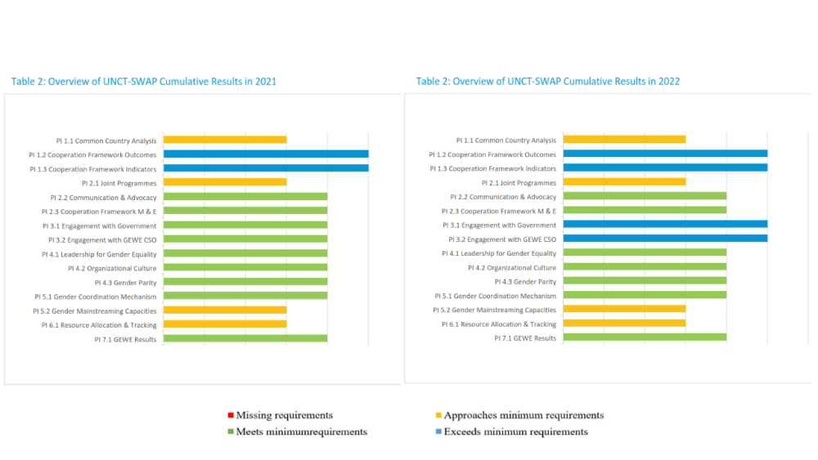
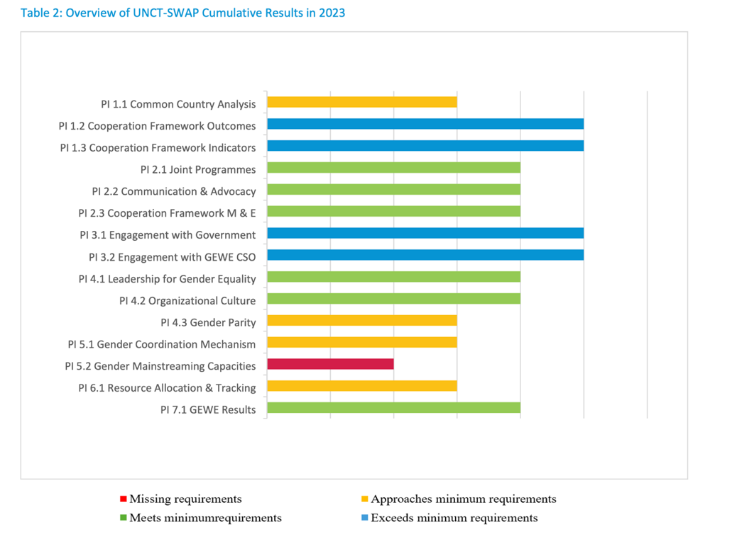
Youth is a critical constituency for the country’s economic development to secure demographic dividend, but it’s not yet the center of development efforts in Timor-Leste. There is a Youth Group, co-chaired by UNFPA and UNICEF, that works to advance youth engagement and integration. However, the Youth Results Group does not implement Youth 2030, the UN system-wide strategy, nor the dedicated Youth Scorecard.

Disability inclusion remains one of the areas of attention for the UNCT along with human rights. While there is yet much to be done to ensure that disability inclusion commitments are upheld by all stakeholders and the general public, there is a strong progress in terms of creating legal and regulatory environment. In 2021 the OHCHR published the Report on the Rights of People with Disabilities in Timor-Leste. In 2022, the country ratified the UN Convention on the Rights of People with Disabilities, laying the foundation for harmonizing national legal framework with international standards and requirements. In 2024, with support of UN in Timor-Leste, the Law on the right of Person with disabilities was developed and adopted. In 2023, UN Partnership on the Rights of Persons with Disabilities (UNPRPD) ) in partnership with UN Women, UNICEF and the UN Human Rights Adviser’s Unit in Timor-Leste provided report on Situational Analysis of the Rights of the Persons with Disabilities in Timor Leste. The report revealed strong legal basis established for disability inclusion in Timor-Leste indicating critical gaps to ensure adequate disability inclusion, which is attention to disability stigma. In terms of communication on disability inclusion, the LNOB study invites the UNCT to more actively address this issue by the UN Communication Group (UNCG) in its articles, social media, blogs or other publications. The UN collectively undertook an assessment in 2023 to review how to make the UN - both operationally and programmatically more disability inclusive but the plan could not be implemented as there were no resources.

EFFICIENCY

Question #7: Was the CF supported by an integrated funding framework and by adequate funding instruments? What were the gaps, if any? Have resources been allocated efficiently?

Finding #7: At individual level, almost none of UN Agencies in Timor-Leste was constrained by lack of funding. On the contrary, the funding is at the level expected but the delivery rate across UN Agencies indicates some inefficiency of operations steadily improved towards 2023. There is high degree of inefficiency in the UNCT Timor-Leste which was largely caused by sub-optimal performance of the DCO HR function and the recruitment process of the UN Agencies, high transaction costs, lack of functioning M&E and knowledge management system. A high level of inefficiency in the process of strategic decision-making within UNCT is also caused through diffused roles and responsibilities between senior and junior staff members. The UNCT communication towards external audience is strategically failing by not responding to the narrative that causes reputational impact on UNCT in Timor-Leste. UN continues to offer unique value-for-money to the Government of Timor-Leste through providing legitimate representation and inclusion of the country in various regional and global dialogues.

The efficiency analysis was carried out along several criteria: (i) financial health and delivery rate, (ii) human resource management, (iii) transaction costs, (iv) M&E, reporting, knowledge management, and communication, and (iv) value-for-money considerations.

(i) Financial health and delivery rate of UN Agencies in Timor-Leste: At individual level, almost none of the UN Agencies in Timor-Leste was constrained by lack of funding. Annex 5 provides evidence on the amount required by Agencies annually and amount received, clearly suggesting that, in most of the cases, there is no funding gap for Agencies. On the contrary, in many instances, there are more funds available than required.

The analysis of expenditure per CF’s outcome revealed some insights on the collective absorptive capacity of UN Agencies. Annex 7 provides an overview of budget delivery per Agency, per outcome area and per year. Annex 8 provides an overview of the budget delivery per outcomes and sub-outcomes per year. In both annexes the delivery rate below 70% is highlighted in red. Low delivery rate in 2021 could be explained by the global pandemic and the national restrictions in all countries that have slowed down the implementation process. The delivery rate has improved towards year 2023 with two exceptions: UNEP demonstrated delivery rate of 10.3% under RG6 in 2023; UNICEF demonstrated delivery rate of 50.6% under RG1 in 2023.

However, the data demonstrates also low delivery rate for year 2023 for three out of four sub-outcomes under outcome 5: Accountable, inclusive and participatory governance and for two out of three sub-outcomes under outcome 6: Sustainable management of natural resources and resilience to climate change.

While there is a push for the Integrated National Financing Framework (INFF) as a tool to finance national priorities and operationalize the Addis Ababa Action Agenda at the national level, the UNCT in Timor-Leste has no INFF in place.

(ii) human resource management: The UNCT in Timor-Leste has unbalanced representation of senior and junior staff. UN country team is composed predominantly with few senior staff and mainly with very junior staff members. This causes highly challenging context where the juniors are still on the curve of learning but due to lack of quality control and supervision usually expected from the middle-level staff, they create much of inefficiency in the operations. The limited number of middle-level roles may impact organizational capacity, particularly in terms of leadership development and succession planning.

The unbalanced staffing is one of the main factors hampring efficiency of the processes within the UNCT. To illustrate the point:
- There is an illusion of ‘inclusiveness’ among UN Agencies in Timor-Leste. It is often case practice to ‘delegate’ participation in strategic meetings (e.g. UNCT meeting or development coordination meeting, or RG meeting) to the next in line staff member. Considering the UN Timor-Leste staff members are at either senior or very junior level, in often cases a strategic meeting is attended by a junior staff and this is interpreted as Agency ‘representation’. This creates high level of inefficiency in the process of communication, discucssion, and strategic decision-making within UNCT. This phenomenon particularly noticeable with regards to non-resident UN Agencies.
- During the most period of the CF’s lifecycle RCO did not have sufficient operational leadership to support coordination of UNCT in Timor-Leste. During the CF cycle 2021-2025, the critical role of the Head of RCO was changed three times, about once a year, and was vacant for almost a year and one year with acting Head of RCO. The RC was left with both strategic and operational coordination on top of multiple other functions to be performed for the UNCT In Timor-Leste. The sub-optimal performance of the DCO HR function hindered the performance of RCO in Timor-Leste.

(ii) Transaction costs: While there are no instruments to calculate ‘transaction costs’ of UN operations in Timor-Leste, it is possible to conclude with high degree of certainty that the transaction costs are very high. This is explained by various factors, including the staffing situation. It could also be explained by the degree of responsiveness of the UN staff and the number of iterations that would be required, which inevitably increases transaction costs. The transaction costs also increases due to abrupt changes in the course of action of the national stakeholders that would require shift and repurposing of the resource allocated for a specific initiative or even uncomplete trajectory of project implementation. High transaction costs diminish the returns and the overall value proposition of UN Agencies in Timor-Leste and over time implies high costs of operations.

(iii) M&E, reporting, knowledge management, and communication: While there is M&E thematic team in the UNCT Timor-Leste, there is no M&E system and function within the UNCT to inform decisions at all levels. De facto the M&E team is left with only one task to collect information required for UNCT annual report. The UNCT reporting fails to inform the reader about the value provided by the UNCT in Timor-Leste, providing inconsistent and confusing information and often unverified data. There is no collective knowledge management function in the UNCT. Knowledge management should be a distributive function among the UNCT but this is not the case and in the absence of ‘key responsible’ this function is hardly visible. Communication of UNCT takes various forms including regular messaging on various themes – climate change, human rights, social protection, etc. However, communication is not concerned with strategic purpose of managing expectations of the various stakeholders, i.e., the Government, the donors, the general public. This issue has been raised during the previous UNCT meetings. There is a negative notion of the role and contribution made by the UN in Timor-Leste, which is not based on objective information on what has been done by UN in the country. For instance, the representatives of CSOs think that UN should keep funding and expanding its funding towards the CSOs to keep providing services that otherwise are not supported by the Government, e.g. service provision to the victims of the war crimes, LGBT+ community, etc. In often cases, representatives of the Government missed to attribute the huge and hard volume of work done at least since 2002 by UN Agencies in Timor-Leste or they simply don’t have that ‘institutional memory’. Donors, while knowing the role of UN, have also much higher expectations towards UN Agencies, particularly regarding more coordinated and prominent role of UN in the country, and this is highly justified and relevant. These landscapes of expectations need to be carefully managed by UNCT communication and messaging to avoid negative narrative and unwarranted expectations that might impact UNCT’s reputation in Timor-Leste. There are critical tools to help the UNCT’s communication team to maximize its impact, such as the Guidelines for Communications and Advocacy Strategy for the Cooperation Framework and Guidelines for UNCT Communications on the SDGs.

(iv) Value for money considerations: The question of the value for money (VfM) was about good resource use and if the resources used are justified. The reflection on the VfM is critical, however, it must be acknowledged that the next-best alternative it not always clear or measurable due to complex environment of the UNCT performance in Timor-Leste and the lack of obvious benchmarks. The evaluative reasoning on the VfM of the UNCT’s efforts is based on the evidence collected and the reflections of the stakeholders and should be seen through the prism of UN’s contribution vis-à-vis its mandate and through the prim of the contribution of the other development partners in the country.

Annex 6 on State budget expenditures 2021-2024 indicates that the annual allocations of the Government of Timor-Leste only for one budget line which is ‘public goods and services’ exceeds the total budget UN Agencies collectively invest in Timor-Leste. This is to indicate that financially the UN operations constitute very modest share compared to Government expenditures in the country. Table 7 provides an overview of the total investments of UN Agencies towards the realization of the CF so far. Similarly, the donors’ investments in various sectors significantly overperform that of UN. For instance, the EU contributed with EUR 12,586,500 to the Nutrition sector over the past five years in Timor-Leste. The EU’s support was implemented through Budget Support modality, in collaboration with the Nutrition Directorate of the Ministry of Health, complemented by support from the United Nations Children Fund (UNICEF).

Despite limited financial resources available for the interventions led by UN Agencies in the country, the work of UN Agencies in Timor-Leste directly supplementing the efforts of the Government has a different legitimacy base as they represent the largest multilateral organization in the world. UN is perceived by the national authorities as the partner that can offer access to international platforms, standards, and expertise. The normative work carried out by UN resulted in establishing various public systems in Timor-Leste is truly exemplary. The fundamental needs for capacity development are much higher than can be effectively addressed by any or all UN Agencies, however, this continuous line of efforts keeps the established system functional at different degree. Importantly, UN stands next to the Government of Timor-Leste in advocating country’s development priorities within and outside the country as well as by ensuring the country’s involvement in international dialogues through multiple international platforms.

The work that the UN Agencies are doing on ASEAN accession should be considered as south -south cooperation. For example, UN Women is part of a regional project on ASEAN through which it supports the government to increase women's participation in peace and security sector.

Table 7: Total investments of UN Agencies to support the realization of UNSDCF 2021-2025

UN Agencies from Country Cooperation Framework | Resident / Non-Resident | Comments | Budget, USD
FAO | Resident | Signed UNSDCF& has Initiative & budget allocation listed in the ATPs report. | 44,722,737.91
UNCDF | Resident | Signed UNSDCF& has Initiative & budget allocation listed in the ATPs report. | 1,759,132.80
UNESCO | Resident | Signed UNSDCF& has Initiative & budget allocation listed in the ATPs report. | 13,097,427.22
UNIDO | Resident | Signed UNSDCF& has Initiative & budget allocation listed in the ATPs report. | 1,950,000.00
UNFPA | Resident | Signed UNSDCF& has Initiative & budget allocation listed in the ATPs report. | 21,512,270.00
UNEP | Resident | Signed UNSDCF& has Initiative & budget allocation listed in the ATPs report. | 45,569,302.53
IOM | Resident | Signed UNSDCF& has Initiative & budget allocation listed in the ATPs report. | 27,402,250.69
UNDP | Resident | Signed UNSDCF& has Initiative & budget allocation listed in the ATPs report. | 113,995,450.56
UNICEF | Resident | Signed UNSDCF& has Initiative & budget allocation listed in the ATPs report. | 65,000,974.56
HIRAU | Resident | Signed UNSDCF& has Initiative & budget allocation listed in the ATPs report. | 199,200.00
UN Women | Resident | Signed UNSDCF& has Initiative & budget allocation listed in the ATPs report. | 20,296,683.59
WFP | Resident | Signed UNSDCF& has Initiative & budget allocation listed in the ATPs report. | 28,790,480.84
UNDRR | Non-Resident | Signed UNSDCF& has Initiative & budget allocation listed in the ATPs report. | 545,580.00
WHO | Resident | Signed UNSDCF& has Initiative & budget allocation listed in the ATPs report. | 36,367,147.00
UNCTAD | Non-Resident | Signed the UNSDCF, has no initiative& budget allocation in the ATPs report | -
UNV | Non-Resident |  | -
UNOPS | Non-Resident | Signed the UNSDCF, has no initiative& budget allocation in the ATPs report | -
ESCAP | Non-Resident |  | -
OHCHR | Non-Resident |  | -
ILO | Non-Resident | Signed UNSDCF& has Initiative & budget allocation listed in the ATPs report. | 30,698,082.30
UNOCHA | Non-Resident |  | -

COORDINATION AND GOVERNANCE

Question #8: To what extent has the RC’s office ensured equitable coordination with other United Nations agencies in the country, particularly in the event of potential overlaps, while maintaining coherence in agencies’ mandates?

Finding #8: The role of RC, while supported with mandate, has little if any practical lever to foster collective action if there is no good will from the Agencies. The governance mechanism around CF is largely dysfunctional and the burden of coordination lies predominantly on RC with limited authority and resources. The RGs are largely dysfunctional though efforts are made to improve the situation. The UN Communications Group (UNCG) and the Gender Thematic Group (GTG) and the Youth Results Group are meeting regularly to streamline the UN’s efforts in these thematic areas. The M&E team has nominal functionality. Importantly, there are largely same people involved in these groups, the division of roles and responsibilities is blurred and causes much of confusion. Programme Management Team (PMT) was recently created and could start playing active role in shaping functional distributive governance and improved coordination within the UNCT. Without functional Head of RCO the work of UNCT was largely constrained. Strong role of the RC to coordinate UN Agencies is welcome by the Government and the donors. There are attempts to shape joint programming but the strong sense of shared intent is missing and programming remains largely fragmented.

(i) Role of RC and RCO: The Resident Coordination Office (RCO) in Timor-Leste does have the responsibility for the interagency coordination but has limited authority, resources, and hardly any instruments to ensure such coordination and should rely on the good will of the Heads of Agencies for cooperation. The job description of RC suggests that ‘The Resident Coordinator system ensures the coordination of all organizations of the United Nations dealing with operational activities for development at the country level, regardless of the nature of their presence in the country’. The MAF of UN system stipulates that the RC has accountability for the coordination and mandate but, in practice, at the country lever there is no real lever except the annual performance review mechanism: ‘The RC chairs UNCT annual performance reviews to assess results achieved in the joint workplan’. (MAF p.13)

Equitable coordination would entail joint messaging, collegial support, and shared vision on how to move forward towards the realization of the CF’s outcomes and sub-outcomes. On all these dimensions, there is divergence of stance within UNCT. Meaningful guidance would require strong evidence, hence analytics, to inform strategic discussions. The RC alone cannot run all operations of the RCO. RCO did not have sufficient operational leadership to support coordination of UNCT in Timor-Leste during the CF lifecycle. During the period of 2021-2024 of the CF’s implementation, the critical role of the Head of RCO was changed three times about once a year (including one year of acting Head of RCO) and was vacant for almost a year. The DCO HR function was very detrimental in keeping RCO functional. The RC was left with both strategic and operational coordination on top of multiple other functionalities for the UNCT In Timor-Leste.

There were several attempts to foster cross UNCT coordination and harmonization of strategic visions between UN Agencies. Towards this end, three retreats were organized for the executive team and RC to shape common understanding of direction, process, progress, and next priority steps. The executive retreats were organized in 2022, in 2023, and 2024. The reports indicated that some issues reflected in this report were addressed on recurrent basis (e.g. coordination for communication, coordination when engaging with senior national authorities, etc.).

(ii) Governance structure around the CF: The RCO has five key functions to support the RC and the UNCT: (1) strategic planning, (20 development economics, (3) partnerships and SDG financing, (4) data and results management and reporting and (5) communications and advocacy.

The governance structure around the CF is largely dysfunctional but efforts are made to change the situation. There are several groups established to govern the CF’s implementation: the Six Results Groups, UN M&E Group, the Operations Management Team, the UN Communications Group (UNCG), the Gender Thematic Group (GTG) and the Youth Results Group. The existing Results Groups are dysfunctional. They meet ad-hoc, predominantly to provide information, if available, for the UNCT annual reporting and to less extend to contribute to the shared annual work plan. The UN Communications Group (UNCG) and the Gender Thematic Group (GTG) and the Youth Results Group are meeting regularly to streamline the UN’s efforts in these thematic areas. For example, the UNCG put efforts to harmonize thematic focus of the monthly messaging from the UN Agencies or to coordinate efforts when shaping the UN annual reporting.

The critical M&E thematic group does exist but largely dysfunctional, with the nominal role to support in shaping UNCT annual report. It does not provide critical input in learning, knowledge sharing and analytics on progress towards the realization of the CF’s outcomes. Importantly, across all these groups, there are the same people – the division of roles and responsibilities is blurred and causes much of confusion.

The UN Agencies prefer to engage in government coordination mechanisms, e.g. WHO is active led of health coordination mechanism, UNICEF is active led on education/early childhood development. Strong role of RC to coordinate the UN Agencies is welcome by the Government and the donors. In response to this dysfunction, the Programme Management Team (PMT) was established in 2023 with the mandate “… [to] guide overall programme coordination and technical support for UNSDCF implementation, ensuring linkages between the Strategic Priorities/ Result Groups, and coordinating the programmatic/thematic discussions.” By linking the M&E to PMT, the PMT has a potential to become instrumental for more coordinated planning and implementation under two caveats: (i) if RGs are performing and providing regular updates to the PMT, and (ii) if internal, agency-based vertical information sharing happens, to ensure that Heads/Deputies of Agencies are adequately briefed before each UNCT meeting. In any case, the PMT would reveal some coordination pressure from the RC allowing better distribution of that function among UN Agencies. Exhibit 3 below illustrates the functional position of the PMT in the governance structure around the CF.

The UNCT meetings are happening regularly, however, due to the constrains explained above (data & analytics and the representation issue) it is often a platform to share information rather than to strategize and decide.

Exhibit 3: Functional position of the PMT

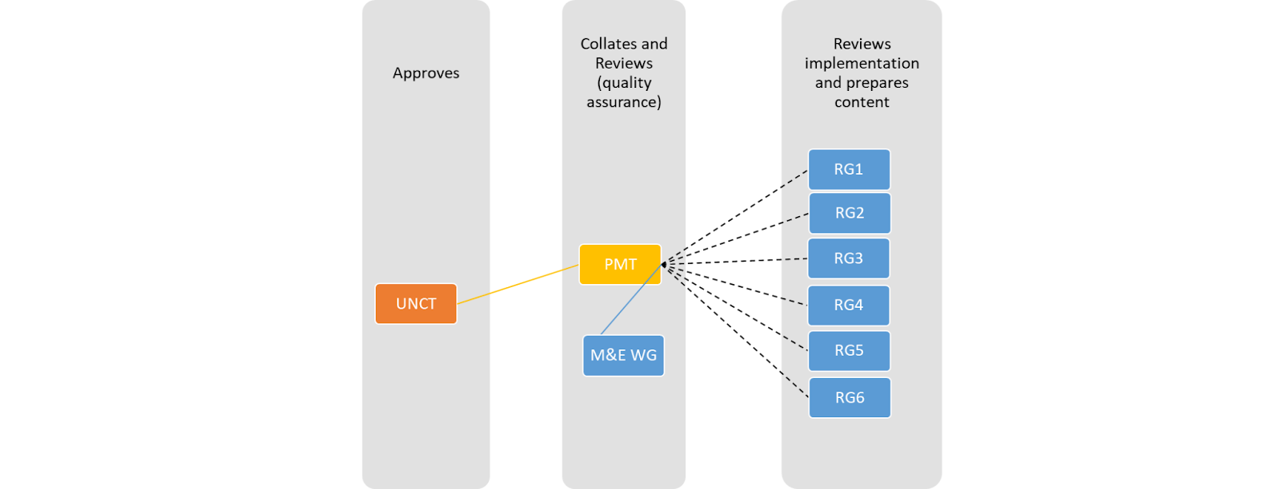

(iii) The value-add of Joint Programming (JP): Joint programming is expecting to be critical drivers of joint efforts among UN Agencies toward the realization of the CF’s outcomes. Within the UNCT in Timor-Leste and during the CF’s lifecycle there were several examples of JPs as indicated in Table 8 below. The respondents largely indicated that joint programming lacked strong sense of shared intent, almost always prepared in rush, and remain largely fragmented throughout their implementation with silos planning and operation. This is a tendency that fits into the current dynamics of accountability, agency-specific administrative and financial capabilities and visibility requirements, as well as fierce competition for funds. All these create the least conducive environment for joint programming. Radical changes are required.

The agencies still do not have enough capacities to do joint analysis at the technical/middle management level to drive strategic discussions and Heads of Agencies are not expected to develop programs. Although they could provide better oversight - this is also left to RCO, overwhelming its little capacities.

Table 8: UN Joint Programmes in Timor-Leste between 2021-2024

# | Joint Programme | Sector/Thematic Areas of the Joint Programme | Total Budget for the Full Joint Programme Cycle, USD | Participating UN Entities | Duration (From Year-To-Year) | Donor Funding | Status (Ongoing/Closed)
1 | Addressing Protection Risks in Humanitarian Settings in Timor-Leste and Papua New Guinea | Governance; Youth; Others (Emergency Preparedness) | 1,812,884 | IOM, UNICEF | 2022 - 2024 | Bureau for Humanitarian Assistance (BHA) | Ongoing
2 | Enhancing Early Warning Systems to Build Greater Resilience to Hydro-Meteorological Hazards in Timor-Leste | DRR | 21,729,122 | FAO, UNEP, UNOPS | 07 Oct 2021 - 24 Mar 2027 | Green Climate Fund (GCF) | Ongoing
3 | Hamutuk ba Igualdade/Together for Equality | Data; Gender; Governance; Youth; DRR; LNOB | 7,718,892 | UNDP, UNFPA, IOM, UN Women | 23 Nov 2020 - 22 Nov 2024 | KOICA | Ongoing
4 | SAY NO TO 5S (Starvation, Soil-Transmitted Helminthiasis, Skin Diseases, Smoking and Sugary/Alcoholic Drinks) | HIV/AIDS, Human Rights; LNOB; Youth; Integrated Policy; Other (Malnutrition & Hunger) | 7,860,000 | WFP, WHO | 08 Mar 2022 - 31 Dec 2025 | KOICA | Ongoing
5 | Emergency Response to El-Nino in Timor-Leste | 6-Month Emergency Response to Households and Individuals Affected by El-Nino | 2,070,819 | WFP, FAO, UNICEF | 2024 | Central Emergency Response Fund (CERF) | Ongoing
6 | Empower for Inclusion | Gender; Disability Inclusion | 600,000 | UN Women, UNICEF, UNHRAU | 2023 - 2024 | United Nations Partnership on the Rights of Persons with Disabilities (UNPRPD) | Ongoing (Round 4)
7 |  |  | 100,000 |  | 2022 - 2023 |  | Closed (Round 3)
8 |  |  | 100,000 |  | 2021 - 2022 |  | Closed (Round 2)
9 | Assessing Vulnerabilities and Resilience in Border Communities in Timor-Leste through the Human Security Approach in the Context of COVID-19 | LNOB; Integrated Policy; Governance; Others (Migration Management) | 223,417 | IOM, UNICEF | 2021 - 2024 | United Nations Trust Fund for Human Security (UNTFHS) | Closed
10 | Strengthening National Food Systems and Promoting Disaster Risk Reduction (Building Resilience & Ending Vulnerabilities in Small Island Developing States (SIDS)) | Data; DRR; Other (Climate Change) | 951,400 | FAO, WFP, WHO | 01 Jan 2022 - 01 Jan 2024 | SDGs Fund | Closed
11 | Entrepreneurship, Energy, Empowerment for Women (3E4Women) | Gender; Private Sector | 280,000 | UNDP, UN Women | 17 Jun 2022 - 31 Mar 2023 | SDGs Fund | Closed
12 | Spotlight Initiative to Eliminate Violence Against Women and Girls | Data; Gender; Governance; Youth; Integrated Policy | 15,641,722 | ILO, UNDP, UNICEF, UNFPA, UN Women | 2021 - 2023 | EU | Closed
13 | Public Finance Management for Children and Climate Change | Development Finance; Youth; Economic Policy Support; Gender | 40,000 | UNICEF, UNDP | 2023 | UNICEF | Closed
14 | Integrated National Financing Framework (INFF) and Financial Diversification in Timor-Leste | Good Health and Well-Being; Reduce Inequalities; Climate Action | 1,000,000 | WHO, UNDP, IOM | 22 Jun 2020 - 30 Jun 2022 | SDGs Fund | Closed
15 | Cash for Work for Improved Rural Communities' Livelihoods and Employment (CIRC LE) | Enhance Livelihoods of Rural Communities | 530,000 | UNDP, ILO | 2022 | United Nations Trust Fund for Human Security (UNTFHS) | Closed
 | Grand Total |  | 60,658,256

SUSTAINABILITY

Question #9: What mechanisms, if any, has the CF established to ensure socio-political, institutional, financial and environmental sustainability? What is the likelihood that progress towards relevant SDGs is sustained by national partners and stakeholders over time?

Finding #9: Much has been done by UN Agencies to establish preconditions for sustainability, yet it remains largely uncertain and fragile due to the country’s dependency on limited oil and gas revenues.

As indicated under the effectiveness section, there are multiple examples of initiatives that were successfully integrated into the national systems and scaled up or replicated. To various degree, they create preconditions for sustainability of the results in a medium term, if there are no abrupt changes in prioritization or course of action on the side of the Government.

The sustainability of all those initiatives, though, remains uncertain in a long-term perspective as they all are dependent on oil and gas revenues allocated for public needs through the Petroleum Fund. The sustainable improvement at the country level would require longer-term efforts to allow newly established systems to be fully functional, capacities to operate those systems in place and continuous improvement of the system performance factored in its operations. State building requires time and resources. Conditionality of sustainability of the system-level results to the resources of the Petroleum Fund (which have quite certain time horizon before they exhausted) and to the donors’ funding, which is shrinking across the globe, is very fragile pretest for sustainability.

In case of Timor-Leste with the lack of internal resources, the sustainability of the results requires stronger regional and global linkage of the country to access markets, to mobilize resources and expertise, and to ensure continuous functioning of the established institutions.

The evaluation team analyzed 85 projects implemented by UN Agencies and found that 69 of them do not have sustainability and exit strategy or any reference on strategic exit. Only 12 projects from UNOPS, 2 from UNDP that has exit strategy, and 2 JP, Spotlight Initiative produced Exit strategy. Table 8 below provide a list of those projects. IOM has demonstrated great consistency in exploring exit thinking of each (with one exception only) its project.

There is also no formalized risk management at the CF level though regular discussions through UNCT meetings compensate partially as critical concerns are raised and discussed during those meetings, allowing some tuning of the UNCT members and thereby, response to some risks.

Table 9: List of projects equipped with exit strategy

Agency | Programme Title
IOM | Reducing Disaster Risk and Enhancing Emergency Preparedness in Timor-Leste
IOM | Addressing Environmental Migration Resulting from Coastal Change in Timor-Leste
IOM | Addressing Protection Risks in Humanitarian Settings in Timor-Leste (Joint Programme)
JP | Together for Equality: Preventing and Responding to Gender-Based Violence in Timor-Leste (Joint Programme)
IOM | Assessing Vulnerabilities and Resilience in Border Communities in Timor-Leste
IOM | Community-Based Active Case Detection and Management of Tuberculosis in Timor-Leste
IOM | Enhancing Disaster Risk Reduction in Timor-Leste
IOM | Integrated National Financing Framework (INFF) and Financial Diversification in Timor-Leste
IOM | Strengthening Government of Timor-Leste Capacity for Disaster Management
IOM | Strengthening the Border Management Capacity in Timor-Leste
UNDP | The Accelerating Clean Energy Access to Reduce Inequality (ACCESS) Project
UNDP | COVID-Resilient Elections in Timor-Leste
JP | Spotlight Initiative

ORIENTATION TOWARDS IMPACT

Question #10: To what extent have UN activities stemming from the CF strengthened socio-economic resilience (in relation to (i) shocks and (ii) towards incremental positive development dynamic) and contributed to reducing vulnerability against shocks and crises?

Finding #11: Through its programming UN Agencies contributed towards strengthening socio-economic resilience in Timor-Leste through inter alia directly addressing causes of vulnerabilities, building coping capacities and contributing to response and recovery capabilities across individual and institutional stakeholders. The development dynamic as well as the volume and typology of efforts invested by UN in Timor-Leste provides promising signals of approaching acceleration on the development curve though with mid-term horizon.

Through its programming UN Agencies contributed towards strengthening socio-economic resilience in Timor-Leste through inter alia by directly addressing causes of vulnerabilities, building coping capacities and contributing to response and recovery capabilities across individual and institutional stakeholders. During this round of the CF, UN has triggered multiple processes in the country that promise to be translated into more substantial pattern and being retranslated into practices across the country. While currently being at the ‘plateau’ of its development trajectory, the development dynamic as well as the volume and typology of the efforts invested by the UN in Timor-Leste provides promising signals of approaching acceleration. The importance is to continue working with and not against the inherent dynamic of the ecosystem and ensuring the consistency and continuity of efforts to create ripple effects. Acknowledging the sustainability concerns, the impact could be expected in the mid-term horizon, yet, for longer-term impact efforts are required to ensure diversification of its revenues and good governance to deliver public value.

Conclusions
C1: Relevance
The CF is highly relevant to the national development priorities, though, remained largely as a reference document for the UN Agencies rather than a strategic guidance for their operations. UN Agencies remained highly responsive to often ad-hoc and unsystematic requests from the Government of Timor-Leste, in often cases, resulted in inconsistent programming. In emergency context, UN remains the trusted partner of the government delivering much needed links to international humanitarian community.

C2: Coherence
CF serves as a general reference document rather than a solid foundation to guide UN Agencies to harmonize and consolidate their programming in spirit of One UN or to engage in transformative partnerships with other development stakeholders in Timor-Leste. The harmonized efforts to perform in spirit of One UN are largely affected by internal competition among UN agencies on the ground and requires strong efforts from the RC to create enabling environment for enhanced performance across all UN agencies.

C3: Effectiveness
UN Agencies have demonstrated that they remain reliable and strong partner of the Government of Timor-Leste and this partnership needs to receive a fresh format and content with the new IX Constitutional Government in office. The UN Agencies in Timor-Leste demonstrated remarkable efforts and progress towards multiple development needs along six strategic priorities of the CF. The ‘quiet’ work of UN requires attention it deserves to be fully and adequately visible on the development landscape of various actors in Timor-Leste. One of the programmatic challenges for the UN Agencies is to ensure adequate attention to prototyping, scaling up, capacity development, and shaping normative environment. Another challenge is related to the lack of reliable data both on the progress towards SDGs as well as on the progress towards the CF’s indicators. LNOB focus remains relatively high within the UNCT.

C4: Efficiency
There is high level of inefficiency among UN Agencies in Timor-Leste caused by sub-optimal performance of the DCO HR function and the recruitment process of the UN Agencies, high transaction costs, lack of functioning M&E and knowledge management system. Lack of strong analytical function within the UN RCO challenges informed decision-making across all agencies and at the RCO level. The UNCT communication towards external audience is strategically failing by not responding to the narrative that causes reputational impact on UNCT in Timor-Leste. UN continues to offer unique value-for-money to the Government of Timor-Leste through providing legitimate representation and inclusion of the country in various regional and global dialogues.

C5: Coordination and Governance
The governance structure around CF remains highly dysfunctional and requires immediate attention to establish effective M&E function, quality reporting and communication to inform strategic decisions at the UNCT and Agency levels. RCO and the role of RC remains critical and instrumental in creating conducive environment within UNCT to foster collaboration and cooperation among UN Agencies and engagement in transformative partnerships with external stakeholders. The UN Agencies are expected to overcome their internal contradictions at the operational level and consolidate around the RC to allow UN to speak one voice and perform above all expectations.

C6: Sustainability
Much has been done by UN Agencies to establish preconditions for sustainability, yet it remains largely uncertain and fragile due to the country’s dependency on limited oil and gas revenues.

C7: Orientation towards impact
Through its programming UN Agencies contributed towards strengthening socio-economic resilience in Timor-Leste through inter alia directly addressing causes of vulnerabilities, building coping capacities and contributing to response and recovery capabilities across individual and institutional stakeholders. The development dynamic as well as the volume and typology of efforts invested by UN in Timor-Leste provides promising signals of approaching acceleration on the development curve though with mid-term horizon.

Recommendations
Given that the planning for the new CCA and CF is underway, it is critical to embrace pragmatic stance vis-à-vis the expectations for the remaining period of the CF and ensure forward-looking recommendations to allow for the process and the outcomes of the new strategic planning be informed of the lessons learned from the current CF implementation.

- Invest in third party-facilitated Strategic Planning Session with the participation of RC, Head of RCO, and all Heads of Agencies of the UNCT members to meet outside the UN campus and preferably outside Dili. The purpose is twofold: (i) to strategize around better results framework, key priority areas for the next planning cycle, to agree on the comparative advantages of each UN Agency, and to shape the composition of the desired UNCT in Timor-Leste for the next round of the CF implementation, and (ii) to reconcile operational contradictions among UN Agencies in Timor-Leste and consolidate around the RC and regain strength as One UN. This could be organized after the CCA but before the CF planning.
Main responsible | Priority | Timing
Head of RCO | High | Short-term

- Critically revise current results framework with the focus on realistic sub-outcomes for the remaining period and indicators to capture UN performance fully in line with the corporate reporting system of UN Agencies to avoid double reporting.
Main responsible | Priority | Timing
Head of RCO | High | Short-term

- Restart strategic partnership with the Government of Timor-Leste through a series of measures:
  - Organize UN Conference in Dili with high-level, preferably Under Secretary General (USG), representation to proudly present the scope of the work done collectively by all UN Agencies under each of the six outcome areas and refresh strategic partnership with the Government of Timor-Leste. This could be combined with the launch of the new CF in Timor-Leste. Ensure the CF is available in Portuguese and widely disseminated among government representatives.
  - Reactivate the Joint Steering Committee between the Government of Timor-Leste and UN, right after the UN Conference to be planned in the first quarter of 2025. Ensure USG participate in the first meeting and conclude the first SC meeting with the joint work plan for the first year of the CF implementation.
Main responsible | Priority | Timing
RC | High | Medium-term

- Improve the governance mechanism around the CF through several measures:
  - Simplify and strategically position thematic groups within UNCT ensuring there are (i) LNOB group including all cross-cutting issues; (ii) Communication group; (iii) OMT; (iv) Security Management Team (SMT); and (v) Policy group (to coordinate and harmonize UN’s efforts across normative work). Ensure rotational on semi-annual basis Chair and Co-Chair roles among the Agencies involved in each thematic group except SMT.
  - Strengthen the function of the M&E group and ensure there are quarterly monitoring updates of the progress on the revised sub-outcome indicators provided to the PMT to inform strategic discussion at the UNCT and Agency levels.
  - Improve the performance of the Results Group by ensuring there are quarterly joint work programmes. Ensure semi-annual rotation of the Chair and Co-Chair of the RGs.
  - Strengthen accountability towards the CF through ensuring that RC contributes to the performance review of each Head of Agency, while each Head of Agency contributes to the RC’s performance review. Establish mechanism in collaboration with the DCO HQ and pilot in 2024.
  - Adopt nexus narrative as a guiding principle for the UN programming in Timor-Leste to ensure maximum impact of the programming.

Main responsible | Priority | Timing
RC | High | Short-term

- Establish ‘analytical’ function of the RCO by taking several steps:
  - creating a repository of key documents,
  - producing Monthly Analytical Bulletins to inform the UNCT meetings on (a) the most important political, socio-economic, etc. developments in the country and in the region; key progress made by UNCT in the last reporting period (with the support of the M&E group); and (c) ensuring there is follow up on the decisions taken at the UNCT;
Main responsible | Priority | Timing
Head of RCO | High | Medium-term

- Develop UN investment strategies in the key sectors under the relevant RG (e.g. health, education, agriculture, economic diversification and decent work, food security, and disaster risk reduction). Ensure there is senior international economic advisor to RC (could be cost-shared from a UN Agency or provide as in-kind contribution to RCO) at least for one year to develop investment plans for each priority area with all Agencies.
Main responsible | Priority | Timing
Senior economic advisor | High | Medium-term

- Raise the inefficient recruitment process to the attention of the DCO and all regional offices and initiate assessment of the human resource among UN Agencies, identify and address gaps.
Main responsible | Priority | Timing
RC | High | Short-term

- Request stronger support and guidance from the DCO in designing and implementing the CF. A coaching scheme could be established to guide UN Agencies in Timor-Leste through 2025 towards the new CF.
Main responsible | Priority | Timing
Head of RCO | Medium | Medium-term

- Explore mechanism of country level pooled fund to ensure implementation of joint programmes under the new cycle of the CF’s implementation.

Main responsible | Priority | Timing
RC | Medium | Medium-term

- Radically revise approach to capacity development – move away from ‘one-few day training’ and engage with long-term (weeks – months) training combining in-class and on-job training. Should be coupled with strong incentive schemes to allow absence from the job, ensure diversity of participants, access to merit-based promotion, and suchlike. A guidance note should be produce on how to approach CD and how to shape incentive schemes.
Main responsible | Priority | Timing
Head of Agencies | High | Short-term

- Invest in addressing data gap in Timor-Leste by organizing assessments (including but not limited to child labour, skilled personnel attended birth, etc.). Create a priority assessments to be conducted by UN Agencies in 2025 and during the next CF cycle.
Main responsible | Priority | Timing
Head of Agencies | High | Long-term

Limitations and lessons learned
- Responsiveness of UN Agencies throughout the whole evaluation process remained a challenge. It required multiple iterations to ensure that UN Agencies provide key documents to inform this evaluation. It was even more challenging to request feedback from UN Agencies. To mitigate this situation partially, the Evaluation Management Team (EMT) members repetitively reached out and in often cases, themselves looked for missing documents from different sources.
- Quality of data available is a known challenge in Timor-Leste. Data related to the development performance across various indicators is either incomplete or missing or outdated (dated back to 2015 or 2016). To mitigate this situation partially, the evaluation increased number of individual interviews to collect and triangulate qualitative data through the prism of critical thinking.
- Limited timing and resources allocated for this evaluation. Given the context and challenges with data collection, triangulation, and feedback loops, the allocated time was not sufficient. To mitigate this situation partially, the RCO has allocated additional four days for each consultant as there was no financial envelop to accommodate the requested number of days. The evaluation team, however, went extra mile to reach the level of confidence regarding the conclusions and recommendations proposed in this report.
- Attempted but uncoordinated timing for CF and country programme evaluations. Almost in parallel with the CF evaluation, there were three evaluations going on – UNICEF country programme evaluation (CPE), UN Women CPE, and UNFPA CPE. The evaluations were not coordinated timewise to provide input to CF evaluation. To mitigate this situation partially, an attempt was made to connect the evaluations and exchange the findings among the evaluation leads in real time, however, given different timing of each evaluation this attempt did not yield expected results.
- Weak CF’s results framework. The CF results framework was of such quality that did not allow for using it as an instrument for CF evaluation, e.g. to guide the UN performance along the outcome, sub-outcome and output indicators. To mitigate this situation, the evaluation team changed the strategy and dropped the focus on CF’s results framework while reflecting on effectiveness criteria. Instead, the team employed much broader focus to capture UN Agencies de facto performance, irrespective if it is included by the results framework or not. This required some alteration of the Evaluation matrix during the data collection phase. Also, this required longer data minding process but was the only and the best way to serve the purpose of this evaluation.
- Poor quality of data and document recording and archiving within UN agencies. The data recorded in various documents does not match and create much of confusion, especially, financial data. To mitigate this situation, the evaluation team with support of EMT has reached out to UN Agencies with request to verify data. This does not result in noticeable improvement of the data.

Summary of performance rating

Criteria / Issue | Rating | Summary comments
- Strategic relevance | Median score- 9
A1. Alignment with SDGs and National strategic priorities | 6
A2. Relevance to national, regional and global priorities and beneficiary needs | 6
A3. Dynamic and Responsive CF | 6 | As the CF does not provide any limitations for any responsiveness
- Coherence | Median score - 4
B1. CF position, credibility and reliability | 2
B2. CF complementarity, harmonization and co-ordination | 2
B3. Synergies and interlinkages of interventions | 2
B4. Forging strategic and effective partnerships | 2
- Effectiveness | Median score - 8
C1.1 Delivery of CF outputs | 0
C1.2 Progress towards outcomes | 4
- Outcome 1
- Outcome 2
- Outcome 3
- Outcome 4
- Outcome 5
- Outcome 6
C2. Adopting and promotion of resilience-building approach | 4
C3. CF focus on national capacity development | 3
C4. Targeting the most vulnerable, disadvantaged, and marginalized population | 4
- Efficiency | Median score - 5
D1. Integrated funding framework | 1
D2. Collectively prioritized activities based on the needs | 2
D3. Effective reallocation of resources to emerging needs and priorities | 5
D4. Timeliness of actions | 3
- Sustainability | Median score - 5
E.1.1 Financial risks | 1
E1.2 Socio-political risks | 3
E1.3 Institutional and governance risks | 2
E1.4 Environmental risks | 3
E2. Catalysis and replication | 2
- Orientation towards impact | Median score - 10
E1 CF contribution to key institutional, behavioral and legislative changes | 4
E2 CF contribution to advance achievement of SDG targets | 4
E3 CF contribution to advance cross-cutting concerns on gender equality | 4
E4 CF contribution to advance cross-cutting concerns on human rights and non-discrimination, including disability inclusion | 4
E5 CF contribution to advance cross-cutting concerns on environmental sustainability | 4
F. Factors affecting performance | Median score- 9
F1. CF design | 2
F2 Quality of RCO leadership and effective oversight | 2
F2.1 Quality of CF implementation by UNCT | 0
F3 Quality of UNCT coordination and integration | 2
F4 National ownership on the CF | 1
F5 CF stakeholder engagement | 5
F6 Communication, knowledge management and M&E | 1
F7 Quality of UNCT collective and joint effort | 4
Overall rating | 50

Annexes

Annex 1: TOR

TERMS OF REFERENCE

United Nations Sustainable Development Cooperation Framework Timor-Leste 2021-2025
Evaluation
Timor-Leste, 2024

Position Title: | Evaluation of United Nations Sustainable Development Cooperation Framework Timor-Leste 2021-2025
Assignment Location: | Home based with field mission to Dili, Timor-Leste and areas selected for data collection
Organizational Unit: | UN Resident Coordinator’s Office
Type of Contract: | Individual Consultant (International and National Consultant)
Languages required: | English
Assignment Duration: | 40 days from 1 May– 30 Sep 2024

- INTRODUCTION

The United Nations Sustainable Development Cooperation Framework (UNSDCF) Timor-Leste 2021-2025 is the result of joint efforts by the Government of Timor-Leste and the UN System to establish a strategic programme framework to support national development priorities as outlined by the Government of Timor-Leste in the Timor-Leste Strategic Development Plan 2011-2030. In response to demands from stakeholders for more strategic, transformative, and integrated UN support, UN Timor-Leste has developed the UNSDCF 2021–2025 through a consultative and participatory process involving the Government, civil society, and development partners. Hence, the UNSDCF is a centerpiece of the UN development system reform in Timor-Leste. It represents UN Timor-Leste’s collective value proposition to support and accelerate the country’s progress towards achieving the SDGs and its national development priorities.

The UNSDCF is structured along the four strategic development sectors defined in the Timor-Leste Strategic Development Plan 2011-2030. The four sectors are: (1) Social Capital (2) Infrastructure Development (3) Economic Development and (4) Governance and Institutional Development. Aligned with these four sectors, six strategic priorities have been established to respond to the evolving needs within each sector, based on the vision of the Government of Timor-Leste and the comparative advantage of the UN System. The six strategic priorities of the UNSDCF 2021-2025 are: (1) Nutrition, food security, and agricultural productivity (2) sustainable economic opportunities and decent work (3) increased access to quality formal and innovative learning pathways (4) primary health care and strengthened social protection (5) accessible, accountable and gender-responsive governance systems, institutions, and services (6) manage natural resources and achieve enhanced resilience. As a nationally owned instrument for planning, implementation, monitoring, evaluation, and reporting of UN activities in Timor-Leste, the UNSDCF is founded on the spirit of continued strong partnership with the Government of Timor-Leste as well as with civil society, academia, the private sector, and other development partners.

In line with the UNSDCF evaluation guidelines, to ensure accountability, support learning, and inform the development and implementation of the new cycle of the UN Sustainable Development Cooperation Framework (UNSDCF), the United Nations Country Team (UNCT) Timor-Leste decided to commission the UNSDCF evaluation, with the planning at the end of 2023 and continue with the inception through the final report by the third quarter of 2024.

The exercise will adhere to and implement UNEG Norms and Standards and will be conducted by an independent evaluation team in an inclusive manner and promote national ownership through the meaningful engagement of relevant national partners throughout the evaluation process.

This document presents the purpose, objectives, and scope of the evaluation, proposed approach, and methodological options for a team composed of a team leader and an additional team member (national), who will be conducting the evaluation under the supervision and guidance of the evaluation manager, the evaluation management team, Regional and DCO HQ. The UN in Timor-Leste is therefore looking for an evaluation team with deep commitment and a strong background in evaluation of development effectiveness to undertake the evaluation.

Country Context

Timor-Leste became the 191st member state of the United Nations in 2002, and since its independence 21 years ago, Timor-Leste has demonstrated a high degree of stability. However, challenges remain, notably, high unemployment, land right issues, economic development, widening inequality, persistent poverty, perceived corruption, and an oil-dependent economy. These challenges particularly affect groups within the population living in rural areas, women, youth, persons with disabilities, among others marginalized groups.

The economy in Timor-Leste is recovering post-COVID, with public spending at a historic high. The country continues to face challenges around a heavy reliance on petroleum revenue, demanding careful fiscal management. Inflation rates are driven by food and oil prices. Labor force participation remains low, especially in the private sector. Youth face educational and employment challenges. Informal employment remains common, especially for women. Private sector growth is hindered by poor data, regulations, and limited credit access. Strengthening human capital and the private sector is key to sustainable growth. Policies exist for economic development but face serious challenges in implementation. Implications include investments in export-oriented industries, monitoring labor and social protection, and strengthening rural development.

COVID-19 left heavy impacts on the health sector of the country, with 22,951 cases and 133 deaths by June 2022. Health services, especially primary care, experienced disruptions. The country responded by expanding healthcare, setting up intensive care unit (ICU) beds, and boosting testing capacity. Immunization efforts saw success, with over 1.9 million COVID-19 doses administered.

Severe food insecurity and malnutrition continue in the country, with 36% facing chronic food insecurity, and 22% acute insecurity. Climate forecasts indicate prolonged below-average rainfall due to El Niño, threatening agriculture. Opportunities exist, including Government prioritization of food security, but risks loom large. These include compounding impacts of El Niño, floods, and the global food price crisis. Timor-Leste's heavy reliance on food imports, particularly rice, is concerning, with prices soaring in 2023. These challenges directly impact nutrition, exacerbating stunting and wasting in children and limiting human capital development. Inadequate food control mechanisms escalate the crisis. Scaled investment in nutrition and food security plans, reinforced laws, streamlined information systems, and food product regulation are vital steps towards a more food-secure country. Strengthening school feeding programs and establishing strategic grain reserves are crucial.

The country experienced devastating floods and landslides in April 2021, causing extensive damage to homes, infrastructure, and agriculture. Timor-Leste is particularly sensitive to climate change effects and El Niño events, which may lead to shifts in rainfall patterns, increased risk of landslides, and heightened flooding intensity. Additionally, rising sea levels are projected to affect 300 kilometre of the country's coastline, resulting in coastal erosion, infrastructure damage, and forced displacement of coastal communities. Timor-Leste has taken steps to enhance its resilience, including establishing disaster response agencies and developing climate change laws and plans.

Legal frameworks for child protection and social impact have been finalized, along with laws pertaining to decentralization and judicial organization. The revised Criminal Procedure Law prioritizes the protection of victims of gender-based violence. Notably, in early 2023, Timor-Leste ratified the Convention on the Rights of Persons with Disabilities, a significant step towards furthering inclusivity. National Action Plans have been instituted to address gender-based violence and to increase women's participation in peace processes. Additionally, the National Mediation Network aims to enhance access to justice for women and vulnerable groups. Key policy messages emphasize the importance of a Human Rights Based Approach for inclusive development, continued focus on migrant rights based on data-driven strategies, and the need for inclusive National Planning and Budgeting aligned with national priorities. The call for greater decentralization remains a priority for future progress in the country.

Despite a robust legal framework, gender discrimination persists due to cultural norms. The society remains patriarchal, with women primarily in traditional domestic roles. Economic and social empowerment for women remains limited, leading to informal employment and heightened poverty risk. While progress in women's participation is noted, leadership roles are still underrepresented. While lacking recent data updates, gender-based violence is deemed prevalent, and social protection schemes require further strengthening. Continued investment and resource allocation are crucial for advancing gender equality.

The country has recently established legal frameworks and policies for disability inclusion, including joining the Convention on the Rights of Persons with Disabilities (CRPD) in January 2023. However, stigma persists, and implementation of plans is slow due to limited resources. Government services face challenges in various sectors, with accessibility issues and lack of training being prominent. The lack of reliable data on disabilities hinders effective programming. Gender, inequality, and limited participation of marginalized groups further affect progress. Women and girls with disabilities face heightened risks, and psychosocial and intellectual disabilities remain stigmatized. Participation of people with disabilities varies depending on location.

For youth in the country, the Government launched the Youth Action Plan in 2023, emphasizing education, employability, and entrepreneurship for youth development. The 2023 budget allocates USD 58 million, or 2.68% of the total budget, towards youth-related initiatives. However, challenges persist, encompassing resource gaps, insufficient vocational training opportunities, a scarcity of job openings, digital disparities, concerns regarding the quality of education, coordination difficulties, gender inequality, cultural barriers, and psychosocial hurdles.

The President declared preschool education as one of his priorities, with a 230% budget increase in 2023 compared to the previous year. It also joined the Southeast Asian Ministers of Education Organization (SEAMEO) and committed to the Southeast Asia Primary Learning Metrics (SEA-PLM) assessment; a significant policy moves.

UNSDCF Highlights

In support to country’s priorities articulated in the Timor-Leste SDP 2011-2030 and in response to the demands from the stakeholders for more strategic, transformative, and integrated UN support, UN Timor-Leste has developed the United Nations Sustainable Development Cooperation Framework 2021-2025 through a consultative and participatory process involving the Government, civil society, academia, the private sector, and other development partners. Six strategic priorities have been identified for the UN's work in the country through the UNSDCF 2021-2025.
To operationalize the UNSDCF, annual Joint Work Plans (JWPs) will be established, capturing collaborative and individual contributions. The JWP includes a funding framework outlining available and mobilization-needed resources.
UN Country Results Report is an annual presentation to the Government, providing a comprehensive overview of the UN Country Team's (UNCT) collective achievements aligned with the UNSDCF. Prepared at the beginning of the year for the preceding year, it assesses financial performance, reviews the budget against actuals, and consolidates joint UN efforts in advocacy, leadership, communications, and operations. Additionally, it highlights new risks, opportunities, challenges, and assumptions related to UNSDCF outcomes.

- Outcome 1: Nutrition, food security and sustainable agriculture

“By 2025, Nutrition, food security and agricultural productivity have improved for all, irrespective of the individual ability, gender, age, socio-economic status and geographical location.”

Intended Development Results
By strengthening health interventions to address all forms of malnutrition and by increasing the dietary diversity of women of reproductive age and children under 5, the UNSDCF will seek to break the inter-generational cycle of malnutrition. This will be achieved through improved quality of nutrition, water and sanitation services, and hygiene practices, creating an enabling environment for faster development of cognitive capacities needed at early childhood stage and for improved health and education outcomes of the general population, in particular of children, adolescents and pregnant women. Focusing on increasing and diversifying the production and productivity of smallholder farmers, fishers and agri-food producers, through climate-resilient and sustainable farming practices , the UNSDCF will support to increase the food security and resilience to shocks, in particular for female farmers and rural youth, reduce poverty including through social protection programmes, while protecting land and ocean resources. The capacity of the Ministry of Agriculture and Fisheries and other relevant public and private institutions will be strengthened to explore ways to assure customary and formal tenure of smallholder male and female farmers.

- Outcome 2: Sustainable economic opportunities and decent work for all

“By 2025, people throughout Timor-Leste in all their diversity, especially women and youth, benefit from sustainable economic opportunities and decent work”

Intended Development Results
Focusing on the policies, institutional framework, incentives, and investments needed for transforming the economy and to develop sustainable pathways, the UNSDCF will contribute to diversifying the economy, creating decent jobs, and include the marginalized active population, in particular youth and women, in a sustainable and just economy.

- Outcome 3: Access to quality education and life-long learning outcomes and skills

“By 2025, all people of Timor-Leste, in particular excluded and disadvantaged groups, have increased access to quality formal and innovative learning pathways (from early childhood though lifelong learning) and acquire foundational, transferable, digital and job-specific skills”

Intended Development Results
By promoting early childhood education and supporting capacities to develop access to early childhood development, the UNSDCF will support Timor-Leste in laying the foundations for the child's learning and well-being. Furthermore, by increasing access to inclusive, equitable and quality basic and secondary education and its completion, creating innovative pathways for learning, and developing foundational, transferable, digital and job-specific skills, the UNSDCF will seek to the achieve greater learning outcomes for all, including those excluded from the traditional education system. Accelerated progress in this direction will result in a balanced set of capabilities for children to become economically productive, develop sustainable livelihoods, contribute to peaceful and democratic societies, enhance individual well-being, transform gender norms and relationships and reduce poverty and inequalities.

- Outcome 4: Quality health care and well-being

“By 2025, the people of Timor-Leste increasingly demand and have access to gender-responsive, equitable, high quality, resilient and inclusive Primary Health Care and strengthened social protection, including in time of emergencies”.

Intended Development Results
The UNSDCF will support greater and equitable access to Primary Health Care services with a view to help Timor-Leste to achieve universal health coverage, including in time of emergency, resulting in improved outcomes for health including sexual and reproductive health, continued reduction of maternal and neonatal mortality, eradication of tuberculosis, and reduction of Non-Communicable Diseases. Under this priority, the UNSDCF will also seek to increase health financing to support the development and retention of a trained health workforce, improve access to essential medicine and reduce the cost of health services and the financial hardship from out-of-pocket expenditures, including through social protection programmes and services.

- Outcome 5: Accountable, Inclusive and Participatory Governance and Quality Public Services

“By 2025, the people of Timor-Leste, especially the most excluded are empowered to claim their rights, including freedom from violence, through accessible and accountable and gender responsive governance systems, institutions and services at national and subnational levels”

Intended Development Results
To ensure transparent, inclusive, accountable and gender-responsive governance systems focused on people’s rights and needs, the UNSDCF will support the consolidation of public institutions and increasing people’s democratic participation, particularly those excluded or under-represented such as the rural poor, women, children and migrants. The intended result is not only to give access to the rule of law and public services to all people of Timor-Leste, however, also to contribute to social cohesion and end violence against women and children.

- Outcome 6: Sustainable Management of Natural Resources and resilience to Climate change

“By 2025, national and sub-national institutions and communities (particularly at-risk populations including women and children) in Timor-Leste are better able to manage natural resources and achieve enhanced resilience to impacts of climate change, natural and human-induced hazards, and environmental degradation, inclusively and sustainably.”

Intended Development Results
The UNSDCF aims to ensure the sustainability of development progress in Timor-Leste by strengthening the ability of its institutions and communities to adapt to climate change and manage the risks of natural disasters, to mitigate their impacts on people’s lives, livelihoods, services, and infrastructures, while preserving its natural resources.

The overall estimated budget to achieve the UNSDCF 2021-2025 is approximately $261 million. It was projected at the start of the implementation in 2020 that about $115 million (44 percent) would be available, leaving $145 million (56 percent) to be mobilized throughout the UNSDCF implementation.

- PURPOSE AND OBJECTIVE

The overall purpose of the UNSDCF evaluation are:
- Promote greater learning and operational improvement. The evaluation will provide important information for strengthening programming and results at the country level, specifically informing the planning and decision-making for the next CF programme cycle and for improving UN coordination at the country level. The UNCT, host government and other CF stakeholders can learn from the process of documenting good practices and lessons learned, which can then be shared with DCO and used for the benefit of other countries.
- Support greater accountability of the UNCT to CF stakeholders. By objectively providing evidence of results achieved within the framework of the CF and assessing the effectiveness of the strategies and interventions used, the evaluation will enable the various stakeholders in the CF process, including national counterparts and donors, to hold the UNCT and other parties accountable for fulfilling their roles and commitments

The objectives of the evaluation are to:
- Assess the contribution of the CF to national development results through evidence-based judgements using evaluation criteria (accountability).
- Identify factors that have affected the CF’s contribution; answer the question of why the performance is as it is; and explaining the enabling factors and bottlenecks (learning).
- Reach conclusions concerning the UN’s contribution across the scope being examined.
- Provide actionable recommendations for improving the CF's contribution, especially for incorporation into the new CF programming cycle. These recommendations should be logically linked to the conclusions and findings of the evaluation and should draw upon lessons learned identified through the evaluation.

- SCOPE

The UNSDCF evaluation will look at the UNSDCF 2021-2025 as a whole and cover contributions of all programmes, projects and activities conducted in Timor-Leste by the UNCT which includes FAO, ILO, IOM, OCHA, OHCHR, UNCDF, UNCTAD, UNDP, UNDRR, UNDSS, UNEP, UNESCAP, UNESCO, UNFPA, UNICEF, UNIDO, UNV, UNCTAD, UNODC, ITU, UN Women, WFP and WHO. It will also examine the UNSDCF cross-cutting issues and the global UN programming principles (e.g. leaving no one behind, human rights, gender equality and women's empowerment, People with Disability, environmental sustainability, and resilience). The UNSDCF evaluation will also consider emerging issues, such as, natural disasters and the COVID-19 pandemic in both the evaluation contents (e.g. the UNCT’s responsiveness, adaptation, and reprioritization) and operation (e.g. methods for managing stakeholder participation and inclusiveness in the COVID context). The evaluation team could suggest any specific thematic areas for specific review, if necessary, after consultation with stakeholders.

The evaluation will be conducted mainly in Dili, Timor-Leste. However, the evaluation team may also consider including field visits in their methodology. These suggestions for specific review on thematic areas and field visits should be proposed by the Evaluation Team in the inception report in consideration of data availability and areas for in-depth analysis. Evaluation time scope to focus on current UNSDCF 2021-2025 (2021-2023 in a summative way and 2024 onward in a formative manner).

The primary users of the evaluation are the UNCT, including non-resident UN agencies, the Government of Timor-Leste, particularly the relevant line ministries and institutions, Civil society, Private sectors, academia, bilateral and multilateral donors, and the broader development partners are also seen as important audience of the evaluation.

Intended use of the UNSDCF evaluations for the users are to:
- Provide accountability and learning from the UNSDCF 2021-2025 and inform the development and the implementation of the new Cooperation Framework;
- Use findings and recommendations to feed into the development of new Country Programme or Strategy of the UN Agency
- Provide learning and insights on effectiveness, efficiency, relevance and sustainability of the UNSDCF 2021-2025
- Inform on areas that need support and improvements to better support the national priorities that can be used in funding decisions

- EVALUATION CRITERIA AND QUESTIONS

The evaluation of the UNSDCF will prioritize assessing its relevance, effectiveness, efficiency, coherence, coordination, sustainability, and impact orientation. The evaluator to finalize the evaluation questions during the inception phase, subject to agreement among the Evaluation Manager, Evaluation Technical Management Team, and National Evaluation Steering Committee as detailed in the inception report.

Relevance and adaptability
- To what extent are the CF objectives aligned and consistent with the needs, priorities, and policies of the government (including alignment to national development goals and targets, national plans, strategies and frameworks).
- How dynamic and responsive has the CF been to emerging and unforeseen needs, especially those of the most vulnerable, disadvantaged, and marginalized groups?

Coherence
- To what extent has the CF promoted complementarity, harmonization and co-ordination within the UN and other key development partners to maximize the achievement of results?
- Post UN reform, to what extent have UN agency programs and work plans been effectively and meaningfully derived from Common Country Analysis (CCA) both in design and implementation?

Effectiveness
- How effective has the CF been in achieving the results outlined in the results framework? What have been the benefits for the people and institutions targeted by the interventions, including the most vulnerable, disadvantaged, and marginalized population?
- To what extent did the UN system follow human rights principles and contribute to the promotion of human rights, including disability inclusion?
- To what extent has the CF contributed to building national and local capacities and ensuring long-term gains? To what changes, in terms of capacities, knowledge of individuals or institutions in the country has the UN system supported contributed to, if any?

Efficiency
- Was the CF supported by an integrated funding framework and by adequate funding instruments? What were the gaps, if any? Have resources been allocated efficiently?

Coordination
- To what extent has the RC’s office ensured equitable coordination with other United Nations agencies in the country, particularly in the event of potential overlaps, while maintaining coherence in agencies’ mandates?
- To what extent has the CF fostered internal coordination, through the promotion of synergies and interlinkages between its interventions?

Sustainability
- What mechanisms, if any, has the CF established to ensure socio-political, institutional, financial and environmental sustainability?
- What is the likelihood that progress towards relevant SDGs is sustained by national partners and stakeholders over time?

Orientation towards impact

- To what extent have UN activities stemming from the CF strengthened economic and individual resilience and contributed to reducing vulnerability against shocks and crises?
- To what extent have UN activities stemming from the CF impacted gender inequality?
- To what extent has the CF promoted a just transition to environmental sustainability and addressed environmental sustainability concerns?

- EVALUATION APPROACH AND METHODOLOGY

Evaluation Approach
As the UNSDCF outcomes are established at a high level and involve multiple stakeholders beyond the UN, determining the direct cause-and-effect relationship (attribution) of UN interventions to observed outcomes is impractical. Consequently, the UNSDCF evaluation will assess the potential contribution (rather than direct attribution) of the UNCT to the attainment of intended results. The overarching approach is participatory and grounded in theory, using UNSDCF theories of change. Gender equality and disability inclusion will be integrated throughout the evaluation, not only in the analysis of evaluation questions but also in the process itself, emphasizing transparency, inclusivity, and equitable power dynamics.

In a broader context, the UNSDCF evaluation will adopt a participatory and inclusive method, fostering national ownership by engaging relevant national partners significantly throughout the evaluation process. It upholds its independence and adheres to UNEG Norms and Standards and ethical guidelines. The evaluation approach will align with the most current UNSDCF evaluation guidance and UNEG's recommendations for incorporating human rights and gender equality, UNEG norms and standards, and international development evaluation principles.

Evaluation Methodology
The evaluation will use a combination of document reviews, analysis of other quantitative secondary data, individual interviews with key informants and focus groups or other types of group discussion to collect data. The evaluation team will develop the evaluation methodology in accordance with the evaluation approach and design tools to collect appropriate data and information as strong, evidence-based answers to answer the overall evaluation questions. The methodological design will include: an analytical framework; a strategy for data collection and analysis; specially designed tools; an evaluation matrix; and a detailed work plan.

- Sampling approach
A purposive sampling approach will be used to select programmes (joint work plans; joint programmes; UN agencies strategic plans etc.) that will be covered in the scope of the CF evaluation. The selected programmes components should have sufficient level of transformational intent (depth, breadth, and size) and maturity.

The purposive sampling approach will also be used to target groups and stakeholders to be consulted. It is expected that the list of target groups will ensure adequate representation of beneficiaries, including civil society organizations with an emphasis on vulnerable groups, e.g people living with disabilities, and other marginalized groups. The selection will be informed by the portfolio analysis and stakeholder mapping undertaken during the inception phase of the evaluation based on the draft stakeholder map prepared by the UNCT. This analysis will yield information on the relevant initiatives and partners to be part of the evaluation (including those that may not have partnered with the UNCT but play a key role in the outcomes to which CF contributes). The evaluation team should clearly outline the sample selection criteria and process and identify any potential bias and limitations, including the steps towards addressing the limitations.

The sampling technique should ensure that the selected samples adequately reflect the diversity of stakeholders of the intervention and pay special attention to the inclusion, participation, and non-discrimination of the most vulnerable stakeholders. This process will enhance the credibility and technical adequacy of the information gathered.

- Data collection
The evaluation will use quantitative and qualitative approaches, including literature review, statistics at national and local levels, survey data, semi-structured interviews, direct observation, focus groups and workshops. The methods and procedures employed for data collection must exhibit responsiveness to gender considerations. Data ought to be systematically disaggregated based on both sex and age, and, whenever feasible, by geographical region, ethnicity, disability, migratory status, and other pertinent markers of equity within the given context. Specific guidelines should be observed, namely the UNEG Guidance on Integrating Human Rights and Gender Equality in Evaluation (2014) and UN SWAP Evaluation Performance Indicators (2018).

- Quality assurance
The data collected should be subjected to a rigorous quality assurance for validation purposes, using a variety of tools including triangulation of information sources and permanent exchange with the CF implementation entities at Country Office level.

- Evaluation Matrix
The evaluation team will use the template of the evaluation matrix provided by the evaluation manager to systematically structure and consolidate the data collected for each of the evaluation questions. This matrix will allow them, among other things, to identify the missing data and thus fill these gaps before the end of the collection. This matrix will also help to ensure the validity of the data collected.

- Participation and inclusion
This evaluation should be conducted using a participatory and inclusive approach, involving a wide range of partners and stakeholders. The evaluation team will carry out a stakeholder mapping in order to identify the direct and indirect partners of the CF, specifically targeting United Nations organizations and representatives of the national government. Stakeholders mapping may include civil society organizations, the private sector, other multilateral and bilateral cooperation organizations and, above all, the beneficiaries of the program.

- Theory of change analysis
During the inception phase or early in the data collection phase, the evaluation team will hold ToC meetings with the result or thematic groups to discuss the programmatic changes that could have occurred in the programme result chain during implementation as a response to emerging challenges and needs. These meetings are led by the Evaluation Team and organized by the Evaluation Manager. The ToC meetings are useful to support the Evaluation Team, UNCT and the Evaluation Steering Committee members to develop a common understanding of ToC activities, expected outcomes, underlying assumptions and consensus on potential outcome indicators to be evaluated. The Synoptic table for the Analysis of the theory of change is used to support the ToC meetings. In some cases, the Evaluation Team may use the findings from these meetings to reconstruct (if necessary) the initial ToC which supported the development of the CF being evaluated, to better align with the CF’s implementation and account for emerging development changes in the country. The ToC analysis also needs to include cross-cutting issues such as gender equality and empowerment of women, human rights and non-discrimination (including disability inclusion), and environmental sustainability.

The theory of change analysis should be limited to the soundness of the “agencies’ and joint work plans” outputs contributions to the outcome level and SDG indicators. Evaluators will base their evaluation on the analysis and interpretation of the logical consistency of the results chain: linking program outputs to changes at a higher level of outcomes, based on observations and data collected during the process along the result chain. This analysis should serve as a basis for the judgment of the evaluators on the contribution of the current CF to the achievement of the outcome level results as targeted by the CF.
The analysis of the CF’s theory of change and the reconstruction of its intervention logic, if necessary, will therefore play a central role in the design of the evaluation, in the analysis of the data collected throughout the evaluation, in communicating results and in developing relevant and practical conclusions and recommendations.

- Finalization of the evaluation questions and assumptions
The evaluation team will finalize the evaluation questions after consultations with the evaluation steering committee and thematic groups. The final evaluation questions should be a reasonable number, generally not exceeding 15. They should clearly reflect the evaluation criteria as well as the indicative evaluation questions listed in this Terms of Reference. They should also take advantage of the results of the reconstruction of the intervention logic of the cooperation framework. The evaluation questions will be included in the evaluation matrix and should be supplemented by sets of hypotheses that capture the key aspects of the intervention logic associated with the scope of the question. Data collection for each of the assumptions will be guided by clearly formulated quantitative and qualitative indicators, also indicated in the matrix.

- MANAGEMENT ARRANGEMENTS
The UN Resident Coordinator’s Office together with UNCT, the result groups and PMT will oversee the UNSDCF evaluation which will be governed by the key actors below, include:

Actors | Roles and Responsibilities
Evaluation Manager  PMT Chair (UNICEF) | - Prepares the terms of reference of the evaluation with support from the regional DCO M&E/programme coordinator who thereafter sends them to the HQ’s DCO Evaluation unit for approval.  - Constitutes the steering committee in consultation with the RCO and UNCT.  - Acts as secretary during the meetings of the evaluation steering committee  - Manages the interaction between the team of evaluators and the steering committee; serving as an interlocutor between both parties.  - Takes all measures to avoid any kind of conflict of interest particularly in recruiting the evaluation team and ensure a gender-balanced evaluation team  - In collaboration with the regional DCO, leads the identification of potential candidates to conduct the evaluation, and prepares the summary assessment table.  - Sets up the initial meeting for the evaluation and provides the team of evaluators with a first set of background documents and other materials.  - Ensures the quality control of deliverables submitted by the evaluators throughout the evaluation process; with particular attention paid to ensuring that the UNEG norms and standards, code of conduct and ethical guidelines for evaluations as well as guidance on integrating human rights and gender equality in evaluation are followed/adhered to  - Assists the evaluators with logistical support in setting up the data collection arrangements -- e.g., for project visits, focus groups, interviews with key informants.  - Prevents any attempts to compromise the independence of the team of evaluators during the evaluation process.  - Reviews the inception report, checking if the approach and the methodology proposed are of professional quality.  - Coordinates comments on, quality assures and approves the deliverables of the evaluators, including the final evaluation report.  - Sends final report to HQ DCO’s Evaluation unit.  - Ensures the dissemination of the final evaluation report and the main findings, conclusions and recommendations and publishes the report, the independent quality assessment and the management response on the country office website.  - Clears the payment to the Evaluation Team once any outstanding issues have been addressed satisfactorily.
Evaluation Technical management team  Representative of PMT & M&E group (RCO, IOM, UNFPA, UN Women, & UNESCO) | - A mix subset of the PMT and M&E groups or results group representatives  - Provides routine day-to-day technical support to the Evaluation Manager for the planning and implementation of the evaluation  - Ensures sound technical review for all the evaluation deliverables
Evaluation Steering Committee  (Member of the UNSDCF JSC from line ministries, Civil society & private sector) | - Supports the evaluation process, guides the Evaluation Team and facilitates access to stakeholders and information.  - Provides input to the evaluation TOR, and selection of evaluation issues and questions.  - Facilitates stakeholder identification and consultations and provides access to information sources (documents and interviewees) to support data collection.  - Provides overall comments on the main deliverables of the evaluation, including the inception report and draft evaluation report.  - Prepares a management response to the evaluation, in consultation with the UNCT members, within two months of receiving the final evaluation report.  - Ensures the evaluation report and its results are disseminated and shared with DCO and other key stakeholders, promoting the use of evaluation and lessons.
Development Coordination Office (DCO)  DCO regional and HQ outfits, including the DCO Evaluation Unit and DCO Evaluation Advisor | - Support the RCO/UNCT to schedule and launch the CF Evaluation.  - Support the RCO/UNCT to identify and select the Evaluation Manager and Evaluation Team.  - Provide support (backstopping) to the Evaluation Manager at all stages of the evaluation.  - Participate in Evaluation Steering Committee meetings when possible.  - Review, comment on and approve the evaluation TOR.  - Support the Evaluation Manager in identifying potential Evaluation Team candidates and review the summary assessment table to pre-qualify consultants.  - Approve the selection of the Evaluation Team.  - Oversee the process to ensure the independence and quality of the evaluation by:  o Establishing a hotline for the Evaluation Team should they encounter risks to the independent conduct of the evaluation.  o Reviewing and approving the inception report, checking if the approach and the methodology proposed are of professional quality.  o Ensuring the quality of the draft and final report, by receiving the first and final draft of the report and the audit trail to ensure the transparency of the process and ascertain that the Evaluation Team was not subject to undue pressure to alter the contents of the report.  o Conducting an external quality check of the draft report and approving the final version of the report.  - Lead and ensure the dissemination and use of evaluation results.  - Ensure accountability mechanisms, submission of the management response, track the implementation of the recommendation, and the use of the evaluation in the design of the next CCA and CF.
United Nations Evaluation Group (UNEG) | - Provide technical advice for guidance materials, as well as for individual cases, on request.  - Support the development of further guidance materials, tools and templates, a draft policy framework and other supporting materials during and after the transition period.  - Facilitate the coordination of agency evaluations and joint evaluations, to the extent possible, as inputs to the CF evaluations.  - Facilitate knowledge exchange for UN entity-wide learning as well as learning at the regional and national level.

Composition of the Evaluation Team
Looking at the contexts, coverage, and the financial aspects, it is recommended to deploy individual consultants for commissioning the UNSDCF evaluation. The consultants will form an evaluation team which consist of a team leader, the international consultant (IC) and two national consultants (NCs) as team members, by taking consideration on the gender aspects to ensure female representation in the team. The evaluation Team will abide by the UNEG Code of Conduct for carrying out the evaluations.

Qualification of the Evaluation Team

 | International Team Leader (1 Person) | National Team Member (2 Persons)
Roles | Leads the entire evaluation process, working closely with all team members. He/she will conduct the evaluation process in a timely manner and communicate with the Evaluation Manager on a regular basis and highlight progress made/challenges encountered; responsible for producing the inception report and the draft and final evaluation reports | Team members contribute to the evaluation process substantively through the inception phase, data collection and analysis; provides substantive inputs to produce quality and timely deliverable
Education | Advanced University degree (Master & equivalent)in development studies, economics, international relations, or related field; phd is considered an asset | Advanced University degree (Master & equivalent) in development studies, economics, international relations, or related field;
Experience | - At least 5 years cumulatively of substantial professional application of results-based management and evaluation procedure and experience in data collection and analysis.  - Minimum of 10 years & of professional experience of conducting programme evaluation/review of programmes and /or outcome levels with international organizations  - Experience and background in gender equality/gender analysis and gender responsive evaluations;  - Sound knowledge of the country context and an in-depth understanding of at least one area of work of UNCT members; collectively, Evaluation Team members should broadly cover all areas of UNCT activity;  - Experience and background in gender equality/gender analysis and gender responsive evaluations;  - Sound knowledge of the country context and an in-depth understanding of at least one area of work of UNCT members; collectively, Evaluation Team members should broadly cover all areas of UNCT activity;  - No conflict of interest such as recent or expected employment by UNCT members or implementing partners, private relationships with any UNCT members of staff or government counterparts or implementing partners; participation in the design, implementation or advising CF being evaluated, among others. Any potential conflict of interest should be declared by candidates during the application process. | - At least 3 years cumulatively of substantial professional application of results-based management and evaluation procedure and experience in data collection and analysis.  - Minimum of 5 years of professional experience of conducting programme evaluation/review of programmes and /or outcome levels with international organizations  - Experience and background in gender equality/gender analysis and gender responsive evaluations;  - Sound knowledge of the country context and an in-depth understanding of at least one area of work of UNCT members; collectively, Evaluation Team members should broadly cover all areas of UNCT activity;  - Experience and background in gender equality/gender analysis and gender responsive evaluations;  - Sound knowledge of the country context and an in-depth understanding of at least one area of work of UNCT members; collectively, Evaluation Team members should broadly cover all areas of UNCT activity;  - No conflict of interest such as recent or expected employment by UNCT members or implementing partners, private relationships with any UNCT members of staff or government counterparts or implementing partners; participation in the design, implementation or advising CF being evaluated, among others). Any potential conflict of interest should be declared by candidates during the application process.
Competency | - Quality of the methodology, approach and planning of the assignment;  - Knowledge of the UN system and proximity with UN programming process | - Quality of the methodology, approach and planning of the assignment;  - Knowledge of the UN system and proximity with UN programming process
Language | Excellent Written and Oral Communication Skills in English.  Knowledge/understanding in Tetun, Bahasa Indonesia or Portuguese will be an advantage. | Excellent Written and Oral Communication Skills in English.  Knowledge/understanding in Tetun, Bahasa Indonesia or Portuguese will be an advantage.

- EVALUATION PROCESS AND TIMELINE
The evaluation timeframe will be further detailed in the inception report, following consultations with key stakeholders.
The overall evaluation process, and timeframe of the CF evaluation is as follows:

Activities | Process | Responsibility | Timeline
Preparatory Phase | RC Notify national counterparts (the CF Steering Committee), DCO and the (UNCT) Result Groups on the CF evaluation through the recruitment of the evaluation team & Identification of stakeholders and map development actors by the EM & EMT. | RC, EM, EMT, NESC, DCO | W4 Sep 2023-W4 Mar 2024
Design Phase | EM & EMT compile the document for Evaluation team through the presentation of the final Inception report and the data collection process by the Evaluation team | EM, EMT, ET, NESC & DCO | W1 May-W2 Jun2024
Reporting phase | ET analyze of the data collected through the final Evaluation report submitted and approved by the DCO | ET, EM, EMT, NESC, RC, UNCT & DCO | W1 Jul – W1 Sep 2024
Management response; Dissemination and use Phase | EMT to facilitate the Management Response process with RC, UNCT Results groups and NESC through the Dissemination of the Evaluation Report global/regional platforms, UNCT website Measures to disseminate the evaluation, and promote the use of evaluation and lesson learning | EMT, RC, UNCT, & DCO | W2 Sep– W3 Oct 2024

- EXPECTED EVALUATION DELIVERABLES

No | Deliverables | Content | Estimated Working Days for IC | Estimated Working Days for NCs | Estimated timeframe
1 | Final Inception Report including PPT | - Preliminary analysis of the CF ToC  - Elaboration of the evaluation approach and methods, including the evaluation design matrix; and a detailed evaluation plan and timeline, including a tentative list of interviews to be arranged or plans for field visits. | 10 | 3 | June 2024
2 | Preliminary Evaluation findings report and validation workshop | Initial Evaluation Findings Report and PPT (English)  in a workshop format | 20 | 14 | Jul 2024
3 | Final CF Evaluation Report | - Final Evaluation Report and PPT (English)  - A five-page evaluation brief (English) | 8 | 2 | Aug 2024
4 | Dissemination workshop including PPT for the workshop | - PPT (English) | 2 | 1 | Sep 2024
Total Days |  |  | 40 Days | 20 Days

The duration of the work is estimated at 40 working days for the evaluation team (40 days for IC and 20 days for both NCs) spread over the period of May - Sep 2024.

More detail on suggested template, requirements, format, structure and length for each of the deliverables is below.

8.1 Inception Report
The inception report is produced by the Evaluation Team to provide the conceptual framework and main operational plan for the evaluation. The inception report should not exceed 10 to 15 pages excluding the annex. The template for Inception Report can be found in Appendix 3 of the UNSDCF Evaluation Guidance. It should contains:
· the timeline for conducting the evaluation.
· an assessment of: (a) the soundness of the ToC for the CF, and (b) the extent to which that ToC evolved during the UNDAF’s implementation.
· an overview of the evaluation objectives, scope, and topic selection
· a systematic purposive sampling framework to identify interventions and stakeholders
· a detailed evaluation approach, criteria and questions, and tools and methodology
· the evaluation design matrix (EDM) detailing evaluation questions, indicators, and data sources
· the management, governance and quality assurance mechanisms plan detailing evaluation activities and a timeline.
In addition to the inception report, a standalone PowerPoint will be submitted to the evaluation manager as part of the evaluation deliverables. The PowerPoint will be prepared and used by the evaluation team in their presentation of the inception report to the evaluation management team and evaluation reference group.

8.2 Preliminary Evaluation findings report and validation workshop
The initial evaluation findings report, and a PowerPoint presentation are produced by the Evaluation Team to facilitate the validation workshop. The report should not exceed 15 pages excluding the annex. The report should include findings from the desk review and data collection, with an initial attempt at triangulation of findings.
The report should also present a matrix of quality of data collected for responding to each evaluation question and pointing to gaps that challenged the data collection phase. The report should also include annexes for example the notes and summaries made during the desk review, and transcripts of qualitative data.
8.3 Final CF Evaluation Report
The evaluation report should be written in a clear and concise manner that allows readers to easily follow its logic. It should not be overly filled with factual descriptions, especially those available elsewhere. The evaluation report will not exceed 60 pages, excluding a stand-alone executive summary (max 2 pages) and annexes. The focus of the report should be to present the findings, the conclusions, and the recommendations in a logical and convincing manner. The report is to be read in line with the UNEG CF term of reference document, with further detail on evaluation conduct and quality assurance found in the UNEG Evaluation Report Quality Checklist and UNEG Norms and Standards for Evaluations. The evaluation team should consider the core principles when producing the evaluation report. The Evaluation Report template including the core principles can be found in Appendix 4 of the UNSDCF Evaluation Guidance. It should contain:
· What was evaluated and why (purpose and scope)
· How the evaluation was conducted (objectives and methodology)
· What was found and on what evidence (findings and evidence/analysis)
· What has been concluded from the findings and in response to the main evaluation questions (conclusions)
· What are the recommendations; and
· What are the key lessons learned,
The PPT presentations will be prepared and used by the evaluation team in their presentation of the preliminary findings to the evaluation management team and evaluation steering committee. A standalone PowerPoint will be submitted to the evaluation manager as part of the evaluation deliverables.
8.4 A five-page evaluation brief
A five-page Evaluation Brief is not the executive summary in the evaluation report. It’s a synthesis report describing the evaluation including introduction, objectives and scope, methodology, findings, and recommendation. The evaluation brief can be resembling in e-book or infographic is intended for a broader and non-technical audience such as government counterparts, development partners, CSOs, at national and sub national level. The evaluation brief will need to be produced using disability accessible and inclusive formats.

- INSTITUTIONAL ARRANGEMENTS
- The Evaluation team will report directly to the Evaluation Manager (PMT Chair)
- The Evaluation team will be expected to collaborate and liaise with RC, UNCT Results groups, PMT, M&E Group, and relevant government counterparts and diverse civil society representatives during the assignment.
- The RC Office will facilitate administrative arrangements and logistical support throughout the duration of the mission including office space in the RC office and related logistical support for implementation of project activities only. The UNCT may be required to support the evaluation team in terms of some logistical supports.

- DURATION OF THE ASSIGNMENT
The assignment will be for 40 working days spreading over the period of May-Sep 2024. The Evaluation team will commence the assignment as soon as the procurement process is completed, and the contract is signed.
.
- SCOPE OF PRICE AND SCHEDULE OF PAYMENT
The financial proposal must be expressed in the form of an “all-inclusive” lump-sum amount, supported by breakdown of costs as per template provided. The term “all inclusive” implies all cost (professional fees, travel costs, living allowances etc.). Under the lump sum approach, the contract price is fixed, regardless of changes in cost components.
- SCHEDULE OF PAYMENTS
The payment will be made based on the deliverables. The selected evaluators (International & national) must submit documents as per deliverables which must be duly approved and serve as the basis for the payment of fees. The evaluation team will be expected to produce the following deliverables within the agreed timeline.
No | DELIVERABLES | ESTIMATED TIME FRAME | Percentage Disbursement
1 | Final Inception Report including PPT | Jun 2024 | 20%
2 | Preliminary findings report or presentation | Jul 2024 | 30%
3 | Final CF Evaluation Report | Aug 2024 | 40%
4 | Dissemination workshop including PPT for the workshop | Sep 2024 | 10%

- RECOMMENDED PRESENTATION OF OFFER
- Letter of application with duly accomplished Letter of Confirmation of Interest and Statement of Availability for the entire duration of the assignment;
- Personal CV, indicating all past relevant experience, as well as the contact details (email and telephone number) and three (3) professional references;
- Brief description of why the individual considers him/herself as the most suitable and how they will approach and complete the assignment;
- Financial Proposal that indicates the all-inclusive fixed total contract price, supported by a breakdown of costs.

- CRITERIA FOR SELECTION OF BEST OFFER
Individual consultants will be evaluated based on a cumulative analysis:
When using this weighted scoring method, the award of the contract should be made to the individual consultant whose offer has been evaluated and determined as:
- Responsive/compliant/acceptable, and
- Having received the highest score out of a pre-determined set of weighted technical and financial criteria specific to the solicitation.
* Technical Criteria weighting: 70%
* Financial criteria weighting: 30%

Technical Criteria | Maximum obtainable points | Weight Percentage
Advanced University degree (Master & equivalent)in development studies, economics, international relations, or related field;phd is considered and asset for the team leader | 15
At least 5 years (for team leader) & 3 years (for team members) cumulatively of substantial professional application of results-based management and evaluation procedure and experience in data collection and analysis. | 40
Minimum of 10 years for team leader & 5 years for team members, of professional experience of conducting programme evaluation/review of programmes and /or outcome levels with international organizations | 25
Quality of the methodology, approach and planning of the assignment | 10
Knowledge of the UN system and proximity with UN programming process | 5
Excellent Written and Oral Communication Skills in English.  Knowledge/understanding in Tetun, Bahasa Indonesia or Portuguese will be an advantage. | 5
Total technical score | 100 | 70%
Financial: |  | 30%

- SUBMISSION & DEADLINE
Please submit your applications together with all relevant requested supporting documents (including academic qualifications) through Inspira (un.org).

The deadline for submitting applications is COB 01 April 2024. Any request for clarification of the Inspira (un.org) process must be sent to carla.fernandesdacosta@un.org and on the TOR processes to ajaureguibeitia@unicef.org and or tasikpina@un.org before the closing deadline.

Only short-listed candidates will be notified. Women candidates are strongly encouraged to apply.

Annex 2: Revised evaluation questions

Question 1: To what extent are the CF objectives aligned and consistent with the needs, priorities, and policies of the government (including alignment to national development goals and targets, national plans, strategies and frameworks).

Question 2: How dynamic and responsive has the CF been to emerging and unforeseen needs, especially those of the most vulnerable, disadvantaged, and marginalized groups?

Question 3: To what extent has the CF promoted complementarity, harmonization and co-ordination within the UN and other key development partners to maximize the achievement of results?

Question 4: Post UN reform, to what extent have UN agency programmes and work plans been effectively and meaningfully derived from Common Country Analysis (CCA) both in design and implementation?

Question 5: How effective has the CF been in achieving the results outlined in the results framework? What have been indications of the benefits for the people and institutions targeted by the interventions, including the most vulnerable, disadvantaged, and marginalized population?
Revised Question 5: how effective were UN Agencies in progressing towards the strategic priorities outlined in CF?

Question 5a: How effective were UN Agencies in prototyping, demonstrating ‘proof of concept’ and integrating into existing systems?
Question 5b: How effective were UN Agencies in capacity development and advocacy?
Question 5c: How effective were UN Agencies in institutional development?
Question 5d: How effective were UN Agencies in generating data and sharing knowledge?

Question #6: To what extent did the UN system follow human rights principles and contribute to the promotion of human rights, including disability inclusion, youth participation and gender equality?

Question #7: Was the CF supported by an integrated funding framework and by adequate funding instruments? What were the gaps, if any? Have resources been allocated efficiently?

Question #8: To what extent has the RC’s office ensured equitable coordination with other United Nations agencies in the country, particularly in the event of potential overlaps, while maintaining coherence in agencies’ mandates?

Question #10: What mechanisms, if any, has the CF established to ensure socio-political, institutional, financial and environmental sustainability?

Question #11: What is the likelihood that progress towards relevant SDGs is sustained by national partners and stakeholders over time?

Question #12: To what extent have UN activities stemming from the CF strengthened socio-economic resilience (in relation to (i) shocks and (ii) towards incremental positive development dynamic) and contributed to reducing vulnerability against shocks and crises?

Annex 3: List of project sites visited

List of Project Sites Visited:
Title of the Project | Brief Description of the project | Stakeholder engagement | Photo
Manatuto Community Health Center - Provision of Maternal and Child Health (MCH) basic medical equipment. | Provision of the MCH basic medical equipment to equip 36 community health centers within six municipality including Manatuto municipality. This support to enhance the quality of services to improve the health status of mother and baby as well as increased the number of institutional deliveries. | Ms. Otilia Pereira - District Public Health Officer | 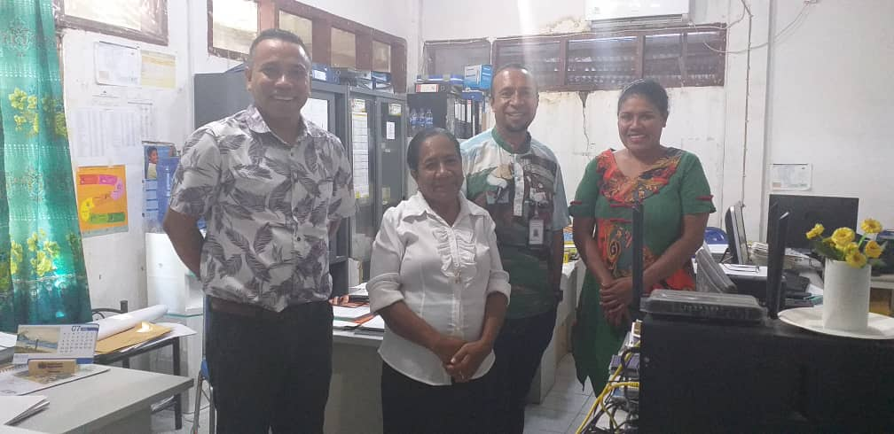
One stop Shop (Balkaun Úniku) Manatuto | Visit the first One-Stop-Shop (Balkaun Uniku) in Timor-Leste for delivering public services to citizens in a centralized location. Citizens can access a wide range of government services and information in a convenient and efficient manner. This shop aims to simplify the process of obtaining public services by reducing the need to visit multiple government offices or navigate through complex bureaucratic procedures. It aims to improve accessibility, efficiency, and transparency in public service delivery, ultimately enhancing the overall experience for citizens. This is the first shop and was inaugurated in May 2024. Government requested UNDP do further develop this model and establish a one of these shops in every municipality. With the shops a digital platform to provide services to the citizens is being developed. | Mr. Joao Luis do R.S. Mariano – Chief of Department | 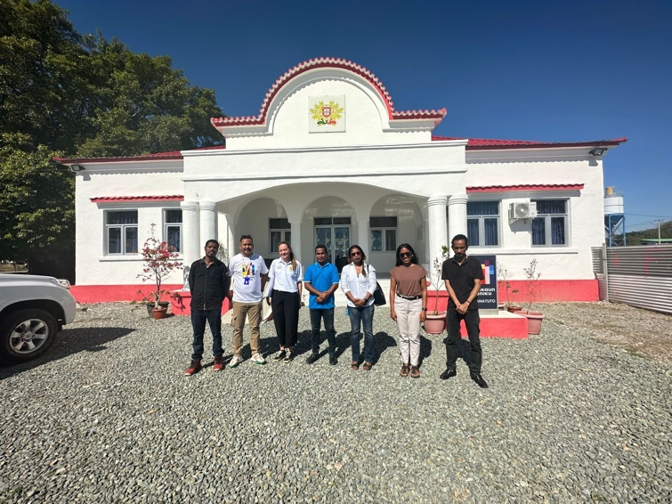
Manatuto Youth Center | Implementation of Healthy Relationship Training for Out-of-School Youth supported by UNFPA. | Jorge Geronimo (coordinator), Aduzinda Soares (member), Jose Soares (member), Charles da Costa (member), Ugu Natalino (member), Jose A. Boavida (member) | 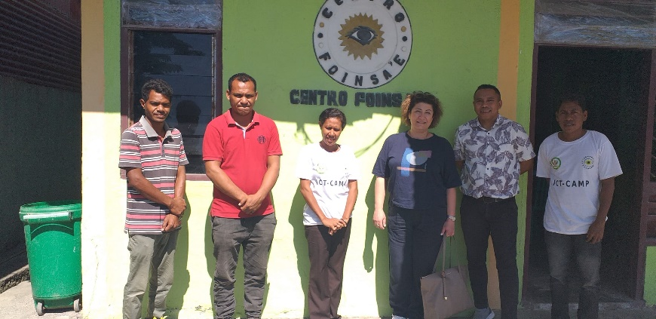
Manatuto Municipal Authority | The Municipal Authority of Manatuto has been actively collaborating with various UN agencies such as UNDP, UNICEF, WFP, and UNFPA to address critical development needs in the region. One of the notable projects is the establishment of a one-stop shop, launched in May 2024, in partnership with the Ministry of State Administration and the Ministry of Justice. This facility provides essential services, including the issuance of legal documents like birth certificates, ID cards, and passports, streamlining access for the local community.  In addition to improving public services, UNDP has supported rural communities in Laclo village, where access to electricity is limited, by providing solar panels and improving access to clean water. These initiatives aim to enhance the living conditions and promote sustainable energy use in remote areas. | Mr. Luis Fernandes – The President of Manatuto Municipal Authority | 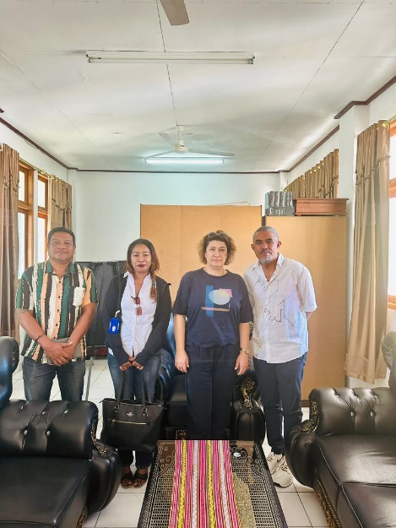
Community Health Center (CHC) Bucoli, Baucau Municipality | Mother Support Groups (MSGs) have been established across all sucos (villages) and aldeias in Baucau Municipality through the Community-Led Total Sanitation (CLTS) initiative. These groups are actively engaged in promoting key health, nutrition, and WASH (Water, Sanitation, and Hygiene) practices. Partner organizations continue to mentor MSG members to ensure the successful implementation of these interventions. Additionally, the MSGs are responsible for collecting and reporting data, contributing to the ongoing monitoring and improvement of community health outcomes. | Ms. Sabina Freitas, Ms. Suzana da Silva, Ms. Maria da Costa, Ms. Estevania Ximenes | 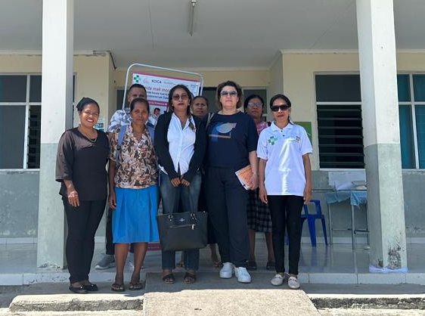
Municipal Authority of Baucau | In Baucau Municipality, UNDP and UN Women have partnered with local authorities to drive various development initiatives. UNDP has focused on the recruitment and training of technical officers, with four staff members supporting municipal planning and investment activities. The Small-Scale Rural Infrastructure (SSRI) initiative, supported by UNDP, is another key project aimed at improving rural infrastructure, such as roads and irrigation systems, which are critical for enhancing agricultural productivity and access to clean water.  In addition, UN Women has played a significant role in advancing women's empowerment through the establishment of the Market Vendor Association (MVA). This association addresses issues faced by market vendors, providing them with a platform to resolve disputes and improving their working conditions. This initiative has reduced the burden on the municipal authority, as local vendors can now resolve many challenges independently.  Furthermore, WFP has contributed to the School Feeding Program (SFP), focusing on improving nutrition for schoolchildren by standardizing menus and providing guidance on nutritious food preparation. | Mr. Eduardo Filipe Ximenes,  Secretario Municipal de Planeamento Investimento e Dezenvolvimento Integrado | 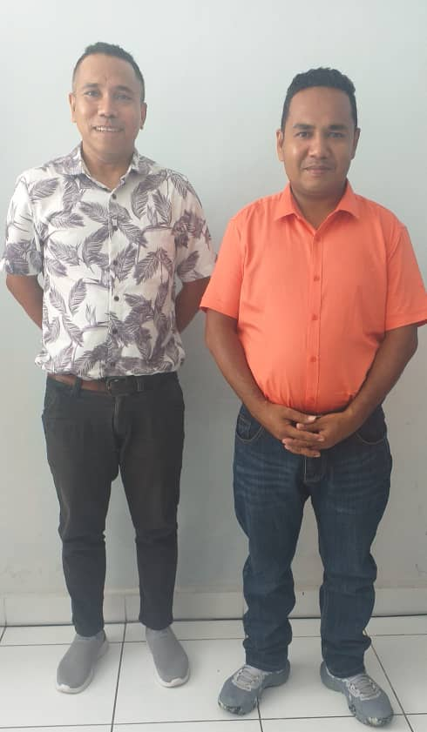
Ensinu Báziku Central (EBC) school Vila Nova, Baucau Vila | WFP supports the Government's School Meals Programme across three municipalities—Baucau, Bobonaro, and Manufahi—reaching approximately 74,000 students in 400 schools. The program provides fortified rice to students and equips all 400 schools with necessary kitchen utensils. In addition, it includes the construction of 10 new school kitchens and implements Social and Behavior Change Communication (SBCC) initiatives aimed at students, teachers, cooks, and school management committees to improve nutrition, food preparation, and hygiene practices. |  | 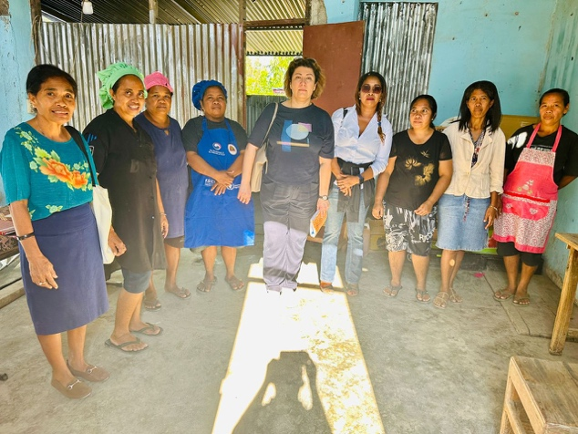
Baucau Regional Warehouse | Four regional warehouses including Baucau have been established across the country to enhance storage capacity at the regional level, enabling the storage of walk-in cold and freezer rooms. These facilities are designed to store vaccines for routine immunizations, as well as other temperature-sensitive medicines and reagents, ensuring faster distribution of vaccines and immunization supplies. Each regional warehouse is equipped with backup generators to address frequent power outages, helping the Ministry of Health maintain the quality of vaccines and medical supplies. | Ms. Angelita Maria Gomes | 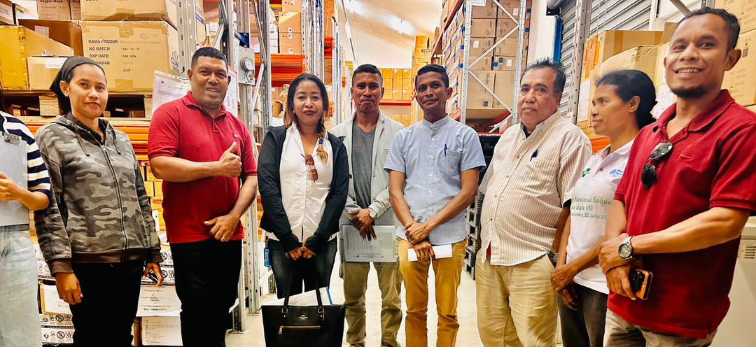

Annex 4: Analysis from CSO survey

This Annex presents the findings from the survey conducted among 13 CSOs in Timor-Leste

Question 1: What is the main thematic focus of your organization?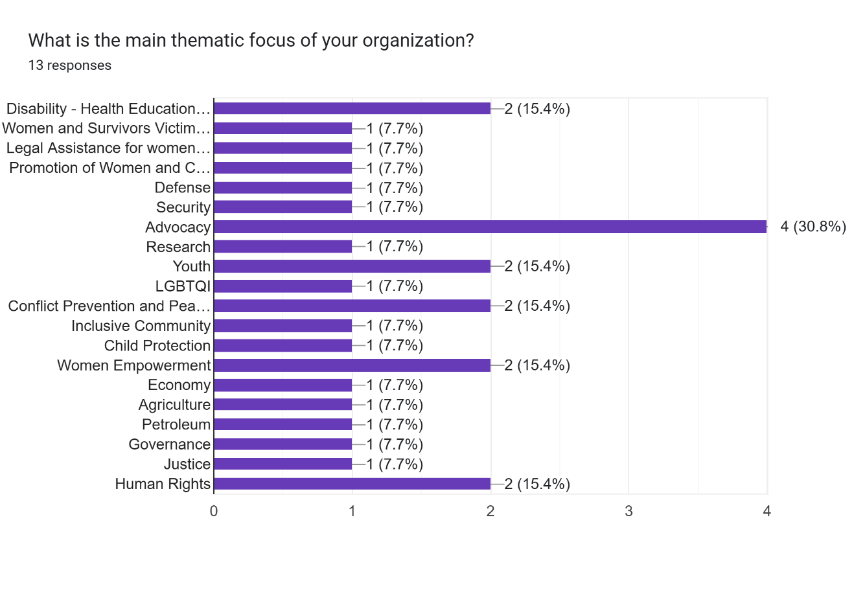
Question 2: In which regions of Timor-Leste is your organization operational?

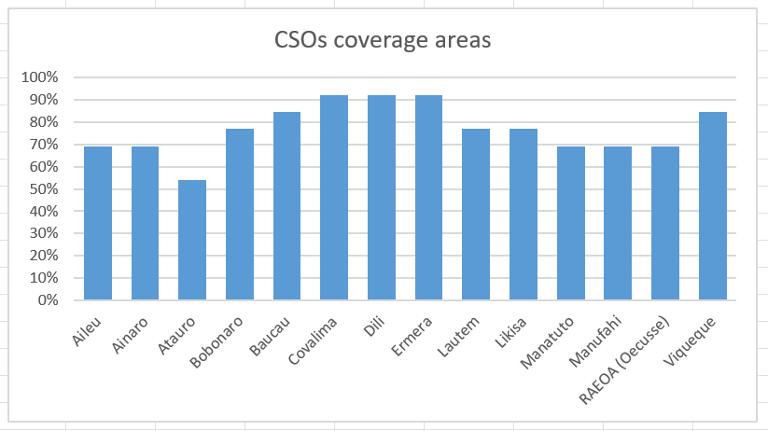
Question 3: What is your role in the organization?

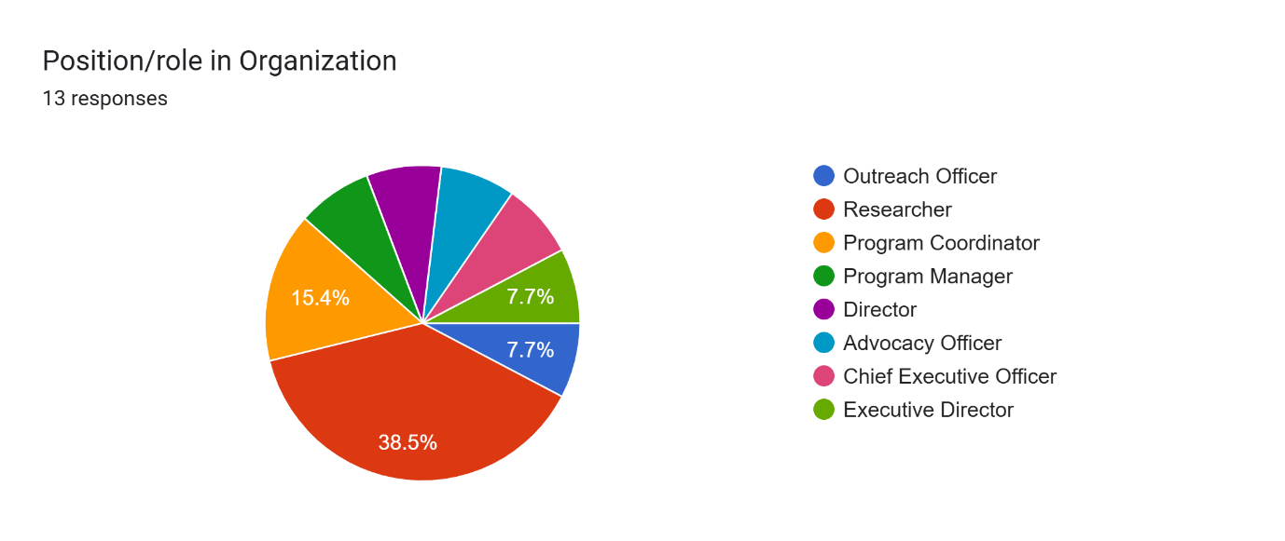

Question 4: What are the most disadvantaged groups in Timor-Leste?

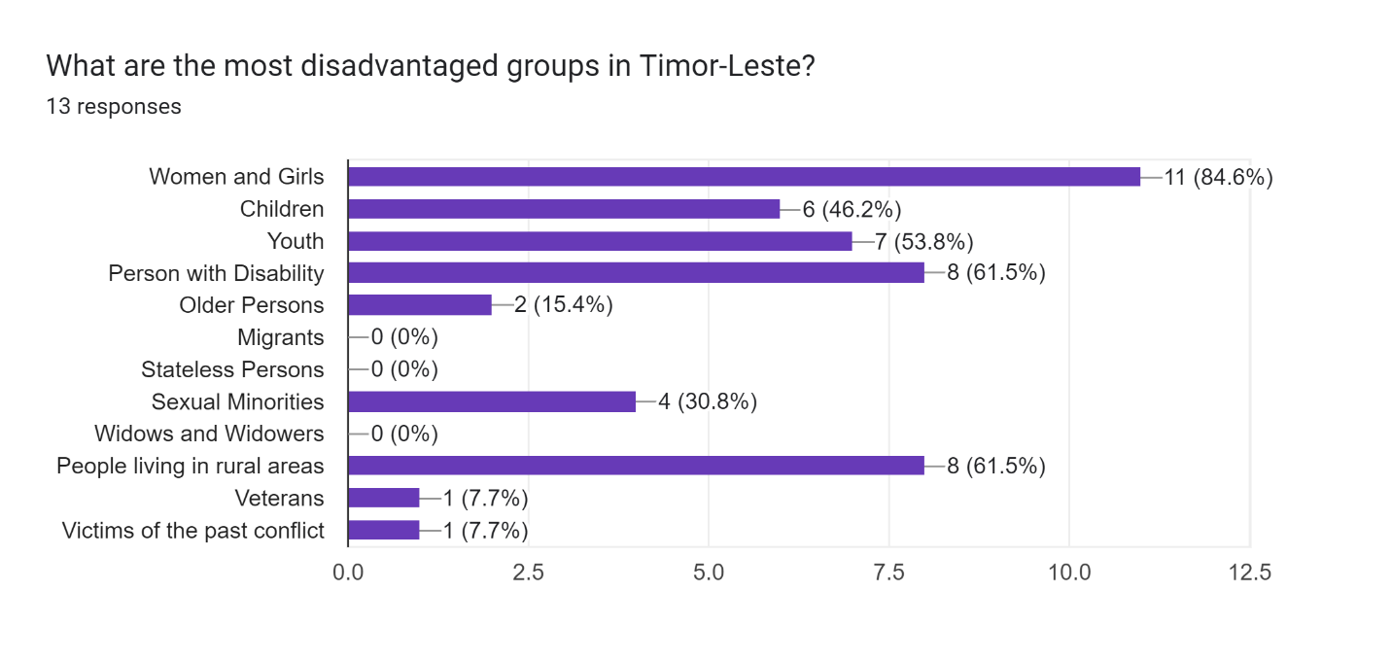

Question 5: What are the main two underlying (root) causes or drivers of their disadvantageous situation?

Question 6: What has been the role of UN in addressing the root causes of inequality in Timor-Leste since 2021? Please, describe.

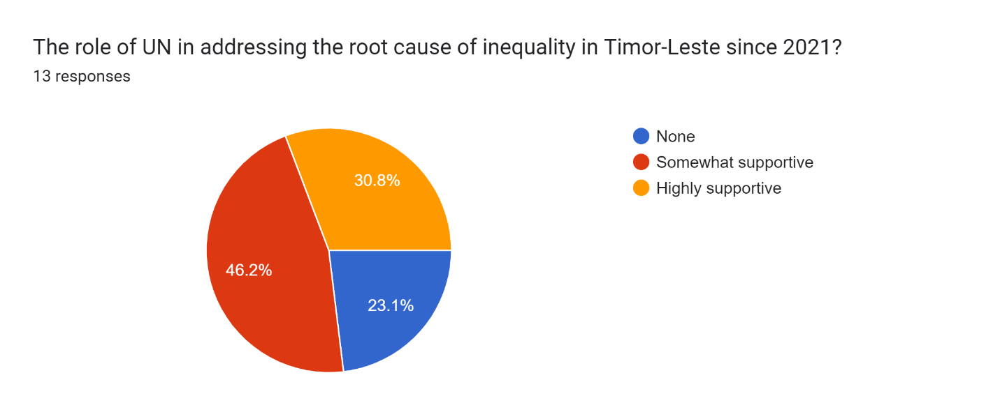

Question 7: What has been the role of government in addressing the root causes of inequality in Timor-Leste since 2021? Please, describe.

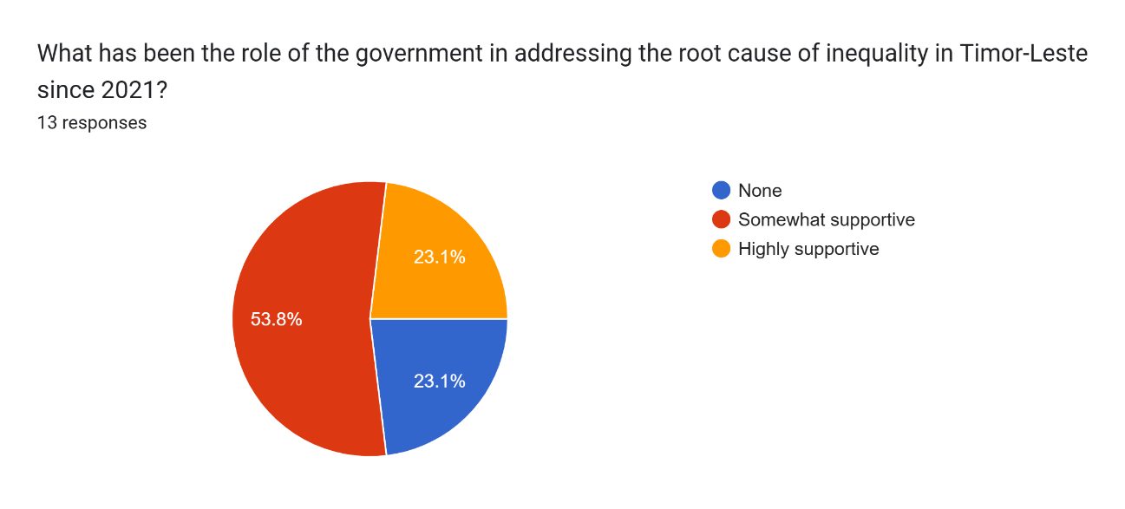

Question 8: Is there a strong and active civil society community in Timor-Leste to advocate for the rights of disadvantaged groups? YES or NO?

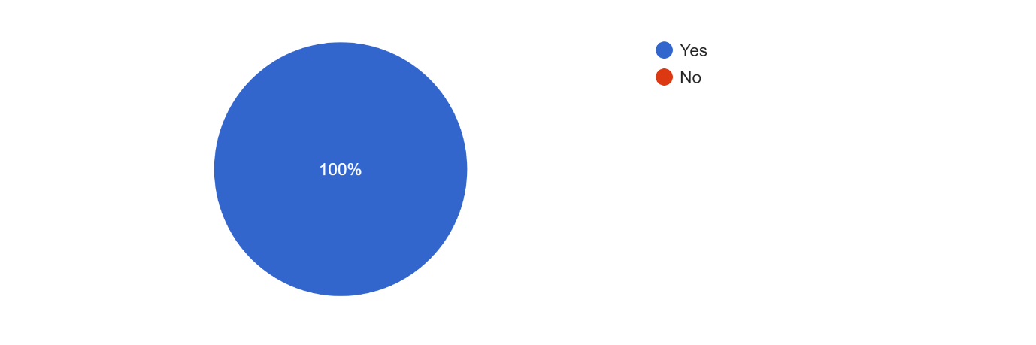
Question 9: What would you recommend to strengthen civil society organizations in Timor-Leste?

Question 10: What would you recommend UN Agencies in Timor-Leste to strengthen civil society organizations in Timor-Leste?

Question 11: Who are the main three donors of your organization?
Please, list them.
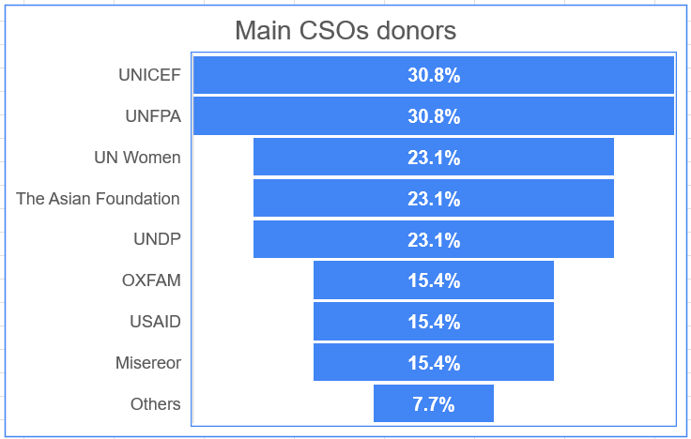

Annex 5: Overview of funding per agency per year per RG

Annex 6: State budget expenditures 2021-2025

Expenditures 2021-2024
Fiscal Year | 2021
Group | Budget details
Total | $2.016.597.513,17 | $51.163.029,79 | $87.475.688,59 | $1.432.288.924,60 | $449.866.179,13 | 75,4%
APPROPRIATION CATEGORY (2) | Budget | Commitments | Obligations | Actual | Balance | Execution %
Salary Wages | $245.961.557,30 | $107.280,42 | $74.859,89 | $226.368.083,41 | $19.437.188,82 | 92,1%
Goods Services | $602.201.708,02 | $18.998.341,96 | $33.887.009,64 | $408.636.512,16 | $141.900.841,40 | 73,5%
Minor Capital | $64.941.378,22 | $10.683.523,04 | $5.366.559,33 | $43.026.623,47 | $7.288.513,89 | 74,5%
Capital Development | $396.108.359,47 | $18.261.039,28 | $46.017.917,32 | $95.319.849,28 | $236.535.848,17 | 35,7%
Transfers | $704.104.434,16 | $2.558.637,84 | $1.726.987,30 | $655.657.784,78 | $44.161.024,24 | 93,4%
Despesas Contigencias | $3.280.076,00 | $554.207,25 | $402.355,11 | $3.280.071,50 | $542.762,61 | 112,3%
Fiscal Year | 2022
Group | Budget Details
Total | $3.208.813.610,12 | $44.611.398,61 | $89.889.029,75 | $1.739.535.445,89 | $1.335.305.058,94 | 57,0%
APPROPRIATION CATEGORY (2) | Budget | Commitments | Obligations | Actual | Balance | Execution %
Salary Wages | $272.393.849,46 | $99.969,00 | $337.221,36 | $256.552.143,10 | $15.405.894,05 | 94,3%
Goods Services | $510.934.121,16 | $13.921.970,48 | $21.936.090,78 | $395.626.341,37 | $79.873.709,00 | 81,7%
Minor Capital | $59.236.010,20 | $7.029.139,24 | $1.812.766,03 | $45.896.559,40 | $4.498.745,53 | 80,5%
Capital Development | $459.800.391,63 | $19.658.259,45 | $65.375.107,33 | $157.033.891,86 | $217.833.887,54 | 48,4%
Transfers | $1.894.501.777,38 | $3.854.014,28 | $179.646,74 | $875.767.408,81 | $1.014.700.707,55 | 46,2%
Despesas Contigencias | $11.947.460,29 | $48.046,16 | $248.197,51 | $8.659.101,35 | $2.992.115,27 | 74,6%
Fiscal Year | 2023
Group | Budget
Total | $1.960.479.533,87 | $33.871.904,76 | $46.410.874,62 | $1.493.199.420,18 | $386.997.334,31 | 78,5%
CATEGORY | Budget | Commitments | Obligations | Actual | Balance | Execution %
Salary Wages | $490.526.569,11 | $727.936,72 | $1.131.733,75 | $447.729.442,52 | $40.937.456,12 | 91,5%
Goods Services | $331.680.929,46 | $11.426.474,85 | $18.347.604,84 | $241.461.733,86 | $60.445.115,91 | 78,3%
Minor Capital | $58.631.976,44 | $4.788.829,48 | $5.386.866,66 | $47.661.857,70 | $794.422,60 | 90,5%
Capital Development | $259.748.191,80 | $14.108.372,53 | $21.009.084,77 | $188.997.495,94 | $35.633.238,56 | 80,9%
Transfer | $819.891.867,06 | $2.820.291,18 | $535.584,60 | $567.348.890,16 | $249.187.101,12 | 69,3%
Fiscal Year | 2024
Group | Budget
Total | $2.237.618.655,00 | $107.332.955,83 | $126.780.342,36 | $984.560.383,99 | $1.018.944.972,82 | 49,7%
APPROPRIATION CATEGORY | Budget | Commitments | Obligations | Actual | Balance | Execution %
Salaries and Wages | $480.198.815,04 | $617.117,20 | $2.366.657,10 | $270.682.813,40 | $206.532.227,34 | 56,9%
Current Goods and Services | $369.565.791,59 | $31.055.787,62 | $46.542.283,14 | $140.262.608,35 | $151.705.112,48 | 50,5%
Public Transfers | $925.297.175,69 | $18.061.130,66 | $5.357.364,20 | $459.293.047,24 | $442.585.633,59 | 50,2%
Minor Capital | $48.970.059,20 | $17.337.221,09 | $13.991.492,90 | $10.502.051,29 | $7.139.293,92 | 50,0%
Capital Development | $413.586.813,48 | $40.261.699,26 | $58.522.545,02 | $103.819.863,71 | $210.982.705,49 | 39,3%

Annex 7: Budget delivery rate per Agency, per year, per results group

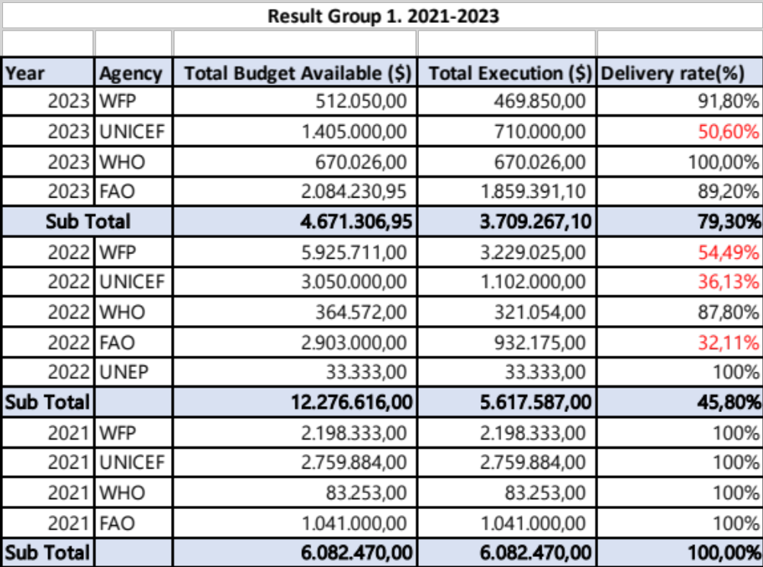

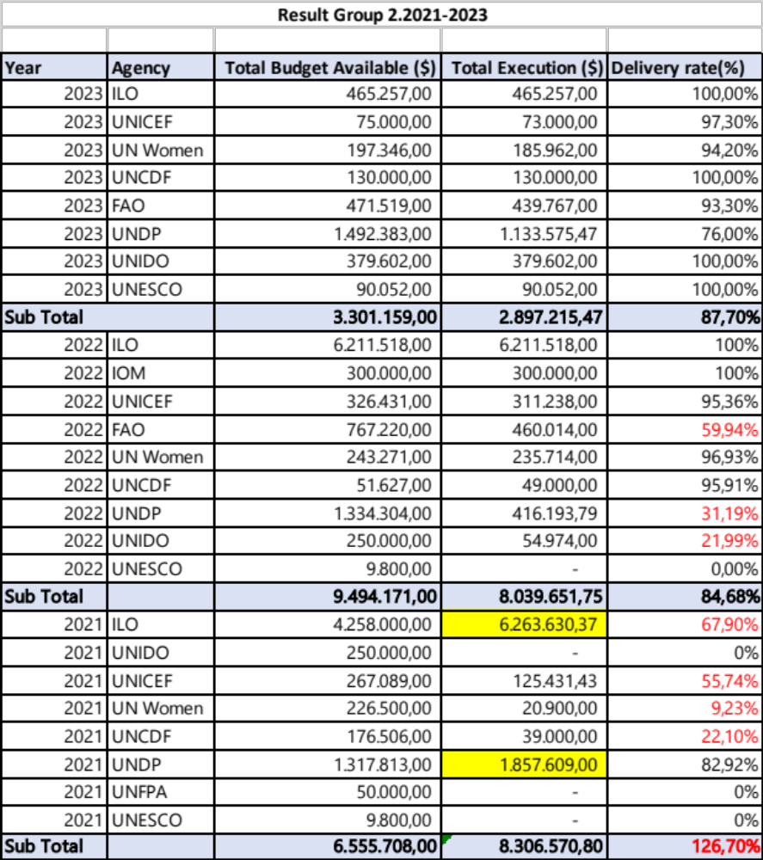

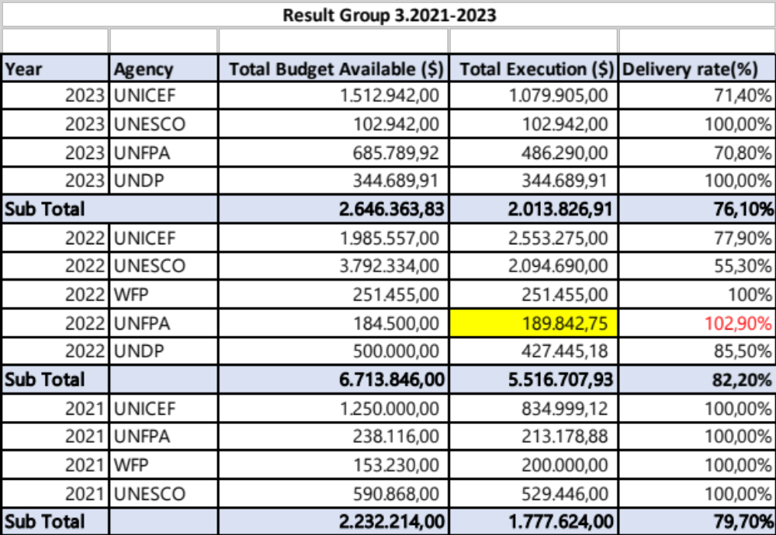

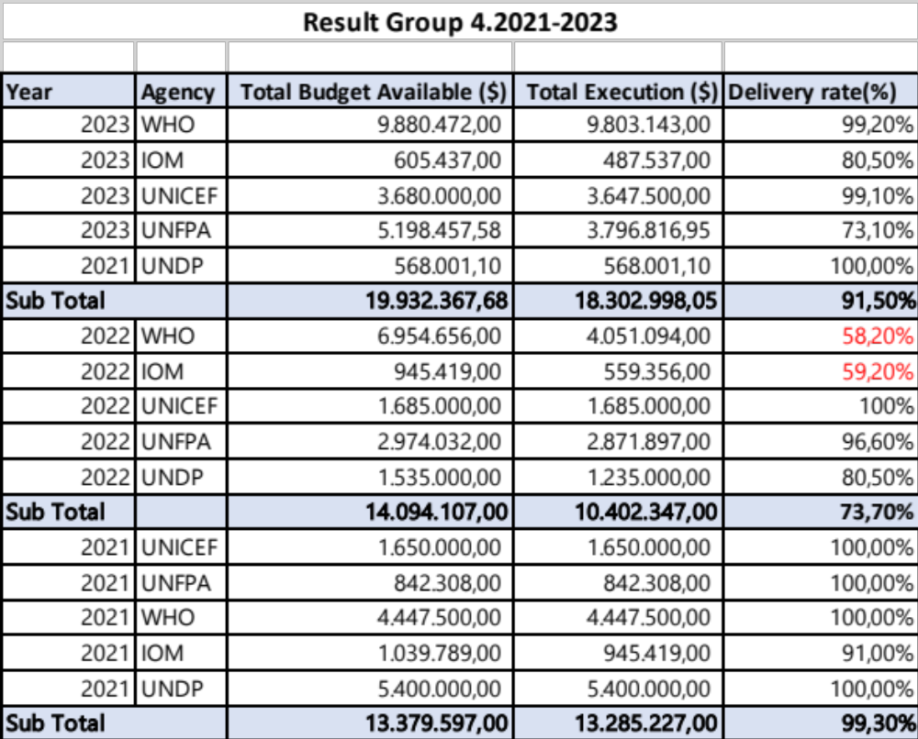

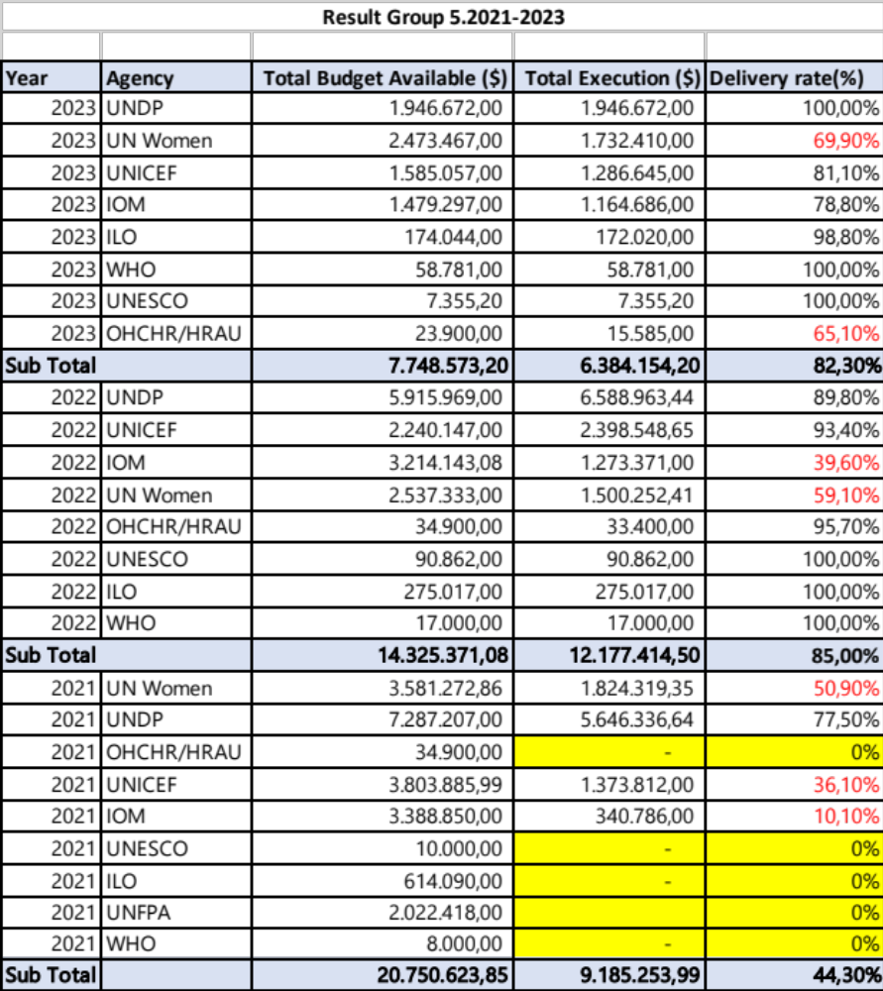

Result Group 6.2021-2023
Year | Agency | Total Budget Available ($) | Total Execution ($) | Delivery rate(%)
2023 | UNDP | 6.335.685,32 | 4.421.937,16 | 69,80%
2023 | IOM | 940.892,00 | 822.616,00 | 87,50%
2023 | FAO | 1.173.139,00 | 1.120.974,50 | 95,60%
2023 | WHO | 297.053,00 | 295.253,00 | 99,40%
2023 | UNEP | 5.708.829,30 | 588.656,88 | 10,30%
2023 | WFP | 61.299,59 | 61.299,59 | 100,00%
2023 | UNICEF | 160.000,00 | 117.000,00 | 73,10%
2023 | UNDRR | 26.215,00 | 26.215,00 | 100,00%
Sub Total |  | 14.703.113,21 | 7.453.952,13 | 50,60%
2022 | UNDP | $9.470.444 | $4.602.000 | 48,60%
2022 | IOM | $811.720 | $310.329 | 38,20%
2022 | FAO | $1.395.960 | $615.596 | 44,10%
2022 | UNEP | $4.005.562 | $754.830 | 18,80%
2022 | WFP | $447.720 | $447.720 | 100%
2022 | UNDRR | $103.000 | $55.000 | 53,40%
2022 | UNICEF | $90.000 | $60.000 | 66,70%
2022 | UNESCO | $75.000 | $0 | 0,00%
Sub Total |  | 16.399.406,00 | 6.845.475,00 | 41,75%
2021 | IOM | 1.215.892,00 | 361.969,00 | 29,80%
2021 | UNDP | 6.478.355,00 | 4.119.491,93 | 63,70%
2021 | FAO | 3.739.663,00 | 1.021.682,46 | 27,30%
2021 | UNEP | 3.921.104,87 | 241.794,00 | 6,20%
2021 | WFP | - | 607.558,00 | 0%
2021 | UNDRR | 74.720,00 | - | 0%
2021 | UNESCO | 75.000,00 | - | 0%
2021 | UNICEF | 150.000,00 | - | 0%
Sub Total |  | 15.654.734,87 | 6.352.495,39 | 40,50%

Annex 8: Budget delivery rate per outcome and sub-outcome area, per year
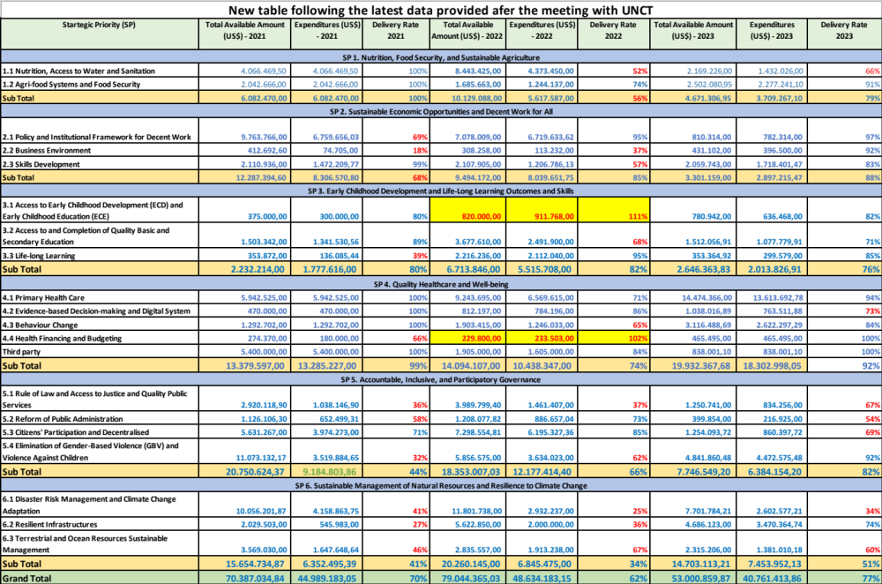
NB. Data in yellow highlights are not correct and must be checked
Correction received from UNEP
Projects | Year | Budget | Expenditures
6.1.5 Establish policy measures to minimize emission of ozone and climate-harmful substances, including in the refrigeration and air-conditioning servicing sector CAP team work on Ozone (Pipat)
 | 2021 | 75,760 | 74,528
 | 2022 | 118,150 | 108,710
 | 2023 | 0 | 0
6.3.1 Sustainable management of natural resources and ecosystems promoted through policies, information systems, knowledge and conservation aligned with international protocol and standards
GEF Nagoya Protocol project (Kavita)
 | 2021 | 571,034 | 108,305
 | 2022 | 451,911 | 73,875
 | 2023 | 284,916 | 804,211
6.3.4 Sustainable land management, through increased climate resilience and reduced land degradation
GEF project on sustainable agriculture/EbA (Moon/Kavita)
 | 2021 | 100,000 | 100,000
 | 2022 | 100,000 | 100,000
 | 2023 | 804,211 | 0
6.1.6 Enhance Early Warning Systems to build greater resilience to hydro-meteorological hazards through systematic drought analysis and establishment of flash flood/flood forecast system
GCF project on climate early warning (Bo Ra Kim/Simanchal)
 | 2021 | 0 | 0
 | 2022 | 4,904,618.30 | 62,482.76
 | 2023 | 7,297,610.82 | 1,352,799.09

Annex 9: List of stakeholders interviewed
No | Name | Gender | Organisation | Position
UN Partners
1 | Funmi Balogun | Female | UN Resident Coordinator Office (RCO) | UN Resident Coordinator
2 | Laura Lima | Female | RCO | Head of RCO
3 | Yew Hee Cheah | Male | UNICEF | OMT Chair
4 | Amy Nishtha Satyam | Female | UN Women | Head of Agency
5 | Ishita Kaul | Female | UN Women | Spotlight Initiative Project Specialist
6 | Bilal Aurang Zeb Durrani | Male | UNICEF | Head of Agency
7 | Ainhoa Jaureguibeitia | Female | UNICEF | Deputy Head of Agency
8 | Khadka Sunam | Female | UNICEF | Chief Child Protection
9 | Domingos da Costa Sousa | Male | UNICEF | Child Protection Specialist
10 | Maki Hayashikawa | Female | UNESCO | Regional Director (Jakarta)
11 | Joao da Costa | Male | UNICEF | Planning, Monitoring and Evaluation Senior Officer
12 | Katyna Argueta | Female | UNDP | Head of Agency
13 | Artemy Izmestyev | Male | UNDP | Economist
14 | Bruno Lencastre | Male | UNDP | Chief Technical Advisor
15 | Bruce Campbell | Male | UNFPA | Acting Head of Agency
16 | Simrin Singh | Female | ILO | Regional Director (Jakarta)
17 | Rajendra Aryal | Male | FAO | Regional Director (Jakarta)
18 | Paula Lopes da Cruz | Female | FAO | Executive Assistance, Head of Programmes
19 | Paulina Ari Setyawati Fernandes,  Toky Razafimamonjy,  Lino Tasik Pina  Ahmed Bilal | 1 female and 3 male | 2 UNFPA, 1 RCO, and 1 UNICEF | UN M&E Group
20 | Cecilia Garzon | Female | WFP | Head of Agency
21 | Helena Conte | Female | WFP | M&E Group Chair
22 | Genki Hara | Male | UNICEF | Data Management Officer
23 | Luis dos Reis | Male | WHO | Planning and Programme Management Officer
24 | Miguela Guterres | Female | WHO | National Professional Officer for Health System Strengthening
25 | Octavia Lita | Female | ILO | National Programme Officer for Timor-Leste
26 | Secondinho Salsinha | Male | UNFPA | M&E Officer
27 | Amin Said | Male | WFP | Deputy Head of Agency
28 | Arvind Mathur | Male | WHO | Head of Agency
29 | Roy Trivedy | Male | RCO Office | Former RC in UN TL
30 | Ahmed Saleem | Male | RCO Office | Communication
Government implementing partners
31 | Francisco Kalbuady Lay | Male | Office of the Vice-Prime Minister | Vice-Prime Minister and Minister Coordinator for Economic Affairs and Minister of Tourism and Environment
32 | Apolinario Serpa Rosa | Male | Ministry of Education | General Director, Preschool, Basic Education and Recurrent Education, and focal point for Southeast Asia Primary Learning Metrics
33 | James Herara | Male | Ministry of Finance | Advisor to Management and Mobilization of External Resources
34 | Samuel Soares | Male | Ministry of Foreign Affairs | National Director for United Nation and Cooperation (MoFaC)
35 | Sebastiana Barros | Female | Ministry of Foreign Affairs | Senior Policy Officer for Economic Development, Directorate of United Nation Cooperation (MoFaC)
36 | Leoneto Mantilo de Araujo | Male | Ministry of Foreign Affairs | General Director for Multilateral Affairs
37 | David Tomas | Male | Ministry of Art, Culture and Youth | General Director for Youth and Sport
38 | Raimundo Mau | Male | Ministry of Agriculture, Livestock, Fisheries, and Forestry | Director General Forestry, Coffee, and Industrial Plants
39 | Antonio Augusto Guterres, | Male | Ministry of State Administration | General Director of Local Governance Decentralization
40 | Mariano Asanami Sabino | Male | Vice Prime-Minister Office | Vice Prime-Minister for Rural Development and Social Sector Coordination
41 | Lidia Lopes | Female | Ministry of Interior | National Director of Civil Safety
42 | Joao Belo | Male | National Police of Timor-Leste | Chief of department for Criminal Investigation
43 | Armando da Costa | Male | Secretariat of State Gender Equality and Social Inclusion | General Director of Secretariat of State
44 | Maria Filomena Babo | Female | Secretariat of State Gender Equality and Social Inclusion | National Director for Planning
45 | Herminio Xavier | Male | Secretariat of State Gender Equality and Social Inclusion | Chief of Planning, Monitoring and Evaluation Department
46 | Gil Oliveira | Male | Secretariat of Sate Art and Culture | Director General of Art and Culture
47 | Karlito de Jesus | Male | Secretariat of State For Professional Employment and Policy | Director General Exterior Employment
48 | Narcisio Fernandes | Male | Ministry of Health | General Director for the Policy, Planning and Cooperation
49 | Luis Fernandes | Male | Municipal Authority of Manatuto | Municipal Authority President
50 | Otilia Pereira | Female | Community Health Center, Manatuto Municipality | District Public Health Officer
51 | Ms. Sabina Freitas, Ms. Suzana da Silva, Ms. Maria da Costa, Ms. Estevania Ximenes | 4 females | Community Health Center, Baucau | 1 General Medic and 3 volunteers
52 | Eduardo Filipe Ximenes, | Male | Baucau Municipal Authority | Secretario Municipal de Planeamento  Investimento e Dezenvolvimento Integrado
53 | Mariano Ana Lopes | Male | Civil Protection Authority | Deputy Commandant of Operations (AERO)
54 | Agustinho Cosme de Belo | Male | Civil Protection Authority | Chief Department of Communication
55 | Jesuinho dos Reis de Matos Carvalho | Male | Civil Protection Authority | President of Civil Protection Authority
56 | Joao Luis do R.S. Mariano | Male | One Stop Shop, Manatuto Municipality | Chief of Department
57 | Dr. Andre Monteiro | Male | Ministry of the presidency of Council of Ministries | Coordinator of Development of Strategic Policy
58 | Angelita Maria Gomes | Female | Baucau Regional Warehouse | Baucau Regional Warehouse Coordinator
Civil society organizations
59 | Maria Imaculada Guterres | Female | Alola Foundation | Director
60 | Maria do Ceu Lopes da Silva | Female | Timor-Aid | Director
61 | Nadia Ribeiro  Yohannes Bouk  Jacinta de Sousa Pereira  Helio R. Dias | Female  Male  Female  Male | BA FUTURU | Acting Director BA FUTURU  Project Coordinator  Project Coordinator  Project Coordinator
62 | Jorge Geronimo (coordinator), Aduzinda Soares, Jose Soares, Charles da Costa, Ugu Natalino, Jose A. Boavida | Male 5, female 1 | Manatutu Youth Centre | One Coordinator and 5 members
Media
National Parliament
63 | Casilda I Afonso | Female | National Parliament | Director of Office of Studies and Parliamentary Advisory
64 | Helena Dias Ximenes | Female | National Parliament | Legal Advisor
Private sector
65 | Mr. Domingos Natividade and  Mr. Rui Manuel de Castro | Male and Male | Timor-Leste Chamber of Commerce and Industry | Executive Director and Vice -President,  Livestock, forestry, aquaculture and agriculture  affairs.
Academia
66 | Ligia Tomas Correia, S.Pp., M.Sc. | Female | National University of Timor-Leste | Vice rector of Academic Affairs
Donors
67 | Rebeca Dodd | Female | DFAT – Australia | Counselor for Human Development
68 | Sunghwan Jang | Male | KOICA | Deputy Country Director
69 | Xu Danyang | Male | Government of China | Charge d'affaires of the Embassy of China in Timor-Leste
70 | Kimura Tetsuya | Male | Government of Japan | Ambassador
71 | Helen Tunnah | Female | New Zealand Government | Ambassador
72 | Bernard Harborne | Male | The World Bank | Country Director
73 | Marc Fiedrich | Male | European Union Delegation in TL | Ambassador
74 | Iotam Lerer | Male | European Union Delegation in TL | Head of Cooperation
75 | Stefania Dina | Female | Asian Development Bank (ADB) | Country Director

Annex 10: Inception report

To be added

Annex 11: UNEG ethical code of conduct

The evaluation fully adhered to UNEG Norms and Standards for Evaluation and UNEG Ethical Code of Conduct. The evaluation’s value-add builds on its impartial and systematic assessment of the project or intervention and involvement of stakeholders should not interfere with the impartiality of the evaluation. The evaluators have the final judgement on the findings, conclusions and recommendations of the evaluation report, and the evaluators must be protected from pressures to change information in the report. It is important to note that if in the course of the evaluation process at any stage the evaluators identify issues of wrongdoing, fraud or other unethical conduct, UN procedures must be followed, and confidentiality be maintained.
The evaluators obtained informed consent to participate in the evaluation activities prior to engaging in data collection. The evaluation team members read the statement of intent of the evaluation and requested the individual to express their willingness to participate or not prior to initiating the discussion or interview in English or Portuguese or Tentum.
All data collected through this evaluation in line with the UNEG evaluation norms and standards received due attention to ensure their confidentiality, integrity and be protected against any unauthorized usage, access, modification, destruction, disclosure, loss or transfer of data, whether accidental or intentional.
Confidentiality of information obtained was ensured through ensuring the actual names of participants were not included in the report. When organizing the discussions with stakeholders engaged in the project or impacted by its implementation, the participants were requested to avoid sharing details regarding their/other participants outside of the space.

Annex 12: Structure of the case studies

Case study structure: UN efforts to support regulatory environment in Timor Leste

Descriptive part:
What is the formal processes and formal mechanisms of adoption of any regulatory document in Timor Leste?

What are examples of UN’s engagement in policy support in Timor Leste since 2021? What are the outcomes: policies and regulations are adopted, rejected or ongoing processes? What are the examples of adoption of any regulatory document? What are the examples of rejection of any regulatory document? Who are the main stakeholders? What are the initiatives under which UN operated?

Analytical part:
After meeting with key stakeholders:
- How responsive was UN to address regulatory needs in Timor Leste? (e.g. how the regulatory needs are identified; what is the role of the government in shaping those needs; what is the role of CSOs, especially those representing vulnerable and disadvantaged groups; is this Agency-based work or requires engagement of various UN Agencies?)
- How effective was UN to shape the process of improving legal and regulatory framework in Timor Leste? (e.g. how UN engaged with the government authorities at all levels (national and local) and with CSOs; how UN engaged with the Parliament of TL; to what extent the existing formal mechanisms were utilized or parallel ‘UN-led’ processes were put in place; to what extent government authorities were satisfied with UN support)
- What are the lessons learned from UN’s efforts towards improving legal and regulatory framework in Timor Leste? (e.g. focus could be on the limitations of the legal and regulatory framework, mechanisms of engagement with UN, capacities of different stakeholders, engagement with CSOs, engagement with the government authorities at all levels (national and local), transparency in resource utilization, etc.)
- What are the recommendations for shaping UN capabilities to effectively support the Government of Timor Leste in its efforts of strengthening its legal and regulatory framework?

Case study structure: UN Crisis Response and recovery

Descriptive part:
What is the disaster risk context of TL?
What crisis situations were encountered in Timor Leste since 2021? What was UN response to each crisis situation? What were UN recovery efforts in each crisis context? Who are the main stakeholders? What are the initiatives under which UN operated?

Analytical part:
After meeting with key stakeholders:
- How responsive was UN to address crisis situations in TL (e.g. quick in allocation of resources and quick in implementation; sufficient resources allocated to address the problems; government was involved along the whole process)
- How effective was UN to address crisis situations in TL (e.g. the affected beneficiaries were reached and critical response provided; LNOB focus was maintained; government authorities are satisfied with UN performance)
- What are the lessons learned from UN crisis response and recovery in TL? (e.g. focus could be on legal and regulatory framework, capacities of different stakeholders, engagement with CSOs, engagement with the government authorities at all levels (national and local), transparency in resource utilization by all stakeholders, etc.)
- What are the recommendations for shaping UN capabilities to address future crisis situations more effectively?

Annex 13: Analysis of staffing across UNCT

Only UNDP provided the required data. In this situation, it is not possible to make conclusion about UNCT staffing based on actual data from all UN Agencies. However, given that the UNDP is one of the largest UN Agencies in Timor-Leste, the findings could be assumed representative. This assumption has high certainty as it fully resonates with the pattern of staffing found through reflection of wide range of stakeholders.

Agency | Fixed Term International |  | (please spesifically indicate how many D1-2 & P1-6 level) | Fixed Term  NO Level |  | (please spesifically indicate how many NO A-D level) | Fixed Term  GS Level  (*not including driver) |  | (please spesifically indicate how many G1-G7 Level) | Service Contract/NPSA  (*not including driver) |  | Volunteer  (*not including driver) |  | JPO  (*not including driver) |  | Driver |  | Total (not including driver) |  |  | Total (including driver)
Agency | Male | Female |  | Male | Female |  | Male | Female |  | Male | Female | Male | Female | Male | Female | Male | Female | Male | Female | All | Male | Female | All
UN Women | 0 | 3 |  | 0 | 3 |  | 2 | 2 |  | 5 | 1 | 1 | 1 | 0 | 0 | 1 | 0 | 7 | 10 | 17 | 9 | 10 | 19
UNFPA | 1 | 2 |  | 3 | 3 |  | 3 | 3 |  | 2 | 0 | 3 | 2 | 0 | 0 | 4 | 0 | 12 | 10 | 22 | 16 | 10 | 26
UNICEF | 5 | 6 |  | 10 | 14 |  | 6 | 3 |  | 2 | 3 | 1 | 0 | 0 | 0 | 7 | 0 | 24 | 26 | 50 | 79 | 26 | 105
UNDP | 3 | 3 | D2=1; P4=2; P3=1; P2=1; P1=1 | 5 | 5 | NOA=2; NOB=7; NOC=1 | 8 | 4 | G2=1; G3=1; G6=9; G7=1 | 48 | 36 | 4 | 10 | 0 | 0 | 18 | 0 | 68 | 58 | 126 | 86 | 58 | 144
IOM | 2 | 1 |  | 1 | 1 |  | 6 | 7 |  | 4 | 5 | 0 | 1 | 0 | 0 | 4 | 0 | 13 | 15 | 28 | 17 | 15 | 32
ILO | 0 | 1 |  | 0 | 3 |  | 0 | 1 |  | 0 | 0 | 0 | 0 | 0 | 0 | 0 | 0 | 1 | 4 | 5 | 2 | 4 | 6
WHO | 8 | 4 |  | 6 | 2 |  | 4 | 5 |  | 45 | 45 | 0 | 0 | 0 | 0 | 8 |  | 63 | 56 | 119 | 71 | 56 | 127
WFP | 3 | 1 |  | 5 | 0 |  | 4 | 4 |  | 12 | 3 | 0 | 2 | 0 | 0 | 6 | 0 | 16 | 9 | 25 | 14 | 1 | 15
FAO | 0 | 0 |  | 0 | 2 |  | 0 | 0 |  | 34 | 10 |  | 1 |  |  | 5 |  | 34 | 13 | 47 | 39 | 13 | 52
UNESCO | 0 | 0 |  | 0 | 0 |  | 0 | 0 |  | 0 | 2 | 0 | 1 | 0 | 0 | 1 | 0 | 0 | 3 | 3 | 1 | 3 | 4
HRAU | 0 | 1 |  | 0 | 2 |  | 1 | 0 |  | 0 | 0 | 0 | 0 | 0 | 0 | 0 | 0 | 1 | 3 | 4 | 1 | 3 | 4
UNCDF | 1 | 0 |  | 0 | 0 |  | 0 | 0 |  | 0 | 0 | 0 | 0 | 0 | 0 | 0 | 0 | 1 | 0 | 0 | 1 | 0 | 1
UN Volunteers | 0 | 0 |  | 1 | 0 |  | 0 | 0 |  | 0 | 0 | 0 | 1 | 0 | 0 | 0 | 0 | 1 | 1 | 2 | 1 | 1 | 2
RCO | 1 | 1 |  | 3 | 0 |  | 0 | 2 |  | 0 | 0 | 1 | 1 | 0 | 0 | 1 | 0 | 5 | 4 | 9 | 6 | 4 | 10
UNDSS | 1 | 0 |  | 0 | 2 |  | 0 | 0 |  | 0 | 0 | 0 | 0 | 0 | 0 | 0 | 0 | 0 | 0 | 0 | 0 | 0 | 3
Total | 25 | 23 |  | 34 | 37 |  | 34 | 31 |  | 152 | 105 | 10 | 20 | 0 | 0 | 55 | 0 | 246 | 212 | 457 | 343 | 204 | 550

Based on the provided data, there appears to be a notable underrepresentation of middle-level professionals (P3-P4 or equivalent) within UNDP. Here's an analysis supporting this observation:
1. Fixed Term International Staff (D1-D2 & P1-P6 Levels)
- Total Staff: 48 (25 males, 23 females) across UN and 6 within UNDP
- Middle-Level Positions (P3-P4): P3=1 and P4=2
2. Fixed Term National Officer (NO A-D Levels)
- Total Staff: 71 (34 males, 37 females) and 10 from UNDP
- Middle-Level Positions (NO nB-C): NOA=2 and NOB=7
3. Fixed Term General Service (GS Levels G1-G7)
- Total Staff: 65 (34 males, 31 females) and 12 from UNDP
- Middle-Level Positions (G3-G4): G3=1 and G4=1
4. Service Contract/NPSA
- Total Staff: 257 (152 males, 105 females) and 94 from UNDP
- Middle-Level Positions: Not specified, but the data suggests a lower proportion of middle-level roles compared to senior and junior positions.
5. Volunteer Staff
- Total Staff: 30 (10 males, 20 females)
- Middle-Level Positions: Typically, volunteer roles are entry-level or support positions, indicating limited middle-level representation.
6. Drivers
- Total Staff: 55 (all males)
- Position Level: Operational roles, generally not classified as middle-level professional positions.

Conclusion: Out of 28 UNDP professional staff and 94 service contracts,
The data indicates that middle-level professional positions (P3-P4 and equivalents) are underrepresented in UNDP – two out of 28 professional staff. This trend is consistent across different contract types and categories. The limited number of middle-level roles may impact organizational capacity, particularly in terms of leadership development and succession planning. Addressing this imbalance could involve targeted recruitment initiatives and career development programs to strengthen the middle tier of professionals within these agencies.

https://timorleste.un.org/sites/default/files/2021-04/UNSDCF%20Timor-Leste%202021-25%20Final_0.pdf
https://www.timorleste.tl/east-timor/about/geography-climate/
https://timor-leste.unfpa.org/sites/default/files/pub-pdf/censuspreliminaryresults2022_4.pdf
https://www.laohamutuk.org/DVD/docs/240313UNDP-HDR-TLS.pdf
https://dashboards.sdgindex.org/rankings
https://documents1.worldbank.org/curated/en/099236104112334682/pdf/IDU0cb57b9d60b98a0438d0a271063e4bea1b02e.pdf?_gl=1*1yj09b7*_gcl_au*MTM5MzU0MDQwLjE3MjU5NjQ5MjQ.
Ibid.
Ibid.
Food Security Assessment, Timor-Leste, 2023
Ibid.
Ibid.
https://www.unicef.org/timorleste/stories/community-pre-school-lays-foundation-quality-education-every-child
https://freedomhouse.org/country/timor-leste/freedom-world/2022
https://timor-leste.gov.tl/?p=13&lang=en
https://culturalatlas.sbs.com.au/east-timorese-culture/east-timorese-culture-religion
https://www.timorleste.tl/east-timor/about/people-culture/
Ibid.
https://timor-leste.unfpa.org/sites/default/files/pub-pdf/NTA%20Brief_final.pdf The dividend period occurs when the number of children needing support goes down relative to the number of workers, while, at the same time, the number of elderly people remains small.
https://timor-leste.unfpa.org/sites/default/files/pub-pdf/NTA%20Brief_final.pdf
https://sdgs.un.org/documents/timor-leste-2019-vnr-report-english-24410
https://timor-leste.gov.tl/wp-content/uploads/2019/05/key_messagesVNAR_2019.pdf
https://timorleste.un.org/en/239646-people-centred-sustainable-development-leaving-no-one-behind
UNSDCF 2021-2025, https://timorleste.un.org/sites/default/files/2021-04/UNSDCF%20Timor-Leste%202021-25%20Final_0.pdf
https://unctad.org/topic/least-developed-countries/list
https://www.statista.com/outlook/co/socioeconomic-indicators/timor-leste#:~:text=The%20employment%20rate%20in%20Timor,to%20US%241.98%20in%202024.
https://www.laohamutuk.org/Oil/PetFund/Reports/230810LPFAR22en.pdf
https://bti-project.org/en/reports/country-report/TLS
https://www.social-protection.org/gimi/ShowCountryProfile.action?iso=TL https://pt.tatoli.tl/2024/03/12/pensoes-sociais-de-velhice-e-invalidez-comecam-a-ser-pagas-na-proxima-semana/
https://www.mof.gov.tl/pagedetails/budget-and-spending-documents https://assets.ctfassets.net/60pzqxyjaawg/27ImSGDfGHWriLIv4FUlv9/ef2caed3271adc3c9781686918300c8a/3_DO_Despesas_Entidades_por_Programa_final_final_final.pdf
https://www.adb.org/sites/default/files/publication/957856/tim-ado-april-2024.pdf
https://timorleste.un.org/en/196067-remittance-mobilization-strategy-timor-leste
https://timor-leste.gov.tl/?cat=39&lang=en#prog1.2
https://inetl-ip.gov.tl/2024/04/23/agricultural-gdp-report-february-2024/
https://trendeconomy.com/data/h2/TimorLeste/TOTAL
https://knowledge4policy.ec.europa.eu/publication/timor-leste-economic-report-january-2024-fit-purpose-crafting-stable-inclusive_en#:~:text=Consumer%20price%20inflation%20has%20remained,same%20period%20(Figure%201.24).
https://docs.wfp.org/api/documents/WFP-0000157652/download/?_ga=2.16793979.350058615.1725966345-741976504.1725966345
https://iris.who.int/bitstream/handle/10665/347425/Timor-Leste-eng.pdf
https://timor-leste.unfpa.org/sites/default/files/pub-pdf/final-main-report_tlphc-census_2022.pdf
https://timor-leste.unfpa.org/sites/default/files/pub-pdf/censuspreliminaryresults2022_4.pdf
https://iwda.org.au/timor-leste/
https://www.statista.com/outlook/co/socioeconomic-indicators/timor-leste#:~:text=The%20employment%20rate%20in%20Timor,to%20US%241.98%20in%202024.
https://www.ilo.org/resource/news/timor-leste-launches-its-2021-labour-force-survey-report
https://data.unicef.org/sdgs/country/tls/
https://www.dol.gov/sites/dolgov/files/ILAB/PESKIJA%20CL%20FINAL%20REPORT.pdf
https://data.unwomen.org/country/timor-leste
Ibid.
https://www.timorleste.tl/documents/timor-leste-strategic-development-plan-2011-2030/
https://timor-leste.gov.tl/wp-content/uploads/2022/11/SDP-Evaluation-Report-Nov-2021-ENG-2.pdf
https://timor-leste.gov.tl/?cat=39&lang=en#prog1.2
https://asean.org/wp-content/uploads/2023/05/FINAL-Chairmans-Statement-42nd-ASEAN-Summit-1.pdf
https://asean.org/selection-and-criteria/
https://www.undp.org/timor-leste/publications/socio-economic-impact-assessment-covid-19-timor-leste-round-2-2021
https://www.undp.org/timor-leste/publications/timor-leste-post-disaster-needs-assessment-pdna
https://www.acaps.org/fileadmin/Data_Product/Main_media/20240513_ACAPS_Timor-Leste__Humanitarian_impacts_of_El_Nino-related_drought_and_heat.pdf
Workshop is an interactive meeting, involving a facilitator, designed to create a specialized results. https://www.lucidmeetings.com/glossary/workshop
The evaluation stance is that complex adaptive systems (CAS) are dispositional, causality could only be inferred in retrospective.
https://www.oecd.org/dac/evaluation/daccriteriaforevaluatingdevelopmentassistance.htm
https://www.unevaluation.org/document/detail/2866
https://www.unevaluation.org/document/detail/1914
https://timor-leste.gov.tl/?p=35409&lang=pt
https://www.unscn.org/layout/modules/resources/files/Cash_transfers_in_emergencies.pdf
https://www.calpnetwork.org/publication/joint-donor-statement-on-humanitarian-cash-transfers/
https://international-partnerships.ec.europa.eu/document/download/62aeefcf-5be2-4d72-a568-3c419d34d6b5_en
https://www.undp.org/timor-leste/publications/socio-economic-impact-assessment-covid-19-timor-leste-round-2-2021
https://www.undp.org/timor-leste/publications/timor-leste-post-disaster-needs-assessment-pdna
https://www.acaps.org/fileadmin/Data_Product/Main_media/20240513_ACAPS_Timor-Leste__Humanitarian_impacts_of_El_Nino-related_drought_and_heat.pdf
https://reliefweb.int/report/timor-leste/un-allocates-us2-million-respond-el-nino-impacts-timor-leste-entetum
https://www.undp.org/timor-leste/publications/socio-economic-impact-assessment-covid-19-timor-leste-round-2-2021
https://www.anticipation-hub.org/news/anticipating-drought-in-timor-leste
https://inetl-ip.gov.tl
https://unsdg.un.org/sites/default/files/2021-09/MAF%20-%20Final%20-%2015%20September%202021.pdf
https://mptf.undp.org/page/un-pooled-funding-key-concepts-and-terms#country-level-pooled-fund
https://unstats.un.org/sdgs/report/2023/The-Sustainable-Development-Goals-Report-2023.pdf
https://www.undp.org/acceleratorlabs/undp-timor-leste-accelerator-lab
https://www.unicef.org/timorleste/media/5851/file/UNICEF_TIMOR_LESTE_INVESTMENT_CASE_WASH_Final.pdf
https://en.tatoli.tl/2024/03/14/unicef-and-mssi-launch-primero-a-case-management-web-application/15/
https://staging.unhabitat.org/content.asp?cid=746&catid=411&typeid=13&subMenuId=0
https://www.wfp.org/news/government-and-wfp-join-forces-boost-school-feeding-timor-leste#:~:text=In%202021%2C%20the%20Government%20of,290%2C000%20students%20across%20the%20country.
https://unsceb.org/sites/default/files/imported_files/CEB%20equality%20framework-A4-web-rev3.pdf
https://unsdg.un.org/sites/default/files/2022-04/Operationalizing%20LNOB%20-%20final%20with%20Annexes%20090422.pdf
https://unsdg.un.org/resources/unct-swap-gender-equality-scorecard
https://www.unyouth2030.com/unctscorecard
https://www.un.org/en/content/disabilitystrategy/assets/documentation/UN_Disability_Inclusion_Strategy_english.pdf
https://www.un.org/en/content/disabilitystrategy/assets/documentation/UNCT_Accountability_Scorecard_on_Disability_Inclusion.pdf
https://data.unwomen.org/country/timor-leste
https://www.ohchr.org/sites/default/files/Documents/Countries/TP/UNHR_Report2011_en.pdf
https://unprpd.org/new/wp-content/uploads/2023/12/CR-Timor-Leste-2023-be4.pdf
https://sdgintegration.undp.org/INFF
https://sustainabledevelopment.un.org/content/documents/2051AAAA_Outcome.pdf
https://unsdg.un.org/resources/guidelines-communications-and-advocacy-strategy-cooperation-framework
https://unsdg.un.org/resources/communicating-together-guidelines-unct-communications-sdgs
http://www.budgettransparency.gov.tl/publicTransparency?fiscalYearId=93&isInflow=false](http://www.budgettransparency.gov.tl/publicTransparency?fiscalYearId=93&isInflow=false)
https://www.eeas.europa.eu/delegations/timor-leste/european-union-releases-eur-1212500-timor-lestes-government-support-nutrition_en?s=254
https://unsdg.un.org/resources/un-resident-coordinator-generic-job-description

